**History Inquiry**

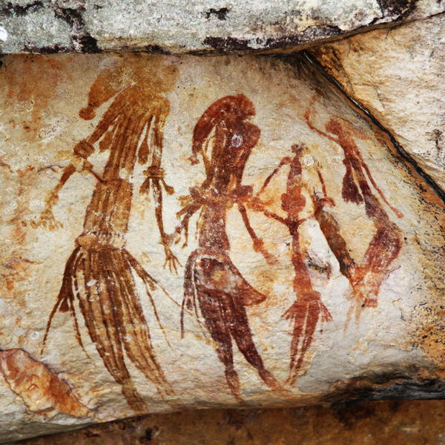

[*http://commons.wikimedia.org/wiki/File:Bradshaw_rock_paintings2.jpg*](http://commons.wikimedia.org/wiki/File:Bradshaw_rock_paintings2.jpg)

Who are Australia’s Indigenous people?



**GETTING KNOWLEDGE READY**

What comes into your mind when you think about Australia’s aboriginal peoples?

1. Write the words that come into your head in the thought bubbles below.

____________________

___________________

1. What are two things that you already know about Aboriginals?

1. What are two things that you would like to know about Aboriginal people?

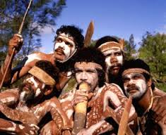

4**.** Read and discuss the following information with your supervisor. Highlight any facts you find fascinating.

**Who are Australia’s Indigenous people?**

Australia is an ancient continent inhabited continuously for many thousands of years. Aboriginal and Torres Strait Islander people lived in Australia long before the arrival of Europeans.

Aboriginal peoples live across the whole continent of Australia, including Tasmania. Traditionally, Torres Strait Islander people lived on the islands in the Torres Strait, which is between Cape York Peninsula and Papua New Guinea.

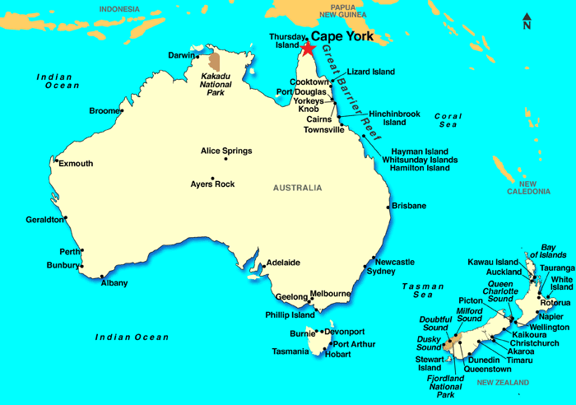

Aboriginal and Torres Strait Islander people are not one group of people. There are many different groups or nations. Each group has its own culture, customs and language. It has been estimated that over 250 different languages were spoken by Aboriginal groups across Australia before European arrival.

The word ‘aborigine’ is from the Latin *ab origine* meaning ‘from the beginning’. It was used by British colonists and later non-Indigenous Australians to describe all aboriginal people of the continent now known as Australia.

**When did Aboriginal people arrive in Australia?**

There are different theories about when and how and even if Aboriginal people came to Australia. There are even different versions in Aboriginal oral traditions from the Dreaming. Some stories say that the Aboriginal people were part of creation and emerged from the Australian land mass itself. Other stories say that they came to Australia by sea.

According to the archaeological record, Aboriginal people have been in Australia for at least 50 000 years, making it the world’s oldest continuous living culture. According to western archaeological theories, aboriginal people probably arrived from south-east Asia by ‘island hopping’ and short voyages by boat or raft during a period when sea levels were lower than they are today. There are no written records to explain their migration.

***Source: Discovering History (Middle Primary) / Arrival and Lifestyle***

***– Jennifer Lawless and Kate Cameron* (PEARSON AUSTRALIA)**

1. List 5 interesting facts that you discovered about Australia’s Indigenous peoples below.

1. Refer back to the information you read about Australia’s indigenous people last week. Answer the following questions.
2. Find the meaning of the following words in a dictionary and write them below.

***indigenous***

***continent***

***inhabited***

***The Dreaming***

1. Aboriginals and Torres Strait Islanders form one group?

**True** *or* **False**

1. What is the difference between where Aboriginals and Torres Strait Islanders live?

1. How else did these groups differ?

1. How many different languages are estimated to have been spoken by Aboriginal groups before European arrival?

1. Where does the word ‘aborigine’ come from and what does it mean?

1. There are different theories about when and how and even if Aboriginal people came to Australia. Draw a picture in the box below to show one way you think they may have come to Australia.

|  |
| --- |
|  |

**REFLECTION**

Please think about what you’ve learnt in this module. In your own words please write your answer below.

1. *What does Indigenous mean?*

1. *Who are Australia’s Indigenous people?*