**Science Inquiry**

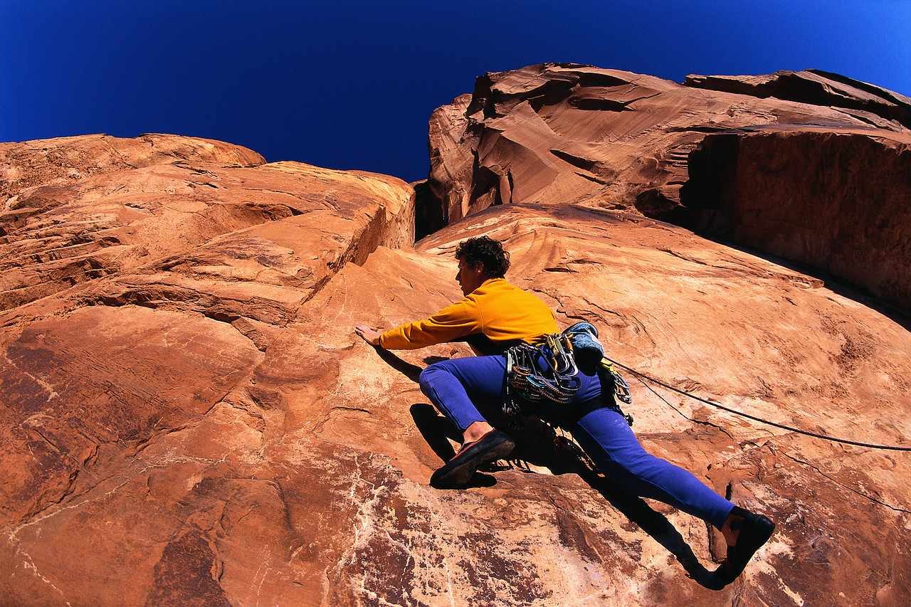

**How has the Earth’s surface changed?**

By the end of these activities you will:

* View the effect of erosion on landforms such as the 12 Apostles and the Grand Canyon.
* Model the effect of erosion by water on soil with an experiment.
* Make simple observations of an experiment and provide possible explanations for them.
* Explain what erosion is.

**C:\Program Files\Microsoft Office\MEDIA\CAGCAT10\j0305257.wmfActivities**

Do you recognize the picture below? This group of rocks are called the “12 Apostles.” They are a famous Victorian tourist attraction. Thousands of people visit them each year.

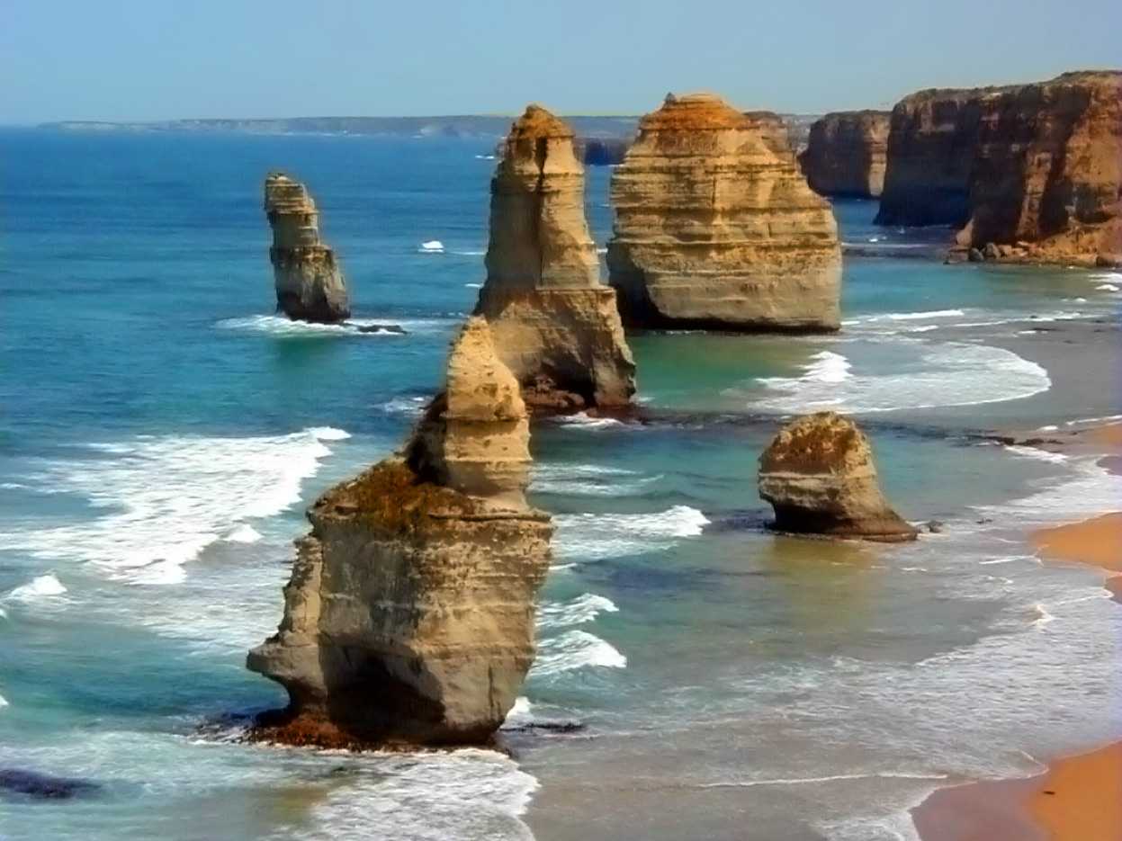

The 12 Apostles

Now take a look at the photo of the Grand Canyon below. It is in America.

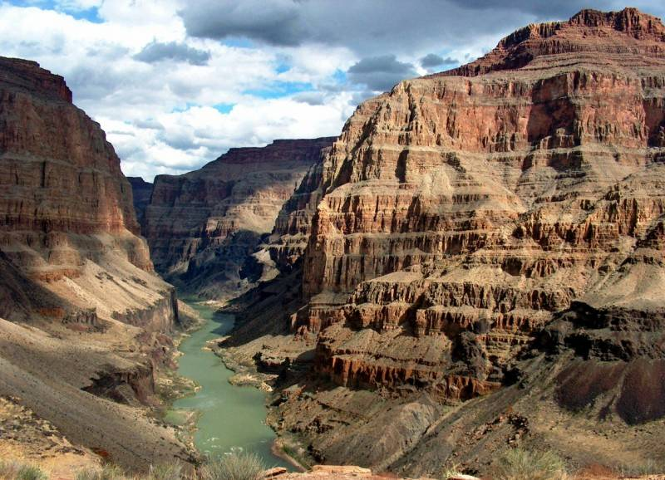

The Grand Canyon (USA)

**FOR YOU TO DO - Activity 1: Venn Diagrams**

For this activity, you need to compare the 12 Apostles with the Grand Canyon. Write the similarities in the overlapping region. Write the differences in the non-overlapping regions.

I have completed one example for you.

GRAND CANYON

12 Apostles

Tourist attraction

Did you notice the horizontal lines on both of the rock formations? These layers of rock are called Strata.

What do you think caused the rocks to be changed like this?

Take a closer look at the 12 Apostles. Can you see that at the base where the water laps against the rock that it appears as though it has been worn away? This process is called erosion.

C:\Users\lmarcon\AppData\Local\Microsoft\Windows\Temporary Internet Files\Content.IE5\K975LXFD\MC900078753[1].wmf**FOR YOU TO DO - Activity: Investigating Erosion**

Before you begin, you will need a sample of soil from your garden. Study it carefully.

Apart from the dirt, circle the other things that your sample contained.

|  |  |  |  |
| --- | --- | --- | --- |
| sand | clay | pebbles | stones |
| leaves | dead animals | worms | faeces (poo!) |

List anything else you found here:

Purpose: To model the erosion of soil

Materials: You need

* 2 large trays (e.g. aluminium pasta trays are great)
* Some garden soil
* Scissors
* Watering can with a sprinkler end
* A thick book to prop the tray up

Method:

* Take one tray. With the scissors, poke 10 small drain holes at one end
* With this same tray, spread about 6 cm of soil over the base
* Prop this tray up at one end with the thick book.
* Carefully place the second collecting tray underneath the soil tray, flat on your bench so you can collect the water that comes out of the drain holes.
* Now carefully pour the water from your watering can over the tray with the soil. Watch carefully at what happens.

Tray with soil.

Phone book

Collecting tray

Observations:

1. Draw a labelled diagram of your experiment
2. Write a sentence to describe what happened in the soil tray.

___________________________________________________

___________________________________________________

___________________________________________________

___________________________________________________

___________________________________________________

Write a sentence to describe what happened in the collecting tray.

___________________________________________________

___________________________________________________

___________________________________________________

___________________________________________________

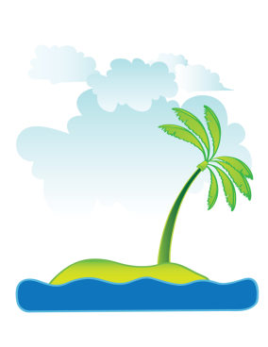

1. Optional challenge question! A geologist told the mayor of a seaside town to stop chopping down trees near the beach. Why did the geologist say this?

_________________________________________

___________________________________________________

___________________________________________________

___________________________________________________

Conclusion: What did you learn about erosion?

___________________________________________________

___________________________________________________

___________________________________________________

C:\Users\lmarcon\AppData\Local\Microsoft\Windows\Temporary Internet Files\Content.IE5\JQ2551LD\MC900272454[1].wmf**DID YOU KNOW**

Have you ever been to the Gold Coast in Queensland? It’s a beautiful place but there is a constant problem. Erosion! You can see how the water and wind has changed the shoreline in the photo below. One way to help is to plant trees. The roots of trees bind the soil together and reduces this wearing away of the shoreline.

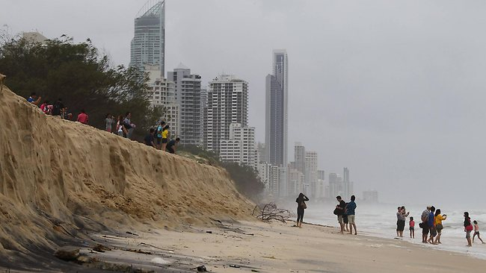

**For you to do – Evaluation**

Tick the box that describes your learning.

|  |  |  |  |
| --- | --- | --- | --- |
|  | I am good at this | I am nearly there | I need help with this |
| I looked at pictures of the 12 Apostles and the Grand Canyon and saw evidence of erosion. |  |  |  |
| I modelled the effect of erosion on the soil with an experiment. |  |  |  |
| I made observations of an experiment and I could explain why it happened. |  |  |  |
| I could explain what erosion is. |  |  |  |

**Activities**

**FOR YOU TO DO : Lake Eyre**

We have looked at how water can erode rocks and soils. Now we will further examine how the Earth’s surface has changed because of water.

Here are some quick questions for you to answer:

1. Have you ever seen a flood? ___________
2. Where does the water go after a flood?

___________________________________________________

Now look at a 3 minute program about Australia’s largest lake – Lake Eyre. Please have a pencil handy and this booklet because you need to make **short dot point notes** as you watch the program.

|  |
| --- |
| All about Lake Eyre – my notes  <http://splash.abc.net.au/media/-/m/107312/?source=upper-primary-science> |

Now select 5 of your dots points and write a question about it.

Here is one example:

|  |  |
| --- | --- |
| FACT | QUESTION |
| Salt is found on the dried lake bed | What would you find on a dried lake bed? |
|  |  |
|  |  |
|  |  |
|  |  |
|  |  |

Here is an image of Italy’s Mt Stromboli. It is an active volcano that last erupted in 2012.

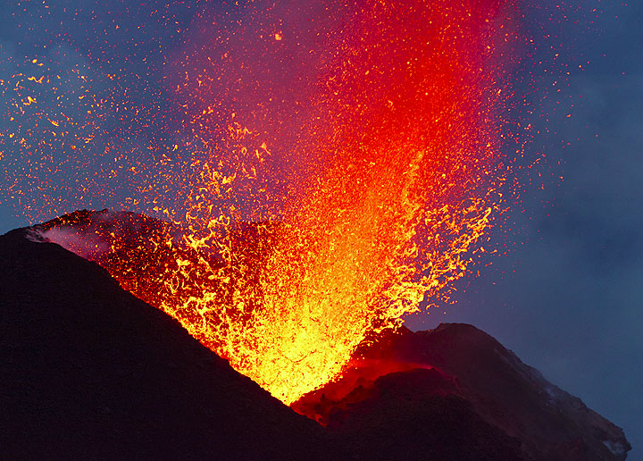

|  |
| --- |
| erupt smoke hot food  volcanic volcanoes lava people  active rock smelly |

When ___________ volcanoes __________, they often spew out molten rock. This is called ________ and it’s very _______. When it cools down, the lava turns into _______. Volcanoes will also make lots of gas, (sometimes __________!) ash and smoke. The soil produced from ___________ eruptions is often very rich. Nearly everywhere ___________are located, people use the soil for ___________ crops.  Even after an eruption, __________ still return because of the fertile soil around the volcano.

**DID YOU KNOW…**

The land that makes up most of Victoria is 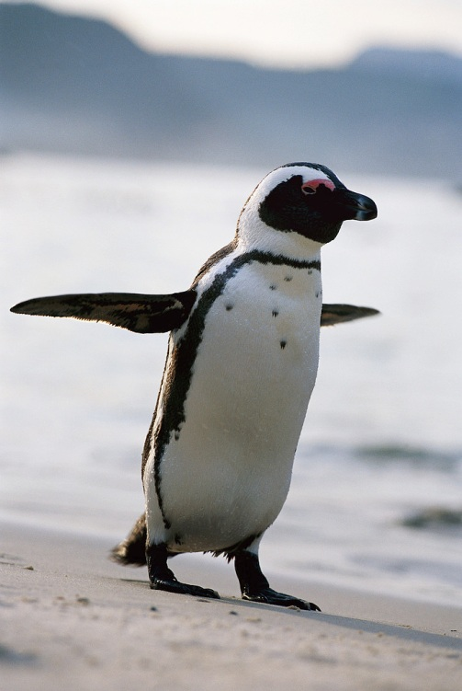volcanic. It was made many millions of years ago by volcanoes. These are no longer active. In fact all of Phillip Island is volcanic. Locals say the old quarry there is actually the dormant volcano!