English



**Think**

**Analyse**

**Understand**

**Communicate**

***Why is it important to explore different texts?***

|  |  |  |
| --- | --- | --- |
| Description: QRDistance | Description: logomedium_black_print  © State of Victoria DEECD 2015 | **H Course Code**  **6108** |

**Only for use for the purpose of education for the student(s) provided with the materials by DECV. Not to be reproduced, communicated or otherwise used except as permitted by the Copyright Act 1968 (Cth).**

English Introduction

Each module contains activities for your child to complete over two weeks.

About 2 hours per day is allocated to English activities. These activities may consist of:

|  |  |  |
| --- | --- | --- |
| *Discussing: Speaking & Listening* | *Thinking, Analysing, Evaluating* | *Reading* |
| *Writing* |  | *Researching* |
| *Vocabulary* | *Viewing / Observing* |
| *Spelling* | *Punctuation* | *Grammar* |

When students use English skills in other subjects, such as Science or Humanities, they are using their English skills in practical ways. Using English skills in other learning areas is sometimes called “Integrated Studies” or “English Across the Curriculum”.

Teachers will expect to see your student applying these English skills in all learning areas.



Independent reading time is a part of the daily English lesson. Students are expected to read books, newspapers or magazines for at least 30 minutes every day. Travelling students may include tourist brochures and other literature that occurs in their travels.

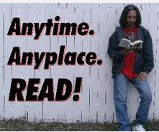

Each Module will have a simple sheet to record your independent reading activities. Your child’s teacher will use this information, in conjunction with the regular English work, to report on your child’s reading.

The completed sheet should be signed and returned to your teacher. By seeing your completed reading sheet, teachers will be able to track and monitor your child’s reading progress. This will give teachers information to put into your school report.

|  |  |  |  |  |  |  |  |  |  |
| --- | --- | --- | --- | --- | --- | --- | --- | --- | --- |
| **Reading Log Week 1: Color** or tick the minutes you read each day: | | | **Minutes I read for each day:** | | | | | | |
| **School** | | | | **Personal** | | |
| **Good** | | **Excellent** | | | **Superior** | |
| **Day** | **What Did You Read?** | **Interest Meter.** | **15 min** | **30 nm** | **45 min** | **1hr** | | **15 min** | **30 min** |
| **1** |  |  |  |  |  |  | |  |  |
| **2** |  |  |  |  |  |  | |  |  |
| **3** |  |  |  |  |  |  | |  |  |
| **4** |  |  |  |  |  |  | |  |  |
| **5** |  |  |  |  |  |  | |  |  |

Dear Reader,

Tick or highlight the statement/s that best describe your reading this week.

\*I don’t like to read. \*I didn’t read much at all. \*It was difficult to find the time to read. \*I sometimes struggle to understand what I read.

\*I enjoyed reading this week. \*I couldn’t stop reading. \*I was able to talk about what I read. \*I am able to work out the meaning of new words.

I verify *(student)* ……………………………………………………………’s  **ID**: ……………………………… **Reading Record**.

**Supervisor’s Signature**:……………………………………………………………………..…

*Please note: these comments will enable teachers to assess your student’s reading progress for writing reports, so it is very important to complete and submit this page.*

|  |  |  |  |  |  |  |  |  |  |
| --- | --- | --- | --- | --- | --- | --- | --- | --- | --- |
| **Reading Log Week 2: Color** or tick the minutes you read each day: | | | **Minutes I read for each day:** | | | | | | |
| **School** | | | | **Personal** | | |
| **Good** | | **Excellent** | | | **Superior** | |
| **Day** | **What Did You Read?** | **Interest Meter.** | **15 min** | **30 nm** | **45 min** | **1hr** | | **15 min** | **30 min** |
| **6** |  |  |  |  |  |  | |  |  |
| **7** |  |  |  |  |  |  | |  |  |
| **8** |  |  |  |  |  |  | |  |  |
| **9** |  |  |  |  |  |  | |  |  |
| **10** |  |  |  |  |  |  | |  |  |

Dear Reader,

Tick or highlight the statement/s that best describe your reading this week.

\*I don’t like to read. \*I didn’t read much at all. \*It was difficult to find the time to read. \*I sometimes struggle to understand what I read.

\*I enjoyed reading this week. \*I couldn’t stop reading. \*I was able to talk about what I read. \*I am able to work out the meaning of new words.

**I verify *(student)* …………………………………………………….…’s  **ID**: ……………………………………… **Reading Record**.

**Supervisor’s Signature**:……………………………………………………………….……..…

*Please note: these comments will enable teachers to assess your student’s reading progress for writing reports, so it is very important to complete and submit this page*.

**DAY 1**

|  |
| --- |
| **Learning Intention:**  Explore a range of strategies to improve reading comprehension.  Identify common word patterns in English. |

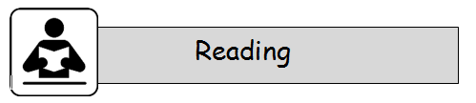

**READING STRATEGIES**

With your supervisor, discuss some of the things you have read in the past few days. Write them here:

I have read:

|  |
| --- |
|  |

**Tick the texts that you and your supervisor discussed:**



|  |  |  |  |
| --- | --- | --- | --- |
| ☐books /novels | ☐short stories | ☐articles | ☐comics |
| ☐poetry | ☐songs | ☐plays | blogs |
| ☐ebooks | ☐photos | ☐graphic novels | ☐cartoons |
| ☐blogs | ☐diaries | ☐storyboards | ☐digital stories |
| ☐websites | ☐magazines | ☐picture books | ☐pop up books |
| ☐lift the flap books |  | ☐choose your own adventures | |
| ☐advertisements | | ☐labels | ☐letters |
| ☐diaries | | ☐emails | ☐web pages |
| ☐cards | |  |  |

**Can you find similarities in the things you’ve read? Discuss these with your supervisor.**

How do you, as a reader, read?

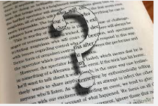

What do you do to help you understand the text you read?

Find something to read aloud to your supervisor. Tell your supervisor what you were doing to understand the text.

Dear Supervisor, would you please list some of the strategies mentioned in your discussion?

|  |
| --- |
|  |

**Reading Comprehension Strategies**

Read this together. **Highlight** the main ideas.

1. **Preview:**  *Scan a text before reading it closely.*

“Scanning” a text enables you to get a sense of what the text is about and how it is organised before reading it closely. Look for pictures, headings or interesting words.

1. **Prior Knowledge:** *Do you know anything about the topic? Use what you know to help you read the text.*

When you read words, use your own knowledge and experience of the topic.

1. **Question to understand and remember:** *Ask questions about the content.*

Ask yourself these questions that most texts try to answer:

“Who? What? When? Where? Why? How?

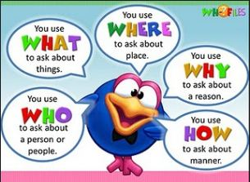

1. **What does the text mean?**

What is the author of the text trying to tell you? Why is the person writing about the topic? How did the writer use words to tell you want was in his or her mind?

1. **What are the main ideas in the text?** *Identify the main ideas and restate them in your own words.*

You should be able to understand most of what you read. Can you use the author’s words to imagine a picture in your mind?

1. **Think about the ideas in the text.**  *Is this something I already know about?*

Try to **connect** the characters, places, events or ideas in the text to something you already know.

1. **Are there other texts I know that are similar or different to this?** *Try to think about other similar things you might have read.*

Have you read other books with the same ideas, the same topics, similar characters.

You should always try to make connections as you read.

*In your mind, ask questions, try to predict what will come next. How do these words connect with you and what you know?*



I would like to see the reading strategies you use to understand what you read.

Write, or draw a labelled diagram to tell me about some of the strategies you use to understand what you read.

|  |
| --- |
|  |

**Words** – vocabulary and spelling



*Say this week’s spelling words aloud. Listen for the sounds and syllables that are within these words. Can you identify the patterns? There are at least three different sound and letter combinations in this list.*

|  |  |
| --- | --- |
| argument | impediment |
| centipede | intelligence |
| dialogue | judgement |
| emergency | language |
| expedition | orthopaedic |
| fatigue | pageant |
| gallery | pedal |
| generosity | peddle |
| genius | pedestal |
| gesture | pedestrian |
| governed | pedicure |
| guarantee | pedometer |
| guidance | percentage |
| guilty | practice |
| heritage | sergeant |

**🗸**Did you work out what the word patterns were?

***“ped”*** *words, from the Latin word for foot – can you see the connection*

*between the word root (ped) and the meaning (foot)*

*‘****soft ‘g’ ’’****sound (oran****g****e)*

**‘hard** **‘g’ ’’** sound (for**g**et) To become familiar with common spelling patterns in English, you have two choices:

Or

Find the flash card pages from the back of this module.

Cut each word out (neatly!)

Try to ‘organise’ your words into different common groups.

Say the words so you can HEAR them as well as SEE them.

Use these groups to make your own lists and email them to your teacher to see if she or he can work out the common element in each group:

**Here is an example of another group:** Can you work out the common feature?

|  |  |  |
| --- | --- | --- |
| *argument* | *emergency* | *impediment* |
| *expedition* | *intelligent* | *orthopaedic* |

*Compare your answer with the one given at the end of the module.*



**Choose** something you enjoy reading: books, magazines, newspapers.

Notice words with this week’s spelling patterns: ‘ped’ ‘soft g’ and ‘hard g’.

**Read** something for at least **30 minutes** everyday.

**Complete** your **Reading Log** at the front of this booklet.

**Enjoy** reading it.

**Important reminder:**  *Please make sure you complete your weekly Reading Log and sent it in to let me know that you ARE reading regularly. I also like to see WHAT you like to read. This is very important information for me to know when I write your report.*

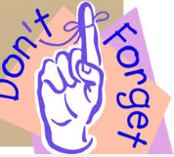

**DAY 2**

|  |
| --- |
| **Learning Intentions**   * Identify features of a particular genre and strategies to understand the text |

Reading



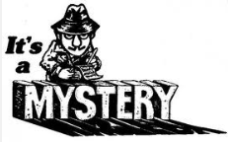

Have you ever had to solve a mystery? Many fiction writers choose to write about detectives and how they solve crimes. **Sir Arthur Conan Doyle** created the famous detective Sherlock Holmes. During the 1920s, **Agatha Christie**, another famous crime writer, created Mrs Marple and Hercules Poirot to solve the crimes in her novels. Although these authors wrote their stories many years ago, they are still popular today. Perhaps you’ve enjoyed books by other mystery writers. Please let me know some mystery books you have read, or you know about:

…………………………………………………………………………………………………………………..……………………

……………………………………………………………………………………………..…………………………………………

……………………………………………………………………………………………..…………………………………………

You can go to this website for some interesting mytsery reading ideas and activities.

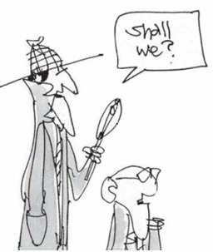

Please let me know what you think.

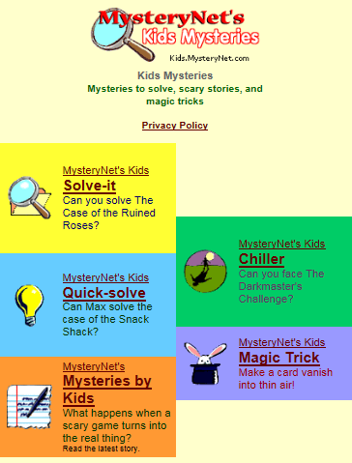

<http://kids.mysterynet.com/>

A famous crime-solving story for younger people is *Emil and the Detectives* by Erich Kastner. This story was first published in 1929 and has been translated from the original German. An extract from this book begins on the next page.

Use the reading strategies discussed in the last Module and in Day1 to read the excerpt from *Emil and the Detectives.*

2. Read the following excerpt from *‘Emil and the Detectives*’.

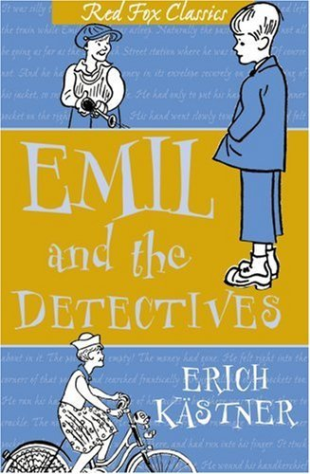

***Emil and the Detectives***

By Erich Kastner

"Have you any identification papers with you?" the cashier asked.

"Unfortunately not *with* me," the thief replied. "But if you'll wait a moment, I'll fetch them from the hotel."

"Don't believe the scoundrel. It's my money. And I must have it back at once," Emil shouted.

"Yes, but even if that were true my boy," the cashier told him, "it's not as simple as all that. How can you prove that it's your money? Is your name written on it by any chance? Or did you make a note of the numbers of the notes?"

"Of course I didn't," the boy replied. "Whoever thinks that he might be robbed? But it's mine all the same, don't you understand? My mother gave it to me to take to my grandmother who lives in Berlin in Schumann Street."

"Was a corner torn off any of the notes or was there any other mark on them?"

"No, not that I know of."

"Well, gentlemen," cried the thief, "I declare on my word of honour that the money really belongs to me. I wouldn't rob small children, would I?"

"Just a moment," Emil shouted, jumping for joy in his relief. "Wait, listen! In the train I pinned the money into my pocket with a pin. And therefore there must be pin‑pricks in all three notes."

The cashier held the notes up against the light. The others held their breath.

The thief stepped back a pace. The bank manager was drumming nervously on the counter with his fingers. "The boy is right," the cashier exclaimed, pale with excitement. "There are actually pin‑pricks in the notes."

"And here is the pin that made them," Emil said, proudly laying the pin on the counter. "And I pricked myself as well."

At this the thief turned round and as quick as lightning, pushed the boys aside with both arms, so that they fell like nine‑pins. Then he bolted through the bank, out of the door and was gone.

"After him!" the bank manager shouted. Everyone rushed towards the door.

When they got into the street they found the thief encircled by at least twenty boys.*Read the extract at least twice.*

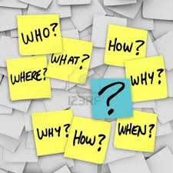

Exploring the text – Comprehension



*Scan the text the first time. (Read it quickly).*

*Highlight ideas or words you don’t understand.*

*As you read, look for answers to these questions.*

1. What sort of identification papers would your parents be able to show a cashier? *Discuss* this with your supervisor before writing your answer.

|  |
| --- |
|  |
|  |

1. *Make a list* of all the ways the cashier mentioned that could have made it possible to recognise Emil’s notes.

|  |
| --- |
|  |
|  |
|  |

1. Explain in your own words what it was that Emil remembered that eventually solved the mystery.

|  |
| --- |
|  |
|  |

1. What clue in the story tells us that the thief felt uneasy when Emil remembered the pin?

|  |
| --- |
|  |
|  |

1. Emil said “Don’t believe the **scoundrel**.” Look up the meaning of the word **scoundrel** in your dictionary before using it in a sentence of your own.

***Dictionary Definition****:*

|  |
| --- |
|  |
|  |
|  |

***My own sentence using the word ‘scoundrel’:***

|  |
| --- |
|  |
|  |
|  |

Illustrate your idea of a ‘scoundrel’ OR illustrate a scene from Emil & The Detectives.



Writing Workshop — Postcard



Imagine that you are Emil. You need to let your mother know what has happened. You don’t have a lot of time so you’ve decided to send her a postcard. *Create a postcard* and briefly tell what happened.

You will be writing “in the first person” because **you** are Emil. Remember that there is not much room to write on postcards.

|  |  |
| --- | --- |
|  |  |

***This example is by Tessa***

|  |  |
| --- | --- |
|  |  |



**DAY 3**

|  |
| --- |
| **Learning Intention:**  Identify main ideas and summarise a text.  Increase awareness of verbs and select verb to create a particular meaning |

Reading



Re-read the extract from *Emil and the Detectives.*

|  |
| --- |
| Explain, in your own words, the key events in the extract. Remember to answers those questions: Who? What? When? Where? Why? How? Whose? Extra points if you can explain the **complication** in the story. |
|  |
|  |
|  |
|  |
|  |
|  |
|  |
|  |
|  |
|  |
|  |
|  |



**Making your writing interesting — *VERBS***

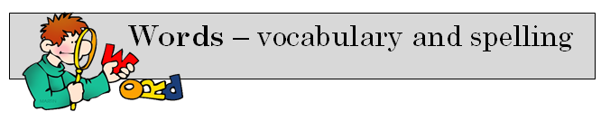

Verbs are the words that tell us what someone or something

**does**, **is** or **feels**. If it is something **you can do**, the word is a verb.

Circle the verb (doing word) in each sentence.

Emil shouted.

He boltedthrough the bank.

Twenty boys encircled the thief.

Some verbs have been listed below. Place the most suitable verb into the sentences below.

**examined listed reached questioned supplied declared**

1. The prisoner ………………………………………………….…… that he was innocent.
2. To begin with, the detective .…………………………….……the names of the suspects.
3. The jury ……………………………………......................... its verdict.
4. A witness …………………………………….…………………………the missing clue.
5. The judge …………………………………….…………………… the witness.
6. Carefully the scientist …………………………………….…………. the specimen.



**It’s your turn to ACT with VERBS!!**

Use the **VERBS** from the previous page, with some interesting verbs from you find in *Emil and The Detectives.* Write your own short mystery using these verbs. Highlight each VERB you used. (Words such as*: is, are am, be, were, can, was, have* are types of verbs. They are necessary for your story, but they are not **INTERESTING.)** *Look at the checklist on p.24 to help you write your story.*

Title:……………………………………………………………………………………………………..

By :……………………………………………………………………………………………………..

|  |
| --- |
|  |
|  |
|  |
|  |
|  |
|  |
|  |
|  |
|  |
|  |
|  |
|  |
|  |
|  |
|  |
|  |
|  |

|  |
| --- |
|  |
|  |
|  |
|  |
|  |
|  |
|  |
|  |
|  |
|  |
|  |
|  |
|  |
|  |
|  |
|  |
|  |
|  |
|  |
|  |
|  |
|  |
|  |
|  |



Give your story to someone else to read. This could be a parent, a grandparent, a friend – someone who you trust to read your work. Of course, this means that you have written a story that is easy to read. You might want to type your draft to give to someone else to read.

Ask them to complete this checklist and write a comment. Send their comments with your work.

A message to the person who reads your story:

Dear Reader,

Thank you for agreeing to read this story and provide some feedback.

The purpose of this activity was to give the student some practice in finding and using interesting VERBS to write in a story.

We at DECV would value your opinion about this story.

Thank you!

|  |  |  |  |
| --- | --- | --- | --- |
| **Story Checklist:**  Title: ……………………………………………………………….  Author: ……………………………………………….................. | **Yes** | **A bit** | **Not really** |
| Was this story easy to read? |  |  |  |
| Did you understand this story? |  |  |  |
| Were the verbs the writer used interesting? |  |  |  |
| Did the sentences make sense? |  |  |  |
| Did the writer include a beginning, middle and ending? |  |  |  |
| Was spelling and punctuation mostly correct? |  |  |  |
| Did you enjoy reading this story? |  |  |  |

*What advice would you give to this young writer?*

|  |
| --- |
|  |
|  |
|  |

Signature:……………………………………………………. Date:……………………..

**DAY 4**

|  |
| --- |
| **Learning Intention:**  Develop strategies to work with unfamiliar words. |

Using your Spelling list for this week, choose ***five words*** you would like to learn more about. Become an expert on your chosen words - complete this “WIRM Word” activity.

|  |  |  |
| --- | --- | --- |
| **W**ord: | **I**mportant idea | **R**emember **M**e |
|  |  |  |
| *In a sentence, example or picture:* |  | |

|  |  |  |
| --- | --- | --- |
| **W**ord: | **I**mportant idea | **R**emember **M**e |
|  |  |  |
| *In a sentence, example or picture:* |  | |

|  |  |  |
| --- | --- | --- |
| **W**ord: | **I**mportant idea | **R**emember **M**e |
|  |  |  |
| *In a sentence, example or picture:* |  | |

|  |  |  |
| --- | --- | --- |
| **W**ord: | **I**mportant idea | **R**emember **M**e |
|  |  |  |
| *In a sentence, example or picture:* |  | |

|  |  |  |
| --- | --- | --- |
| **W**ord: | **I**mportant idea | **R**emember **M**e |
|  |  |  |
| *In a sentence, example or picture:* |  | |



**Acronyms**



**Acronyms** are words that are made by joining together the first letters of several words. Often the words from which acronyms are made are the names of groups or organisations. Acronyms evolve because it’s often easier to use one word rather than repeat the whole name. Most acronyms can be pronounced as a single word and they are usually written using **all capital letters**. For example:

**ANZAC** **A**ustralian (and) **N**ew **Z**ealand **A**rmy **C**orps

**QANTAS** **Q**ueensland **a**nd **N**orthern **T**erritory **A**erial **S**ervices

Acronyms don’t have full stops between the letters and **sometimes** they are written with only the first letter as a capital e.g. **Anzac**. There are some acronyms that have become so much a part of our language that we don’t even write them with capital letters any more. Did you know that scuba, radar and laser are really acronyms?

1. *Use your dictionary* to find out the words from which laser, scuba and radar, are the shortened forms.

**LASER***……………………………………….……………………………………….…………………………………….……………………………………….……………………………………….…………………………………..*

**SCUBA***……………………………………….……………………………………….……………………………………….……………………………………….……………………………………….………………………………***RADAR***……………………………………….……………………………………….……………………………………….……………………………………….……………………………………….…………………………….*

1. Think of as many examples of acronyms as you can and complete the A-Z below. You may use a **dictionary** or the **internet** to assist you. Don’t forget that many acronyms are used with computers, such as LOL (Laugh out loud.)

|  |  |  |
| --- | --- | --- |
|  | **ACRONYM** | **FULL VERSION** |
| **A** |  |  |
| **B** |  |  |
| **C** |  |  |
| **D** |  |  |
| **E** |  |  |
| **F** |  |  |
| **G** |  |  |
| **H** |  |  |
| **I** |  |  |
| **J** |  |  |
| **K** |  |  |
| **L** |  |  |
| **M** |  |  |

|  |  |  |
| --- | --- | --- |
|  | **ACRONYM** | **FULL VERSION** |
| **N** |  |  |
| **O** |  |  |
| **P** |  |  |
| **Q** |  |  |
| **R** |  |  |
| **S** |  |  |
| **T** |  |  |
| **U** |  |  |
| **V** |  |  |
| **W** |  |  |
| **X** |  |  |
| **Y** |  |  |
| **Z** |  |  |

****http://www.dpmc.gov.au/accountability/filelist/acronyms\_abbreviations.cfm#Q

Reading



The Wikispace (shown below) belongs to a Year 1 class. They are using this space to show their learning in reading and writing. You will see some interesting work of their learning progress.

<http://primaryportfolios.wikispaces.com/home>

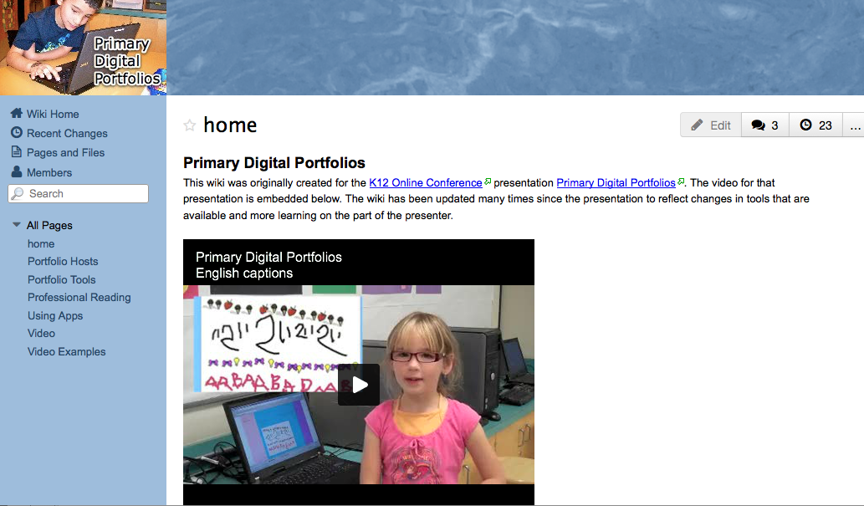

|  |  |  |
| --- | --- | --- |
| *Something*  *I liked:* |  | |
|  | |
|  | |  |
| *Something that was interesting:* |  | |
|  | |
| *An idea I had*: |  | |
|  | |
|  |  | |
| *An idea for improvement*: |  | |
|  | |
|  |  | |

As you look through these students’ Wikispaces, think about how **you** can use a Wikispace to create your own learning portfolio. Complete this review of the WIkispace



**DAY 5**

**Words** – vocabulary and spelling



Your supervisor will test you on your spelling words for Week One.

Supervisors please encourage your student to review his or her own work and identify their own errors. Do not use a cross for an incorrect word – instead highlight or underline the **error** and ask the student to write the word correctly.

|  |  |
| --- | --- |
|  |  |
|  |  |
|  |  |
|  |  |
|  |  |
|  |  |
|  |  |
|  |  |
|  |  |
|  |  |

**To the student:** Congratulations if you spelt every word correctly! If you wrote some words incorrectly, look at the word and try to work out why you made that error – tick the statements that apply to you.

*I was careless. I didn’t listen to the word properly. It sounded like something else.*

*I didn’t understand. I got it mixed up with another word. I didn’t pay attention.*

Reading



**Choose** something you enjoy reading: books, magazines, newspapers.

**Read** something for at least **30 minutes** everyday.

**Complete** your **Reading Log** at the front of this booklet.

**Enjoy** reading it.

DECV Teachers need to assess your reading. Your Reading Log is a crucial part of your assessment. Your completed Reading Log will help us determine your reading achievement. Send in in with every Module, even if it is incomplete.



Please complete this self assessment:

|  |  |  |  |
| --- | --- | --- | --- |
|  | Not like me | A bit like me | A lot like me |
| I love to read. |  |  |  |
| I understand what I read. |  |  |  |
| When I read I sometimes stop to make sure I understand. |  |  |  |
| I concentrate when I read – I am not easily distracted. |  |  |  |
| IF something does not make sense, I read that part again. |  |  |  |
| I have a place where I can read without being disturbed. |  |  |  |
| I read many different types of texts. |  |  |  |
| I read just about every day. |  |  |  |
| Other people in my family read regularly. |  |  |  |



**Writing Workshop —** WikiSpace Entry

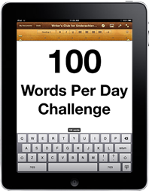

Your challenge today is to write a WikiSpace entry about “where you are” and enter it into your Wikispace.

Choose your words carefully to provide wiki-visitors with a sense about the place you are in right now.

Here are exactly 100 words about “Where I am now.”

*It is quiet. Very quiet, except for the consistent, tap-tap-tap of the keys on the computer keyboard. It’s a school, and I am checking student work, talking to students, collaborating with students, emailing students, but the busy humdrum of hardworking students is missing. Large windows let some light in – but not air. I work at computer station that is in a pod of four. My colleagues work quietly too. My desk is busy and messy, with a big pile of student work, full of interest and surprise, to be assessed. My dictionary and grammar guide are always within easy reach.*

Exactly 100 words!



I was able to add to my Wikispace by

* following instructions from the “Help” menu on WikiSpaces
* finding out by reading about Wikispaces
* watching You Tube videos about Wikispaces
* asking people who knew more than I did.

**BUT…**

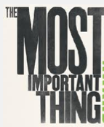

I had a go!

I tried things out to see if they would work!

I ***wasn’t*** afraid to make a mistake (the ‘Undo” icon was very helpful here!”)

You can use this page to draft your ***100 word*** statement for “Where I am now”.

OR you can use a computer to write your ***100 word*** statement.

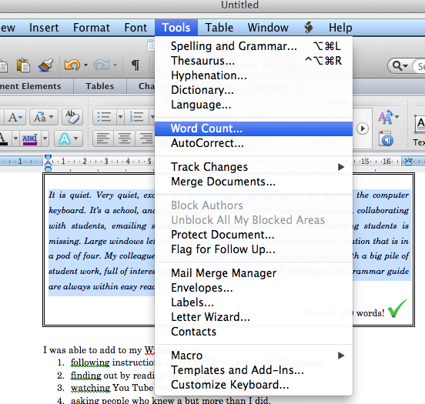

Type what you want to describe.

***Highlight*** the section of text you typed.

Select the “***Tools”*** menu.

Select ‘***Word Count***”.

Adjust your writing until you have exactly 100 words.

If you want to write your statement on paper, use a pencil and page below.

The most important things are to:

* carefully observe “*where you are now.”*
* think of some good words and phrases to describe and explain your place now
* get your thoughts and ideas on paper
* play, edit and revise your words until they are ‘just right’
* follow the guidelines on the next page to add your text and pictures to the DECV2014 WikiPage.

|  |  |  |  |  |  |  |  |  |
| --- | --- | --- | --- | --- | --- | --- | --- | --- |
|  |  |  |  |  |  |  |  | 4 |
|  |  |  |  | 8 |
|  |  |  |  | 12 |
|  |  |  |  | 16 |
|  |  |  |  | 20 |
|  |  |  |  | 24 |
|  |  |  |  | 28 |
|  |  |  |  | 32 |
|  |  |  |  | 36 |
|  |  |  |  | 40 |
|  |  |  |  | 44 |
|  |  |  |  | 48 |
|  |  |  |  | 52 |
|  |  |  |  | 56 |
|  |  |  |  | 60 |
|  |  |  |  | 64 |
|  |  |  |  | 68 |
|  |  |  |  | 72 |
|  |  |  |  | 76 |
|  |  |  |  | 80 |
|  |  |  |  | 84 |
|  |  |  |  | 88 |
|  |  |  |  | 92 |
|  |  |  |  | 96 |
|  |  |  |  | 100 |
|  |  |  |  | 104 |
|  |  |  |  | 108 |
|  |  |  |  | 112\* |
|  |  |  |  |  |

*\*We have given you a few extra words to ‘play with’.*

If you were able to post your “Where Am I Now” statement to the WikisPage, you don’t have to send this page. IF you did not have internet, please send this page for your teacher to see.



The information on the next page may be useful in creating your WikiPage .

|  |  |  |
| --- | --- | --- |
| **Go the Internet:** | <http://decv2013teamred.wikispaces.com/>  **User Name:** TRwiki.GUEST  **Password**: TRwiki.GUEST | |
|  | Look for DECV 2014 on the left hand panel.  You can work in the DECV 2014 page  **OR**  you can click the + to start your own page.  Create a name for your page – add 2014 into your title. | |
|  | | |
| Use the features in the Wiki Toolbar to create your page. | | |
|  | | If you want to use one of your photos, you have to upload it to WikiSpaces.   1. Click the “upload files” tab. 2. Find the photo on your computer. 3. Click “Upload File”. 4. Select My Most Recent Uploads. 5. Wait for you photo to appear in the left panel. 6. Double click it to load it into your WIkiSpace – it will appear automatically after a few seconds (depending on your Internet connection.) |
|  | | Every time you want to make a change to your WikiSpace– find the Edit button on the top right of the screen.  The “undo” button is very useful. Don’t be afraid to make a mistake – you can “undo” straight away |
|  | | If you ‘left click’ on the elements on the page, a menu will appear underneath the object.  (With a Mac, hold the “Control Key” and click for the menu to appear.) |

***Email*** *your teacher to let him or her know that you have successfully added to your Wikispace.*

**DAY 6**

**Learning Intention:**

Understand that prefixes can be used to create antonyms.

Sharing enthusiasm for books and reading through WikiPages.

**Words** – vocabulary and spelling



What is the common pattern for this week’s spelling list?

……………………………………………………………………

|  |  |
| --- | --- |
| igneous | imposter |
| ignite | improper |
| ignition | inferring |
| ignorant | inmate |
| illegal | insane |
| illiterate | interpret |
| illogical | intolerable |
| illustrate | irrational |
| immortal | irregular |
| imperfection | irreversible |
| impossible | irritating |

Did you work out that ***most words*** have **PREFIX** that starts with ***il, im, in*** or ***ir.***

When these prefixes are added to a ‘base word’, it makes an antonym (opposite) meaning. Can you find the words which are not prefix+base word? **Hint:** the ‘base word’ has a clear meaning when the prefix is taken away.

**Find more interesting prefixes and suffixes at:**

[**http://www.learnthat.org/pages/view/roots.html**](http://www.learnthat.org/pages/view/roots.html)



On the website, when you click on the icon on the left, you will see a comprehensive list of words with that prefix – this is an example:

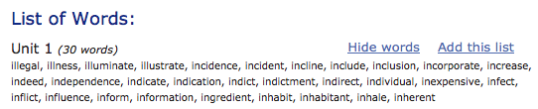

<http://www.prefixsuffix.com/rootchart.php>

You can check your word knowledge by the quiz with ***“Rooty”*** and “***Meany***.”



Write the list words that match the picture:

|  |  |  |
| --- | --- | --- |
|  |  |  |
| ………………………………….. | ………………………………….. | ………………………………….. |
|  |  |  |
| ………………………………….. | ………………………………….. | ………………………………….. |

*Please check the back of this module to see if you used the same words as I did.* Discover more about the list words by completing this WIRM word activity.

|  |  |  |
| --- | --- | --- |
| **W**ord: | **I**mportant idea | **R**emember **M**e |
|  |  |  |
| *In a sentence, example or picture:* |  | |

|  |  |  |
| --- | --- | --- |
| **W**ord: | **I**mportant idea | **R**emember **M**e |
|  |  |  |
| *In a sentence, example or picture:* |  | |

|  |  |  |
| --- | --- | --- |
| **W**ord: | **I**mportant idea | **R**emember **M**e |
|  |  |  |
| *In a sentence, example or picture:* |  | |

|  |  |  |
| --- | --- | --- |
| **W**ord: | **I**mportant idea | **R**emember **M**e |
|  |  |  |
| *In a sentence, example or picture:* |  | |

|  |  |  |
| --- | --- | --- |
| **W**ord: | **I**mportant idea | **R**emember **M**e |
|  |  |  |
| *In a sentence, example or picture:* |  | |

|  |  |  |
| --- | --- | --- |
| **W**ord: | **I**mportant idea | **R**emember **M**e |
|  |  |  |
| *In a sentence, example or picture:* |  | |



**Reading**



Think about these quotes. Do they apply to you, or to someone who you know who does not like to read?

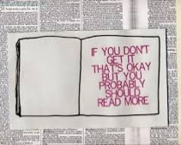

**HELP** someone find a great book to read!



Go to the DECV Year 6 Wikispace:

<http://teamrindzo2010.wikispaces.com/>

User Name: Password:

* Find the DECV2014 page.
* Click “Edit”.
* Add your book recommendations for ‘good reading.’

**DAY 7**

|  |
| --- |
| **Learning Intention:**  Using reading strategies to aid comprehension |

Reading



Use your reading strategies to help you understand the text.

|  |  |  |
| --- | --- | --- |
| **Reading Strategy** | **What you should do:** | **I did this!** |
| Preview: | *Look at the title. What will this text be about? Think of ideas the title generates. Look over a few key words to see if there are any clues in the text.* |  |
| Scan | *Scan the text.* |  |
| Prior Knowledge: | *Do I know anything about this topic? Do I know any of the words that I scanned?* |  |
| Question: | *What is this text trying to tell me? Ask any other questions every time you come across something you don’t understand?* |  |
| What is this text about? | *As you read, make sure you understand each sentence, each paragraph.* |  |
| What is the main idea? | *Why did the author write this text?* |  |
| When you have finished, | *What was the main idea for this text?* |  |
| Have I read something similar? | *Has something like this has happened to you or someone you know?* |  |

Read the story on the next page:



**TONY PUT HIS SCHOOLBAG** in the doorway of the supermarket and walked inside. Now the time had come, he began to have doubts, but not for long. He saw the sign in the window, and turned ot read it as he went by. There was a picture of a bird, with the words,

***“Boys and girls –***

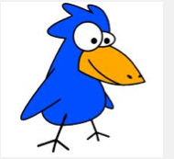

***Our little bird is watching you***

***so please be good in all you do.***

***Don’t take goods from our store today***

***unless you have the money to pay.***

***It makes our little bird very sad***

***when he has to tell your mum and dad.”***

“Stupid rhyme. For little kids. I won’t get caught,” Tony thought.

One of the boys as school had told him, “Just be careful and quick, that’s the trick.” Tony remembered another boy in his class had been caught.

“Yeah, I was sprung,” Michael had told Tony. “A guy who works there took me to the manager’s office. The manager was tough on me. He asked me who I would like him to ring, my parents or the principal. Some choice I had! I told him he’d better ring my parents. Did I get into trouble when I got home!”

Tony’s attention came back to the job at hand. He walked casually along the aisle to the chocolate bars. The man who worked in that section wasn’t around – probably afternoon tea-time. Tony looked to check the time, but his watch was not on his arm. Then he remembered he had put it in his bag before sport.

He took a block of chocolate off the shelf, walked slowly until he thought he was clear, then hurriedly pushed it into his pocket. He was shaking.

It wasn’t as great as others had said. Down the next row, past the biscuits and breakfast foods, not looking to left or right. He knew his way home.

The packets of toffee wouldn’t be so easy. They were a bit too close to the registers. Of course, that made it more of a challenge, more to brag about tomorrow; to show how game he was. He pretended to tie his shoelace. He looked up the aisle, no feet in sight; looked up at the registers, all the cashies busy. He reached out, then stuffed a packet of toffees into his other pocket.

Breathing heavily, he made his way to the door. He felt hot, althrough there was a cold wind blowing outside.

Tony sighed deeply. “I’ve done it! I’ve done it!”

He reached for his bag. It wasn’t there. He couldn’t believe it. He had put it there only a few minutes ago. It had his books, and sports clothes in it. He’d be in hot water when he arrived home. Oh! Gosh! His watch was in it, too. That terrific watch Uncle Bill had sent him from America. He reckoned he was the only kid in school with one like it.

Tony didn’t know where to look. He didn’t have a clue. He hurried home. The trouble would be to get to his room without his mother finding out. He didn’t want to have to answer questions. He raced past the kitchen door, into his room. He couldn’t eat his dinner. He didn’t sleep much. A terrible night.

\* \* \* \*

Next morning, he called “Goodbye” to his mother as he was leaving. Phew! She didn’t notice his bag was missing.



The siren went for assembly. Tony was in line. How would he manage without his books? Having to attend school was a drag when he had so much on his mind. Not at all the way he planned it when he had decided to steal the chocolate from the supermarket.

What was the principal saying? A lady had handed in a schoolbag.

She had found it in her front garden.

“Is Tony Lawler here?”

“Yes, Sir.” Tony pushed forward to claim his bag.

The children broke up to go to classes.

Excitedly, Tony opened his bag. The books were there. The sports clothes were there. He pushed his hand further down. He wanted to cry out. “The watch is here! My watch is here!”

He went to class, but found it difficult to concentrate. He sat and thought about the lady who had returned his bag.

“At least some people are honest,” he thought. And if he hadn’t been so determined to prove to others that he had the courage to shoplift, he would not have lost his bag. Suddenly Tony felt ashamed of himself. There was something he had to do.

After school, Tony went to the supermarket, hurried to the chocolate section. He put his hand in his pocket, took out the chocolate bar, and hastily put it back on the shelf. The toffees would be a problem, but he had to try. He walked up to the cashier, with the packet of toffees in his hand. “This must have dropped,” he said. He hurried from the store. “Heck! Never again!”

*Thinking about the story, write your idea in each row:*

|  |  |
| --- | --- |
| **PLUS** (*something good about the story.)* |  |
| **INTERESTING** |  |
| **MINUS** *(something not so good.)* |  |

Demonstrate how well you understood the story by completing these statements and answering the questions:

*Tony’s intention at the start of the story was to*

|  |
| --- |
|  |
|  |
|  |
|  |

*The purpose of the poem on the door of the shop was to*

|  |
| --- |
|  |
|  |
|  |
|  |

*Michael warned Tony that*

|  |
| --- |
|  |
|  |
|  |
|  |

*Find the sentence: “It wasn’t as great as others had said. ‘Explain in your own words what this sentence means.*

|  |
| --- |
|  |
|  |
|  |
|  |

*“He pretended to tie his shoelace.” Explain why Tony tied his shoelace.*

|  |
| --- |
|  |
|  |
|  |

*What were Tony’s feelings at this point of the story?*

|  |
| --- |
|  |
|  |
|  |

*Find and write the words in the text that support your opinion.*

|  |
| --- |
|  |
|  |
|  |

What does “He’d be in *hot water* when he arrived home” mean? Explain this idea in your own words.

|  |
| --- |
|  |
|  |
|  |

What was the main reason Tony wanted to steal from the shop?

|  |
| --- |
|  |
|  |
|  |

Find the words in the story that support your opinion and write them here.

|  |
| --- |
|  |
|  |
|  |

Explain the events that made Tony change his mind about shoplifting.

|  |
| --- |
|  |
|  |

What type of person do you think Tony was?

|  |
| --- |
|  |
|  |
|  |

What would you have done if you had been in the same situation as Tony?

|  |
| --- |
|  |
|  |
|  |

What is the ‘moral’ or the ‘lesson’ from this story?

|  |
| --- |
|  |
|  |
|  |



**DAY 8**

**Learning Intention:**

Understand that word patterns can be used to create ideas in poetic forms.

**Writing Workshop — Cinquain Poetry**



**Cinquains** (pronounced *sin-cane*) **are POEMS that always tell their story in five lines.**

**There** are many variations of these five line poems. The cinquain poem below is made up with:

1. **one noun** (naming words),
2. some **adjectives** (describing words),
3. some **verbs** (doing or action words),
4. a **statement** and
5. a **synonym (**a word with the same or a similar meaning to another). This cinquain poem is about **home**.

Identify each element (from the list above.) Discuss this with your supervisor. READ the **cinquain poem** aloud a few time.

*Home*

*Warm, comfortable*

*Sleeping, eating, drinking*

*There’s no place like it*

*Shelter*

The pattern for writing this form of cinquain poetry is as follows:

***TITLE*** *– one noun (things, people, places, ideas, events,)*

***LINE 2*** *– two adjectives (words that describe nouns)*

***LINE 3*** *– three verbs (doing words)*

***LINE 4*** *– one statement (connected words to form an idea)*

***LINE 5*** *– one synonym for the title*

With your supervisor, gather some words and ideas that you can use in your Cinquain Poems. The NOUNS that you put in the first row will be topics that you can write about. Where will you find some interesting words?

|  |  |
| --- | --- |
| ***TITLE*** *– one noun* |  |
| ***LINE 2*** *– two adjectives* |  |
| ***LINE 3*** *– three verbs* |  |
| ***LINE 4*** *– one statement* |  |
| ***LINE 5*** *– one synonym for the title* |  |

**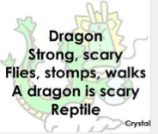**

**Read more cinquain poems at this website:**

http://www.poemhunter.com/poem/cinquain-poems/Write one cinquain poem about*home*. What does your home mean to you?

After that, write some more cinquain poems on topics of your choice.

**Home**

**\_\_\_\_\_\_\_\_\_\_\_\_\_\_\_\_\_\_\_\_\_\_\_\_\_\_\_\_\_\_\_\_\_\_\_\_\_\_\_\_\_\_\_\_\_\_\_\_\_\_\_\_\_\_\_\_\_\_\_\_\_\_\_\_\_\_\_\_\_\_\_\_\_\_\_\_\_\_\_\_\_\_\_\_\_\_\_\_\_\_\_\_**

**\_\_\_\_\_\_\_\_\_\_\_\_\_\_\_\_\_\_\_\_\_\_\_\_\_\_\_\_\_\_\_\_\_\_\_\_\_\_\_\_\_\_\_\_\_\_\_\_\_\_\_\_\_\_\_\_\_\_\_\_\_\_\_\_\_\_\_\_\_\_\_\_\_\_\_\_\_\_\_\_\_\_\_\_\_\_\_\_**

**\_\_\_\_\_\_\_\_\_\_\_\_\_\_\_\_\_\_\_\_\_\_\_\_\_\_\_\_\_\_\_\_\_\_\_\_\_\_\_\_\_\_\_\_\_\_\_\_\_\_\_\_\_\_\_\_\_\_\_\_\_\_\_\_\_\_\_\_\_\_\_\_\_\_\_\_\_\_\_\_\_\_\_\_\_\_\_\_\_\_\_\_\_\_\_\_\_\_\_\_\_**

**\_\_\_\_\_\_\_\_\_\_\_\_\_\_\_\_\_\_\_\_\_\_\_\_\_\_\_\_\_\_\_\_\_\_\_\_\_\_\_\_\_\_\_\_\_\_\_\_\_\_**

**\_\_\_\_\_\_\_\_\_\_\_\_\_\_\_\_\_\_\_\_\_\_\_\_\_\_\_\_\_\_\_\_\_\_\_\_\_\_\_\_\_\_\_\_\_\_\_\_\_\_\_**

**\_\_\_\_\_\_\_\_\_\_\_\_\_\_\_\_\_\_\_\_\_\_\_\_\_\_\_\_\_\_\_\_\_\_\_\_\_\_\_\_\_\_\_\_\_\_\_\_\_\_\_\_\_\_\_\_\_\_\_\_\_\_\_\_\_\_\_\_\_\_\_\_\_\_\_\_\_\_\_\_\_\_\_\_\_\_\_\_\_\_\_\_**

**\_\_\_\_\_\_\_\_\_\_\_\_\_\_\_\_\_\_\_\_\_\_\_\_\_\_\_\_\_\_\_\_\_\_\_\_\_\_\_\_\_\_\_\_\_\_\_\_\_\_\_\_\_\_\_\_\_\_\_\_\_\_\_\_\_\_\_\_\_\_\_\_\_\_\_\_\_\_\_\_\_\_\_\_\_\_\_\_**

**\_\_\_\_\_\_\_\_\_\_\_\_\_\_\_\_\_\_\_\_\_\_\_\_\_\_\_\_\_\_\_\_\_\_\_\_\_\_\_\_\_\_\_\_\_\_\_\_\_\_\_\_\_\_\_\_\_\_\_\_\_\_\_\_\_\_\_\_\_\_\_\_\_\_\_\_\_\_\_\_\_\_\_\_\_\_\_\_\_\_\_\_\_\_\_\_\_\_\_\_\_**

**\_\_\_\_\_\_\_\_\_\_\_\_\_\_\_\_\_\_\_\_\_\_\_\_\_\_\_\_\_\_\_\_\_\_\_\_\_\_\_\_\_\_\_\_\_\_\_\_\_\_**

**\_\_\_\_\_\_\_\_\_\_\_\_\_\_\_\_\_\_\_\_\_\_\_\_\_\_\_\_\_\_\_\_\_\_\_\_\_\_\_\_\_\_\_\_\_\_\_\_\_\_\_**

**\_\_\_\_\_\_\_\_\_\_\_\_\_\_\_\_\_\_\_\_\_\_\_\_\_\_\_\_\_\_\_\_\_\_\_\_\_\_\_\_\_\_\_\_\_\_\_\_\_\_\_\_\_\_\_\_\_\_\_\_\_\_\_\_\_\_\_\_\_\_\_\_\_\_\_\_\_\_\_\_\_\_\_\_\_\_\_\_\_\_\_\_**

**\_\_\_\_\_\_\_\_\_\_\_\_\_\_\_\_\_\_\_\_\_\_\_\_\_\_\_\_\_\_\_\_\_\_\_\_\_\_\_\_\_\_\_\_\_\_\_\_\_\_\_\_\_\_\_\_\_\_\_\_\_\_\_\_\_\_\_\_\_\_\_\_\_\_\_\_\_\_\_\_\_\_\_\_\_\_\_\_**

**\_\_\_\_\_\_\_\_\_\_\_\_\_\_\_\_\_\_\_\_\_\_\_\_\_\_\_\_\_\_\_\_\_\_\_\_\_\_\_\_\_\_\_\_\_\_\_\_\_\_\_\_\_\_\_\_\_\_\_\_\_\_\_\_\_\_\_\_\_\_\_\_\_\_\_\_\_\_\_\_\_\_\_\_\_\_\_\_\_\_\_\_\_\_\_\_\_\_\_\_\_**

**\_\_\_\_\_\_\_\_\_\_\_\_\_\_\_\_\_\_\_\_\_\_\_\_\_\_\_\_\_\_\_\_\_\_\_\_\_\_\_\_\_\_\_\_\_\_\_\_\_\_**

**\_\_\_\_\_\_\_\_\_\_\_\_\_\_\_\_\_\_\_\_\_\_\_\_\_\_\_\_\_\_\_\_\_\_\_\_\_\_\_\_\_\_\_\_\_\_\_\_\_\_\_**

**\_\_\_\_\_\_\_\_\_\_\_\_\_\_\_\_\_\_\_\_\_\_\_\_\_\_\_\_\_\_\_\_\_\_\_\_\_\_\_\_\_\_\_\_\_\_\_\_\_\_\_\_\_\_\_\_\_\_\_\_\_\_\_\_\_\_\_\_\_\_\_\_\_\_\_\_\_\_\_\_\_\_\_\_\_\_\_\_\_\_\_\_**

**\_\_\_\_\_\_\_\_\_\_\_\_\_\_\_\_\_\_\_\_\_\_\_\_\_\_\_\_\_\_\_\_\_\_\_\_\_\_\_\_\_\_\_\_\_\_\_\_\_\_\_\_\_\_\_\_\_\_\_\_\_\_\_\_\_\_\_\_\_\_\_\_\_\_\_\_\_\_\_\_\_\_\_\_\_\_\_\_**

**\_\_\_\_\_\_\_\_\_\_\_\_\_\_\_\_\_\_\_\_\_\_\_\_\_\_\_\_\_\_\_\_\_\_\_\_\_\_\_\_\_\_\_\_\_\_\_\_\_\_\_\_\_\_\_\_\_\_\_\_\_\_\_\_\_\_\_\_\_\_\_\_\_\_\_\_\_\_\_\_\_\_\_\_\_\_\_\_\_\_\_\_\_\_\_\_\_\_\_\_\_**

**\_\_\_\_\_\_\_\_\_\_\_\_\_\_\_\_\_\_\_\_\_\_\_\_\_\_\_\_\_\_\_\_\_\_\_\_\_\_\_\_\_\_\_\_\_\_\_\_\_\_**

**Words** – vocabulary and spelling



Here are some of this week’s list words. Find the base word for each one. Make sure you spell the base word correctly. Use your dictionary to check.

|  |  |
| --- | --- |
| argument |  |
| intelligence |  |
| judgement |  |
| generosity |  |
| governed |  |
| fatigue |  |
| gallery |  |
| guilty |  |
| guidance |  |
| percentage |  |
| impediment |  |
|  |  |

**Reading**



Check our WikiSpace to see if other students have recommended good books to read. Maybe you could put your favourite books in the DECV 2014 WikiSpace.

**Go to the DECV Year 6 Wikispace:**

<http://decv2103teamred.wikispaces.com>

**User Name:** TRwiki.GUEST  **Password:** TRwiki.GUEST

* Find the DECV2014 page.
* Click “**Edit”.**
* Add your book recommendations for ‘good reading.’



**Choose** something you enjoy reading: books, magazines, newspapers.

**Read** something for at least **30 minutes** everyday.

**Complete** your **Reading Log** at the front of this booklet.

Remember to use your **reading strategies.**

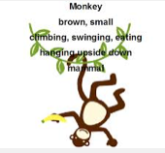

**DAY 9**

|  |
| --- |
| **Learning Intention:**  Identify elements of a narrative text and write a book report. |

|  |
| --- |
| Description: titlebookreport  *A Book Report is a great way to take what you have read and show others how much you know about the book. You can also share your opinion about the book, to help others decide if they want to read it or not.* |

**Supervisor:** If your student has not read a novel recently, please find a short story or a longer picture book to complete this activity.

**Title:**

|  |
| --- |
|  |
|  |
|  |
|  |
|  |
|  |

*Briefly tell WHERE and WHEN the story takes place.*

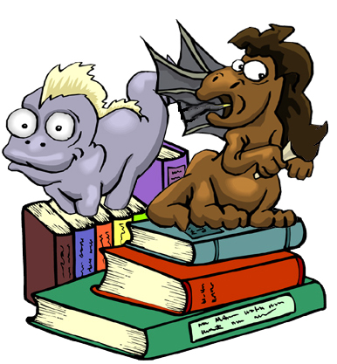

**Author**:

**Setting:**

|  |  |  |  |  |  |  |  |  |  |  |
| --- | --- | --- | --- | --- | --- | --- | --- | --- | --- | --- |
| CHARACTER DESCRIPTIONS.  Characters are crucial to the development of the story.   * **WHO** are the characters in the story? * **WHAT** are their features, characteristics and mannerisms? * **HOW** do the characters interact with each other? * **WHAT** is the character’s role in the story?   **Find out more about characters from this website**  <http://www.learner.org/interactives/story/characters.html>  **or** [**http://tinyurl.com/decvenh**](http://tinyurl.com/decvenh)  Complete the activity on the website – it’s very helpful!   |  |  | | --- | --- | | Main Characters: | Something about the character: | |  |  | |  |  | |  |  | |  |  |   Plot: |

**PLOT:** Write anoutline of the story.

* What happens?
* What is the complication or problem the characters have to solve?
* What is the most exciting part of the story?
* How was the complication / problem resolved?
* What did you think of the story? (Opinion).

|  |
| --- |
|  |
|  |
|  |

|  |
| --- |
|  |
|  |
|  |

**Complication and Resolution:**

|  |
| --- |
|  |
|  |
|  |
|  |
|  |

|  |
| --- |
|  |
|  |
|  |
|  |
|  |

What did you think about the book?

|  |
| --- |
|  |
|  |
|  |
|  |
|  |

Would you encourage someone else to read this book? Explain why.

|  |
| --- |
|  |
|  |
|  |
|  |
|  |

**For you to SEND**



**DAY 10**

|  |
| --- |
| **Learning Intention:**  Understand abstract nouns and use them in a piece of writing. |

Your supervisor will choose 20 Spelling words test you on your spelling for Week 2.

Remember to listen carefully and to visualise the words in your mind,

Supervisors please encourage your student to review his or her own work and identify their own errors. Do not use a cross for an incorrect word – instead highlight or underline the **error** and ask the student to write the word correctly.

|  |  |
| --- | --- |
|  |  |
|  |  |
|  |  |
|  |  |
|  |  |
|  |  |
|  |  |
|  |  |
|  |  |
|  |  |

**To the student:** Congratulations if you spelt every word correctly!

If you wrote some words incorrectly, look at the word and try to work out why you made that error – tick the statements that apply to you.

*I was careless. I didn’t listen to the word properly. It sounded like something else.*

*I didn’t understand. I got it mixed up with another word. I didn’t pay attention.*

**Words** – vocabulary and spelling



Read this list of words: Think about why these words make a group.

|  |  |  |  |  |
| --- | --- | --- | --- | --- |
| belief | bravery | charity | childhood | honesty |
| hope | idea | law | happiness | power |
| friendship | skill | truth | sleep | peace |
| love | memory | feelings | success | fun |

We know that these words are **NOUNS,** but they are not **THINGS** that we can touch or feel, like a cup, spoon or XBox.

These words are **IDEAS,** **QUALITIES** or **FEELINGS**.

We know these words are **NOUNS** because we can use words like “**the**” “**a**” “**my**” “**our**” ‘**your**” with them.

“**My** memory is bad today.”

**“The** law is there to protect us”.

**The** truth is that 4+5 make 9.”

Find out about abstract nouns:

<http://www.free-teacher-worksheets.com/abstract-nouns.html>

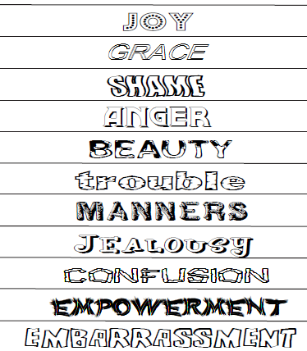

***“Do It Yourself” Teaching:***

Feel free to find and download your own ‘teacher worksheet!

Please send it in for me to see.

Here are some examples of **abstract nouns.**  Do you know what each abstract noun means?

**Watch this slide share for more information:**

<http://www.slideshare.net/kerryhickman/abstract-nouns>

Use your dictionary and your internet searching skills to find at least 15 **abstract nouns.** Write these nouns in the grid:

**ABSTRACT NOUNS**

|  |  |  |  |  |
| --- | --- | --- | --- | --- |
|  |  |  |  |  |
|  |  |  |
|  |  |  |
|  |  |  |
|  |  |  |
|  |  |  |
|  |  |  |

Make sure you know the meaning of the words. Use these words in an interesting short story. Underline or highlight the abstract nouns you used.

Think about this diagram which shows how nouns are described.

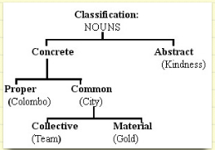

Macintosh HD:Users:all:Desktop:DECV Logo.jpg ID: …………………….. Name:………………………………..……Date………………

Module: …………... Day: …………………

|  |  |
| --- | --- |
| **TITLE of your WORK:** |  |
|  | |
|  | |
|  | |
|  | |
|  | |
|  | |
|  | |
|  | |
|  | |
|  | |
|  | |
|  | |
|  | |
|  | |
|  | |
|  | |
|  | |
|  | |
|  | |
|  | |
|  | |
|  | |
|  | |
|  | |

|  |
| --- |
|  |
|  |
|  |
|  |
|  |
|  |
|  |
|  |
|  |
|  |
|  |
|  |
|  |
|  |
|  |
|  |
|  |
|  |
|  |
|  |
|  |
|  |
|  |
|  |
|  |
|  |
|  |

|  |
| --- |
|  |
|  |
|  |
|  |
|  |
|  |
|  |
|  |
|  |
|  |
|  |
|  |
|  |
|  |
|  |
|  |
|  |
|  |

*Make sure you* ***highlight the abstract nouns.***

*How many abstract nouns did you use in your story? ………………*

*Tell me something you like about your story:*

**Flash Cards**

*Cut out and use these cards. Sort the words into the three different spelling groups: ‘ped’, ‘soft g’ and ‘hard g’. Find OTHER ways you can group these words – for example, the same number of syllables or words with suffixes. Please let me know some of the other ways these words can be grouped. Email the words in their new groups – see if I can work out why you made those words a group.*

*✁*

|  |  |
| --- | --- |
| *argument* | *impediment* |
| *centipede* | *intelligence* |
| *dialogue* | *judgement* |
| *emergency* | *language* |
| *expedition* | *orthopaedic* |
| *fatigue* | *pageant* |
| *gallery* | *pedal* |
| *generosity* | *peddle* |
| *genius* | *pedestal* |
| *gesture* | *pedestrian* |
| *governed* | *pedicure* |
| *guarantee* | *pedometer* |
| *guidance* | *percentage* |
| *guilty* | *practice* |
| *heritage* | *sergeant* |

|  |  |  |  |  |
| --- | --- | --- | --- | --- |
| ***a****rgument* | ***e****mergency* | ***i****mpediment* | *All the words in this group* ***start*** *with a* ***vowel.*** |  |
| ***e****xpedition* | ***i****ntelligent* | ***o****rthopaedic* |  |

**Day 6:**

|  |  |  |
| --- | --- | --- |
|  |  |  |
| *imposter* | *impossible / “Mission Impossible”* | *illustrate* |
|  |  |  |
| *irritate* | *igneous /irregular* | *illiterate* |

Other words are possible for these pictures. If you want to tell me other words you chose, please call me or email me!

|  |  |  |  |
| --- | --- | --- | --- |
| **Student Name**: |  | **Student ID**: |  |
| **Date:** | | | \_ \_ \_ / \_ \_ \_ /\_ \_ \_ |

**ENGLISH**

|  |  |  |  |  |  |
| --- | --- | --- | --- | --- | --- |
| **Level** | **SPEAKING & LISTENING** | **Demonstrated** | | **Needs further opportunity** | **Teacher assessment** |
| 6 | Participate in and contribute to discussions, clarifying and interrogating ideas, developing and supporting arguments, sharing and evaluating information, experiences and opinions |  | |  |  |
|  | **READING & VIEWING** | | | | |
| 6 | Select, navigate and read increasingly complex texts for a range of purposes, applying appropriate text processing strategies to recall information and consolidate meaning |  | |  |  |
| 6 | Use comprehension strategies to interpret and analyse information and ideas, comparing content from a variety of textual sources including media and digital texts |  | |  |  |
|  | **WRITING** | | | | |
| 6 | Understand how ideas can be expanded and sharpened through careful choice of verbs, elaborated tenses and a range of adverb groups/phrases |  |  | |  |
| 6 | Understand how to use banks of known words, word origins, base words, suffixes and prefixes, spelling patterns and generalisations to learn and spell new words, for example technical words and words adopted from other languages |  |  | |  |
| 6 | Plan, draft and publish imaginative, informative and persuasive texts, choosing and experimenting with text structures, language features, images and digital resources appropriate to purpose and audience |  |  | |  |



|  |  |  |  |  |  |  |  |
| --- | --- | --- | --- | --- | --- | --- | --- |
| Description: Description: Description: Description: Description: Description: Description: Description: logoCAPS2**315 Clarendon Street, Thornbury 3071**  **Telephone (03) 8480 0000**  **FAX (03) 9416 8371 (Despatch)**  **Free call(1800) 133 511**   |  |  | | --- | --- | | |  | | --- | | **STUDENT NUMBER \_\_\_\_\_\_\_\_\_\_\_\_\_\_\_\_\_\_\_**  **STUDENT NAME \_\_\_\_\_\_\_\_\_\_\_\_\_\_\_\_\_\_\_\_\_\_**  **\_\_\_\_\_\_\_\_\_\_\_\_\_\_\_\_\_\_\_\_\_\_\_\_\_\_\_\_\_\_\_\_\_\_\_\_\_\_\_** | | | | | | | |  |
| Fix your student barcode  label over this space. |
|  |
| 6108  [6108] |
| **SUBJECT** | English | | | [ZX] |
| **COLOUR** | Red | **MODULE** | H |
| **TEACHER** | \_\_\_\_\_\_\_\_\_\_\_\_\_\_\_\_\_\_\_\_\_\_\_\_\_\_\_ | | |

|  |
| --- |
| **THINKING ABOUT YOUR LEARNING**  Description: Description: Description: Description: http://t0.gstatic.com/images?q=tbn:ANd9GcTiyp1Q0EWVRSXlqyIMaG6be3rodf0nBbu2oBIY8JlYVh1iP8U7**I understand** \_\_\_\_\_\_\_\_\_\_\_\_\_\_\_\_\_\_\_\_\_\_\_\_\_\_\_\_\_\_\_\_\_\_\_\_\_\_\_\_\_\_\_\_\_\_\_\_\_\_  \_\_\_\_\_\_\_\_\_\_\_\_\_\_\_\_\_\_\_\_\_\_\_\_\_\_\_\_\_\_\_\_\_\_\_\_\_\_\_\_\_\_\_\_\_\_\_\_\_\_\_\_\_\_\_\_\_\_\_\_\_\_\_\_\_\_\_\_\_\_\_\_\_\_\_  \_\_\_\_\_\_\_\_\_\_\_\_\_\_\_\_\_\_\_\_\_\_\_\_\_\_\_\_\_\_\_\_\_\_\_\_\_\_\_\_\_\_\_\_\_\_\_\_\_\_\_\_\_\_\_\_\_\_\_\_\_\_\_\_\_\_\_\_\_\_\_\_\_\_\_  \_\_\_\_\_\_\_\_\_\_\_\_\_\_\_\_\_\_\_\_\_\_\_\_\_\_\_\_\_\_\_\_\_\_\_\_\_\_\_\_\_\_\_\_\_\_\_\_\_\_\_\_\_\_\_\_\_\_\_\_\_\_\_\_\_\_\_\_\_\_\_\_\_\_\_  \_\_\_\_\_\_\_\_\_\_\_\_\_\_\_\_\_\_\_\_\_\_\_\_\_\_\_\_\_\_\_\_\_\_\_\_\_\_\_\_\_\_\_\_\_\_\_\_\_\_\_\_\_\_\_\_\_\_\_\_\_\_\_\_\_\_\_\_\_\_\_\_\_\_\_  **Description: Description: Description: Description: http://t2.gstatic.com/images?q=tbn:ANd9GcQ72LH2Bxoxf3yTTP_t93kaIPDpv8jVzb20Dfacv1j6Jv1Vb43VI need help with \_\_\_\_\_\_\_\_\_\_\_\_\_\_\_\_\_\_\_\_\_\_\_\_\_\_\_\_\_\_\_\_\_\_\_\_\_\_\_\_\_\_\_\_\_\_\_\_\_**  **\_\_\_\_\_\_\_\_\_\_\_\_\_\_\_\_\_\_\_\_\_\_\_\_\_\_\_\_\_\_\_\_\_\_\_\_\_\_\_\_\_\_\_\_\_\_\_\_\_\_\_\_\_\_\_\_\_\_\_\_\_\_\_\_\_\_\_\_\_\_\_\_\_\_\_**  **\_\_\_\_\_\_\_\_\_\_\_\_\_\_\_\_\_\_\_\_\_\_\_\_\_\_\_\_\_\_\_\_\_\_\_\_\_\_\_\_\_\_\_\_\_\_\_\_\_\_\_\_\_\_\_\_\_\_\_\_\_\_\_\_\_\_\_\_\_\_\_\_\_\_\_**  **\_\_\_\_\_\_\_\_\_\_\_\_\_\_\_\_\_\_\_\_\_\_\_\_\_\_\_\_\_\_\_\_\_\_\_\_\_\_\_\_\_\_\_\_\_\_\_\_\_\_\_\_\_\_\_\_\_\_\_\_\_\_\_\_\_\_\_\_\_\_\_\_\_\_\_**  **\_\_\_\_\_\_\_\_\_\_\_\_\_\_\_\_\_\_\_\_\_\_\_\_\_\_\_\_\_\_\_\_\_\_\_\_\_\_\_\_\_\_\_\_\_\_\_\_\_\_\_\_\_\_\_\_\_\_\_\_\_\_\_\_\_\_\_\_\_\_\_\_\_\_\_** |

|  |
| --- |
| **YOUR QUESTIONS OR COMMENTS** |
| **TEACHER’S COMMENTS**  **Some great things about your work were:**  **Try to do the following next time:** |
|  |

