English



*How can I be persuasive*

*in my writing?*



**Read before you begin.**

|  |  |  |
| --- | --- | --- |
| Welcome to Module E. In this Module you will complete activities which will help you answer the question:  ‘How can I be persuasive in my writing?’ | |  |
|  | Learning Intentions for Module E |

Writing Workshop

Study the style and techniques used in persuasive writing.

Grammar and Punctuation

Learn about emotive language. Study modal verbs.

How Words Work

Adding a prefix and suffix to words.

Spelling and Phonics

Study 10 given spelling words and your own 10 words. You will be tested at the end of the Set. In phonics, you will look at the vowel sounds ‘oa’ and ‘ai’.



|  |  |
| --- | --- |
| Contents | |
| Set One | Reading and Writing Workshop   * Exploring the text - reading and learning about a persuasive text * Talk to someone at home and complete activities about a persuasive text   Spelling Activities and Phonics   * Ten given words and ten words of your own choice * The ‘oa’ sound   Grammar and Punctuation   * Emotive language   How Words Work   * Adding prefixes   Spelling Test   * Spell the words for this Set |
| Set Two | Reading and Writing Workshop   * Write a persuasive text   Spelling Activities and Phonics   * Ten given words and ten words of your own choice * the ‘ai’ sound   Grammar and Punctuation   * Modal verbs   How Words Work   * Adding suffixes   Spelling Test   * Spell the words for this Set   Reflection   * Summary * Answer written questions about the topic |

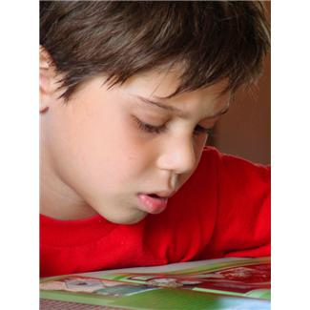

Getting Knowledge Ready

Persuasive texts aim to influence the reader’s point of view.

Advertising is a form of persuasive writing.

On the lines below, write the names of some places you know where people can find advertising.

Where do you see advertising?

___________________________ ___________________________

___________________________ ___________________________

___________________________ ___________________________

___________________________ ___________________________

___________________________ ___________________________

___________________________ ___________________________

___________________________ ___________________________

|  |
| --- |
| Set One |



What is a persuasive text?

A persuasive text is a form of writing that tries to persuade a reader to a point of view, opinion or idea about an issue.

.

A persuasive text can be a formal letter, speech or debate, or an informal letter or advertisement.

A persuasive text can also entertain or inform.

A persuasive text has specific structures and language features.

The structure of a persuasive text usually has the following features:

1. Introduction
2. Main body of text
3. Conclusion

1.

**Introduction**

An opening sentence is given, presenting the issue or argument and the writer’s point of view.

2.

**Main body of text**

A paragraph stating each argument is given. The most important argument is given in the first paragraph. Less important arguments follow in order. Supporting evidence, reasons or facts are given for each argument.

3.

The issue is repeated with a short summary of the arguments stated in the main body.

A concluding statement is given.

**Conclusion**

Read the following persuasive cartoon about penguin life.

Look for ways this text type tries to persuade you.

Opinions for and against.

**Penguin Life**

My cousin Mark, who lives in the wild, thinks I must be bored in the zoo. He says that I should move to Antarctica.

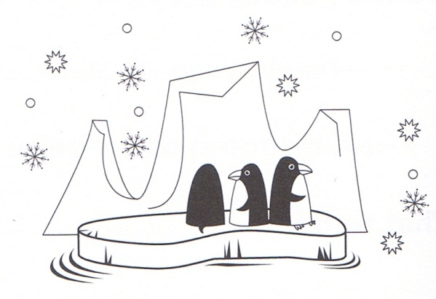

I am Pat the penguin and I live in the zoo. I meet new people every day and my keeper feeds me juicy fish. I love it here and always will.

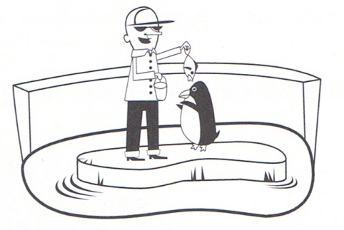

Emotive language helps to make the writer’s opinion stronger.

I could move to Antartica, but I might miss my home and friends. I would be sad to leave the zoo.

I am very happy here. I want to stay forever.

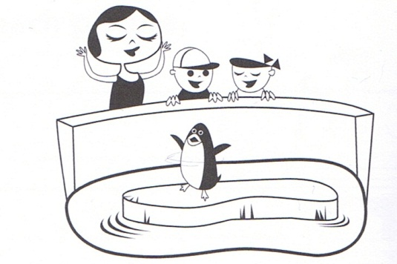

Mark thinks I should be diving from icebergs into the great ocean and hunting for my own food.

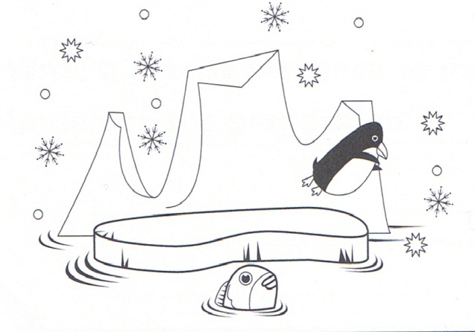

The writer’s opinion is repeated at the end.

In the persuasive text, the author listed some of the reasons for and against him staying at the zoo. Can you think of any others? Complete the following *For and Against* chart with three more arguments about whether the penguin should stay at the zoo. The first one of each has been done for you.

Should the penguin stay at the zoo?

AGAINST

FOR

The penguin is not free.

The penguin is safe.

Put your arguments in order of how persuasive they are. Give them a number from one to three. One is your most persuasive argument and three is your least persuasive argument.

Discuss with someone at home the *for* and *against* arguments.

Answer the following questions.

What argument did you list as your most persuasive and why?

__________________________________________________________________

__________________________________________________________________

__________________________________________________________________

What argument did you list as your least persuasive and why?

__________________________________________________________________

__________________________________________________________________

__________________________________________________________________

What is your point of view on the penguin living at the zoo?

__________________________________________________________________

__________________________________________________________________

__________________________________________________________________

Do you have any evidence to back it up?

__________________________________________________________________

__________________________________________________________________

__________________________________________________________________

C:\Users\jmiller\AppData\Local\Microsoft\Windows\Temporary Internet Files\Low\Content.IE5\O584SN30\MC900053962[1].WMF

Grammar and Punctuation

What is emotive language?

Emotive language is any word or phrase that is used because it causes the reader to have a strong emotion. It usually has words that make us feel. Emotive language is common in persuasive texts and was used in the penguin cartoon.

Read these sentences.

* The boy was happy with his new toy.
* The boy was so excited with his new toy that he couldn’t stop smiling and jumping up and down.

The first sentence does not use much emotive language to describe how the boy is feeling but the second sentence does.

How has the writer made the second sentence more persuasive?

__________________________________________________________________

__________________________________________________________________

__________________________________________________________________

__________________________________________________________________

[](http://thumbs.dreamstime.com/z/cute-boy-toy-car-17074150.jpg)

Now circle the sentences that use emotive language.

1. The boxer happily raised his arms in victory.

The boxer won the fight.

1. I fell over outside.

I cried in pain as I fell to the hard ground.

1. The angry man shouted at the thief.

The man walked past the thief.

1. The girl was sad.

The girl was crying loudly and really upset.

1. The boy wanted to play a video game.

The boy was really excited and happy that he was going to play the video game.

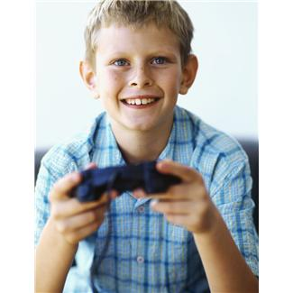

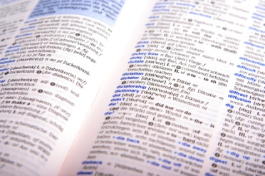

How Words Work

What is a prefix?

Prefixes are word parts added to the beginning of a word.

They change the meaning of the word.

The four prefixes used most in English are **un-**, **re-**, **in-** and **dis-**.

Here are some prefixes that mean ‘not’. They change the meaning of a word to its opposite meaning.

dis: disagree, dissatisfied

il: illegal, illogical

im: impossible, impatient

in: invisible, inside

ir: irregular, irresponsible

mis: misbehave, misunderstanding

non: non-smoking, nonsense

un: unhelpful, uneasy

1. The prefix *dis* means ‘not’ or ‘apart’. Write *dis* in front of each word.
2. _________like (b) _________obey (c) _________agree
3. Write a sentence using one of the words from the above list.

________________________________________________________________

________________________________________________________________

________________________________________________________________

________________________________________________________________

1. Write *like* or *dislike*.

Do you like or dislike cereal for breakfast? _______________

Do you like or dislike animals? ______________

1. Write *agree* or *disagree*.

Do you agree or disagree that chocolate tastes nice? ______________

1. Write *respect* or *disrespect*.

Do you show respect or disrespect for the land? ________________

The prefix **un**-means ‘not’. Write **un** in front of each word.

(a)_________satisfactory (b)_________able

Write a sentence containing a word that has the prefix ‘un’

________________________________________________________________

________________________________________________________________

________________________________________________________________

________________________________________________________________



Spelling

Ten Spelling Words for Set One

look people play about could

road load oak boat goat

1. Use these three words – people boat goat – in one sentence.

__________________________________________________________

__________________________________________________________

___________________________________________________________

___________________________________________________________

___________________________________________________________

1. Use some list words in these sentences.
2. The __ __ __ __ ran away from the farm.
3. The __ __ __ __ __ walked quickly in the city streets.
4. Susan went to __ __ __ __ in the park.
5. Use a dictionary to find and write the meaning of these words:

people_____________________________________________________

oak_______________________________________________________

1. Draw pictures to illustrate these sentences.

A goat is standing on the road.

|  |
| --- |
|  |

Happy people are in a boat.

|  |
| --- |
|  |

Look at the ‘**oa**’ sound. It has two vowels.

Say the say the word t**oa**st. What sound do you think **oa** makes?

It makes the **long o** sound. Say another word with the **oa** sound, b**oa**t, and notice the **long o** sound it makes.

Here are some words missing the **oa** sound. Put in the **oa** sound and draw a picture to match each word.

|  |  |
| --- | --- |
| Fill the gaps with **oa** | Draw a picture to match. |
| r__ __d  t __ __ d  g __ __ t  __ __ k |  |

Find **oa** words and write them on the lines below.

|  |  |  |  |  |  |  |  |  |  |  |  |  |  |  |
| --- | --- | --- | --- | --- | --- | --- | --- | --- | --- | --- | --- | --- | --- | --- |
| g | o | a | l | t | h | r | f | e | r | y | u | o | p | e |
| q | e | r | t | x | c | v | o | f | d | c | o | a | l | q |
| s | h | o | a | l | r | f | a | h | m | k | y | t | e | w |
| j | i | m | l | i | r | n | m | b | o | l | y | t | r | e |
| r | g | y | i | p | r | w | l | w | r | t | t | e | u | t |
| e | c | h | l | o | a | n | i | s | f | b | y | r | y | g |
| d | x | b | u | j | t | w | u | e | d | v | g | t | f | r |
| s | q | r | j | y | r | q | j | r | e | r | o | a | m | e |

______________________ _____________________

______________________ _____________________

______________________ _____________________

[](http://thumbs.dreamstime.com/z/detective-cartoon-illustration-11853829.jpg)

j0226124Spelling Test

Practise the words below and then give this page to someone at home.

Ask him or her to test your spelling.

|  |  |
| --- | --- |
| Spelling Words for Set One | |
| Set One Module Words | Set One Own Words |
| look |  |
| people |  |
| play |  |
| about |  |
| could |  |
| road |  |
| load |  |
| oak |  |
| boat |  |
| goat |  |



**Checklist**

This Set you should have completed the following tasks. Tick the ones you have completed.

* Reading and Writing workshop—Persuasive writing
* Spelling activities—LCWC and own Words
* Phonics—the ‘oa’ sound
* Grammar and Punctuation—Emotive language
* How Words Work—Prefixes
* Spelling and Dictation Test

|  |
| --- |
| End of Set One |

|  |
| --- |
| Set Two |



This Set you will plan and write a persuasive cartoon.

Remember there are many different types of persuasive texts.

Here are some different examples of persuasive texts:

advertisements, book reviews, brochures, business letters, commercials, editorials, essays, letters to the editor, posters, letters and speeches.



Plan and write a persuasive text cartoon.

This cartoon is to advertise a product called *Penguin Feed*. You have four boxes to draw your persuasive cartoon. Include your introduction to *Penguin Feed*, your arguments as to why it’s the best penguin food there is, and your conclusion.

Penguin Feed is the Best!

Plan before you write

|  |
| --- |
| What are you going to write in your introduction to grab the reader’s attention?  ________________________________________________________________  ________________________________________________________________ |

|  |
| --- |
| What is your first argument as to why Penguin Feed is the best?  ________________________________________________________________  ________________________________________________________________ |

|  |
| --- |
| What is your second argument?  ________________________________________________________________  ________________________________________________________________ |

|  |
| --- |
| What is your conclusion?  ________________________________________________________________  ________________________________________________________________ |

**Draft of Persuasive Cartoon**

Title: ____________________________________

Introduction:

____________________________

____________________________

____________________________

Draw your cartoon:

First argument:

____________________________

____________________________

____________________________

Draw your cartoon:

Second argument:

____________________________

____________________________

____________________________

Draw your cartoon:

Conclusion:

____________________________

____________________________

____________________________

Draw your cartoon:

:

Final Piece

Complete the final copy.

How will you do this?

You can use the computer program *Word* or write your final piece.



Spelling, Phonics and How Words Work

It’s time for you to learn your words for this Set. You also need to choose ten words for **My** **Own Words.**

These can be from:

* your own writing
* your reading
* your memory

1. Write the ten words you have chosen, in the My Own Wordscolumn on page 28 at the back of Set Two.

Learn these and the ten words given to you for this Set.

Remember to use L.C.W.C to help you.

Ten Spelling Words for Set Two

Saturday football animal favourite teacher

snail detail nail wail retail

1. Write these list words in alphabetical order:

____________________________________________________________

____________________________________________________________

____________________________________________________________

____________________________________________________________

____________________________________________________________

1. Write the **list** word that has only 5 letters

____________________________________________________________

1. Write list words for:

a day __ __ __ __ __ __ __ __

a sport __ __ __ __ __ __ __ __

used with a hammer __ __ __ __

1. Write words from the list that rhyme with these.

fail _____________________________________________________

preacher ________________________________________________

cannibal ________________________________________________

1. Find and write the dictionary meanings of the following words.

animal ____________________________________________________

____________________________________________________________

____________________________________________________________

____________________________________________________________

teacher ____________________________________________________

____________________________________________________________

____________________________________________________________

snail _______________________________________________________

____________________________________________________________

____________________________________________________________



Look at the ‘**ai**’ sound. The ‘**ai**’ makes a **long a** sound. It is usually found in the middle of words.

Say r**ai**n. Think about the **ai** sound when you are saying the word. Notice how the **ai** letters make r**ai**n a **long a** sounding word.

**1.** Use one of these **ai** words to complete each sentence.

|  |
| --- |
| wait paid sailor  daisy sailing straight |

1. A ____________­­­­­­­______________ is a flower.
2. We went ____________________________ on the lake.
3. That is bent but this is ______________________________.
4. We saw a _____________________________ on the ship.
5. I __________________________ ten dollars for the toy train.
6. We must _________________________ here until the rain stops.



What is a suffix?

Suffixes are word endings. We use suffixes to change words into different parts of speech. A suffix is added to the end of a base word.

Suffixes that change words into adjectives:

-able: agreeable, enjoyable, suitable, valuable

-al: coastal, comical, musical, natural, practical

-ive: active, creative, exclusive, expensive, positive

-ful: beautiful, cheerful, dreadful, graceful, useful

Suffixes that change words into nouns:

-ance: allowance, appearance, distance, entrance

-dom: boredom, freedom, kingdom, stardom

-ment: government, management, movement

1. When adding the suffix-**ing**, drop the final **e**.
2. Write a new word by adding –**ing**.

Remember– ‘When *ing* comes to stay, *e* goes away.’

arriving

1. arrive__________

(b) place____________________

(c) write____________________

(d) chase____________________

1. Add the suffix –ment to each word. Keep the *e* in these words.
2. place __________________
3. achieve________________
4. judge__________________

(d) employ________________

1. Underline the words with –ment and then answer the questions.
2. What is your greatest achievement?

___________________________________________________________

___________________________________________________________

1. What do you do for enjoyment?

___________________________________________________________

___________________________________________________________



Daily Reading

Find something enjoyable to read each day.

C:\Users\jmiller\AppData\Local\Microsoft\Windows\Temporary Internet Files\Low\Content.IE5\O584SN30\MC900053962[1].WMF

Grammar and Punctuation

What are Modal verbs?

Modal verbs are for example *may*, *can*, *must*, *should*, *need*. They can express ability, permission, or wish to do something.

For example:

**May** I sit down?

In this sentence may is the modal verb because the person is asking permission.

Complete each sentence with one of the modal verbs from the box.

|  |
| --- |
| may must should  need could can |

1. _ _ _ _ _ you turn the television off?



1. I _ _ _ _ the window open.
2. You _ _ _ _ _ _ walk the dog.
3. _ _ _ I have some cake?
4. I _ _ _ do that for you.
5. I _ _ _ _ get there before the shop closes.

Fill in the sentences with the modal verb.

1. We _________________ to win the race.

(need / have)

1. He __________________ be in bed now.

(should / might)

1. They ________________ stay up late.

(may / will)

1. You _____________ not sleep.

(must / won’t)

1. ________________ I go to the movies with them?

(should / will)

1. It ____________ be done.

(can / has)



Spelling Test

First take a moment to write down some of the things you have done this Set to help you learn your words.

_________________________________________________________________

_________________________________________________________________

_________________________________________________________________

|  |  |
| --- | --- |
| Spelling Words for Set Two | |
| Set Two Module Words | Set Two Own Words |
| Saturday |  |
| football |  |
| animal |  |
| favourite |  |
| teacher |  |
| snail |  |
| detail |  |
| nail |  |
| wail |  |
| retail |  |

Reflection

**Persuasive Text**

Write something you know about a persuasive text.

|  |
| --- |
| **What is a persuasive text?**  _______________________________________________________________  _______________________________________________________________  _______________________________________________________________  _______________________________________________________________  _______________________________________________________________ |

Write some words that have a prefix.

__________________________________________________________________

__________________________________________________________________

Write some words that have a suffix.

__________________________________________________________________

__________________________________________________________________



**Checklist**

This Set you should have completed the following tasks. Tick those you have completed.

* Writing—Persuasive text
* Spelling activities—LCWC and own Words
* Phonics— ‘ai’ sound
* Grammar and Punctuation—Modal verbs
* How Words Work—Suffixes
* Spelling Test

|  |
| --- |
| End of Set Two |

YOUR QUESTIONS OR COMMENTS