Maths

Learning Booklet 5



**Copyright**

*The Department of Education and Training (DET) encourages the dissemination and re-use of information provided in this document.*

Material on this website is provided under a Creative Commons Attribution 4.0 international licence, with the exception of:

* any images, photographs, trademarks or branding, including the Victorian Government logo and the DET logo; and
* content supplied by third parties.



For licence conditions, see: [Creative Commons Attribution 4.0 international licence](http://creativecommons.org/licenses/by/4.0/)

**Attribution**

Material to be attributed as:

© State of Victoria (Department of Education and Training)

|  |  |
| --- | --- |
|  | **Topics** |
| **TASK 1** | NUMBER AND ALGEBRA– Make, continue and record patterns made from shapes.  Explain the repeated elements in shape patterns.  – use of interactive learning object to practice shape patterns |
| **TASK 2** | NUMBER AND ALGEBRA – Create, estimate and solve addition and subtraction equations, number stories or number sentences using appropriate language, mental strategies and concrete materials. |
| **TASK 3** | MEASUREMENT – Time. Create a *Seasons Wheel* after discussing the sequences days of the week, months and seasons.  Discuss events occurring during different days, months, seasons. |
| **TASK 4** | NUMBER AND ALGEBRA – Model, solve and record addition and subtraction problems using number cards, sign cards and mental strategies.  Create number sentences from given numbers.  Practise patterns in subtraction. |
| **TASK 5** | MEASUREMENT AND GEOMETRY – Name and explore the properties of 3D objects by using fruit and vegetables. Cut this food into cross-sections and examine the different shapes that are created. |
| **TASK 6** | NUMBER AND ALGEBRA — Make two groups that when added together equal ten.  Create addition number stories for these equations. |
| **TASK 7** | NUMBER AND ALGEBRA — Brainstorm addition and subtraction.  Model, solve and record addition problems using mental strategies and concrete materials to equal ten.  Use appropriate language, pictures and numbers to describe these situations. |
| **TASK 8** | STATISTICS AND PROBABILITY — Collecting data. Examine the features of graphs and interpret information from them. |
| **TASK 9** | STATISTICS AND PROBABILITY — Collect and present data in various ways.  Examine the features of graphs and tables and interpret information from them. |
| **TASK 10** | REVIEW |

Note: Activity sheets are numbered and provided at the back of this resource

**Task 1**

**Focus: Number**

|  |  |
| --- | --- |
| **Getting Knowledge Ready**  **Step1**  Use the shape cards cut up from Activity sheets 1, 2 and 3.  Hold up the square shape and ask your child to tell you what it is.  Do the same with the triangle , the rectangle  the circle , the diamond and the oval . |  |

**Application**

**Step1**

Use Activity sheet 4.

* Ask your child what he/she already knows about shapes and patterns.
* Help your child to record his / her ideas around the star-shaped heading *Shapes and Patterns.*
* You can write or draw your child’s responses.

What patterns can I make with these shapes?

What do I already know about shapes?

**Step 2**

Jumble the four triangle and four square shape cards and place them randomly on the floor or table.

Ask your child to tell you what he / she knows about the different shapes.

What are the names of the shapes?

**Step 3**

Make a pattern with the shapes by placing them in a line.

Use Activity sheet 5 and help your child to record his / her pattern in shapes,

such as:

Ask: *Is there another pattern that you could make using the same shapes?*

Ask your child to show his / her new pattern.

Show all the shapes

And ask: *How many patterns can you make with all the shapes?*

Record more shape patterns using any of the six shapes on Activity sheet 5.

|  |  |
| --- | --- |
| **Step 4** |  |

|  |  |  |  |
| --- | --- | --- | --- |
|  |  |  |  |

**Finish the Patterns**

You will need a Shape Die, either label a blank die or block or you can make one from the net on Activity sheet 6

|  |  |
| --- | --- |
| * This is a game for two people. * Decide who will be Player A and Player B. * Take turns to roll the shape die. |  |

* When your shape die shows the shape that is next in any of the four rows in your Player A or Player B grid and draw that shape in your grid.
* The first person to finish all four rows of patterns on their grid is the winner.

**Step 5**

If you have access to a computer play Rock Art and create your own patterns

<https://pbskids.org/peg/games/rock-art>

**Task 2**

**Focus: Number**

**Getting Knowledge Ready**

**Step1**

Use Activity sheet 8 and cut out the numbers and signs along the lines.

Place these cards in a straight line on the table. Ask:

* *Can you make an equation using these cards?*
* *Are there any other equations that you could make?*

Talk about related facts, eg. if 6 + 7 = 13 then 13 – 7 = 6, 7 + 6 = 13, 13 – 7 = 6

* Record any equations your child created on Activity sheet 9

**Step 2**

Help your child to fill in Activity Sheet 9 to show what he / she knows about addition and subtraction.

What do I already know about addition and subtraction?

What equations can I make by adding and subtracting?

4 = 1

+ 5 –

+ 1 5

**Step 3**

Explain to your child that an equation is a just like a word sentence except we are using numbers instead of words in the sentence.

A number story or number sentence means the same as an equation.

1. Show five fingers on one of your hands and ask your child:

*How many fingers can you see on this hand?*

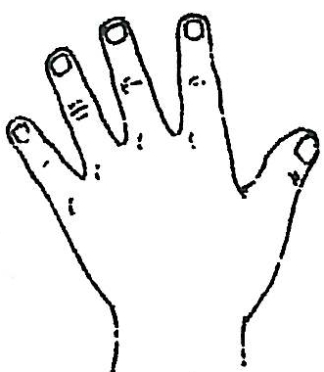

1. Show four fingers on the other hand and ask your child:

*How many fingers can you see on my other hand?*

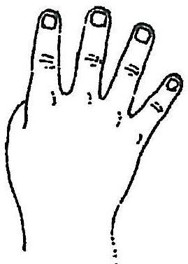

1. Show both hands together and ask your child to make up a number sentence about your fingers.

*For example: Kim showed me five fingers and then showed me four fingers.*

*All together there were nine fingers showing.*

|  |  |
| --- | --- |
|  |  |

1. Ask your child if there are any other number sentences you could make using addition or subtraction with the numbers 4, 5 and 9. If we *turn around* the numbers, we can make new number sentences or equations.

For example:

*Alex bought four icy-poles and then bought five more. How many icy-poles were there altogether?*

*Ben showed me nine fingers then he took away five fingers. There were four fingers left.*

*Megan had nine party hats. She gave four of them to her friends. Megan had five party hats left over.*

**Application**

**Step 1**

Look at the pictures on Activity sheet 10

Ask your child to tell you a number story about each picture as you write the words for the story on the lines provided.

**Step 2**

Look at the equations on Activity sheet 11. Ask your child to find any similarities between the equations. Complete the number sentences on by filling in the missing digits. This sheet uses the language ‘turn around number sentences’, your child may be more familiar with the term ‘fact families’

**Task 3**

**Focus:** **Measurement**



|  |  |  |  |
| --- | --- | --- | --- |
|  |  |  |  |

**Getting Knowledge Ready**

**Step 1**

Use Activity sheet 12 and prepare the *Months cards* by cutting along the straight lines.

**Step 2**

Ask your child:

*What month is it now?*

*What was last month?*

*What is next month?*

Set out the cards in sequence—January to December, with the help of your child.

Teach your child the rhyme below, informally explaining a leap year.

*Most years have 365 days, except for every fourth year, which has 366 days.*

|  |  |  |
| --- | --- | --- |
|  | **Jingle of the Months**  *Thirty days has September,*  *April, June and November,*  *All the rest have thirty-one*  *Excepting February alone,*  *Which has but twenty-eight days clear*  *And twenty-nine in each leap year.* | September, April, June, November  30  31  January, March, May, July, August, October, December  28  29  February |

**Application**

Look at a calendar and ask:

* *What is the name of this month?*
* *How many days are there in this month?*’
* *How many months is it until the summer holidays? How many days is it until the weekend? How many days / months is it until your birthday?*

**Step 1**

Using the *Months cards* from Activity sheet 12 sequence the months in order from January to December and paste them onto Activity sheet 13.

**Step 2**

Ask your child:

*What day is it today?*

*What day was it yesterday?*

*What day is it tomorrow?*

*What season is it now?*

*What are the names of the seasons?*

*What months make up the seasons?*

Look at Activity sheet 14.

What information does your child know about the seasons?

Ask your child: *Is it always hot in December?*

Discuss the fact that the months are only a guide to the seasons and often the garden is the best indicator of change.

* Ask your child to tell you the names of the months in each season.
* Write the months down in the appropriate places on Activity sheet 14.
* Ask your child to draw pictures or cut and paste pictures from a magazine about each season.

**Task 4**

**Focus: Number**

**Getting Knowledge Ready**

**Step 1**

Use Activity sheet 15 and cut out the numbers and signs.

Lay out the numbers *0, 1, 2, 3, 4, 5, 6, 7, 8, 9, 10* and the signs +, –, = .

Lay out 10 counters on the table or floor.

Ask your child to create a number sentence using + or – with counters or numbers.

**Application**

**Step 1**

* Using Activity sheet 16 create number sentences to answer the questions. Only one digit from each circle can be used for each number sentence.
* Your child may need to select a number from the right circle first if he / she is creating a number sentence with *take away*, or *subtraction*.

**Step 2**

* Show your child Activity sheet 17 and using the pictures of the ice-creams as a visual aid, complete the number sentences subtracting a single digit from 20.
* Discuss with your child any patterns that they can see.

**Step 3**

* Use Activity sheets 18 and 19 and play *Roller Coaster Ride* with your child.
* Explain to your child that he / she will need to keep a record of the number sentences created throughout the game.
* Ask your child to record number sentences throughout the game.
* For example:

Roller Coaster Ride

My number sentences:

|  |
| --- |
| 10 - 1 = 9  9 + 3 = 12  12 - 4 = 8 |

* This will encourage mental addition and subtraction skills to be developed. Some students may need the aid of counters to help them process the number sentences as they progress through the game.

MCj02904350000[1]**Task 5**

**Focus: Space**

**Getting Knowledge Ready**

**Step1**

Hold up one piece of fruit or vegetable and ask your child to tell you what it is.

Say: *If we cut this in half, what shape do you think it would make?*

Say: *If we cut this on a different angle what shape would it make?*

**Application**

Provide a variety of fruits and vegetables of different shapes for your child to cut at different angles—using an appropriate knife and accompanied by an adult. Discuss what horizontal, vertical and diagonal mean.

Ask: *What shape is produced when you cut it horizontally?*

Ask: *Can you cut it a different way to show a different shape?*



Use Activity sheets 20 and 21 and ask your child to dip the faces created by the cross-sections into paint and use them to print shape patterns on these pages. Allow time for the paint to dry thoroughly. If you don’t have access to paint trying drawing the shape you see.

Encourage your child to share the things he/she learned when making the cross-sections.

Ask: *If I can see a circular-shaped cross-section, what 3-D shape could it have come from?*

**Task 6****Focus: Number**

**Getting Knowledge Ready**

**Step 1**

Ask your child: *What do you know about the numbers from 1 to 10?*

**Step 2**

Place the pictures of beach balls from Activity sheet 22 on the floor or table. Ask your child to count them out loud.

|  |  |  |  |  |  |  |  |  |  |  |
| --- | --- | --- | --- | --- | --- | --- | --- | --- | --- | --- |
| |  |  |  |  |  |  |  |  |  |  | | --- | --- | --- | --- | --- | --- | --- | --- | --- | --- | |  |  |  |  |  |  |  |  |  |  | |

**Step 3**

Ask your child to sort these beach balls into two groups and create number stories to make 10.

* Remind your child that he can use + or – in his number stories.

**Application**

**Step 1**

Show your child Activity sheet 23

* Ask your child if he / she can see two numbers that could be added together to make ten.
* Ask him / her to join the two numbers with a line. Here is an example:

9

1

* Ask your child to create a number story or number sentence about these beach balls and record these on Activity sheet 24.
* Repeat these steps by making different groups each time.
* Talk about the number sentences after each new group has been created.
* Continue until your child has matched up all combinations to equal ten.

**Step 2**

Show your child Activity sheet 25*.*

* Discuss the picture and create a story about it.
* Complete Activity sheets 25 and 26 by creating pictures or number stories where required.

**Task 7**

**Focus: Number**

**Getting Knowledge Ready**

**Step 1**

Show your child one finger and then four fingers.

|  |  |
| --- | --- |
|  |  |

* Ask your child to tell you what is different about each set of fingers. Encourage the use of *more, less, add, subtract*.
* Repeat this activity using two different sets of fingers each time.

|  |  |
| --- | --- |
|  |  |

* Ask your child to make some finger sets of their own and create the number stories to go with them.

**Application**

**Step 1**

Ask: *What do you do every day that uses adding or subtracting?*

You can talk about activities such as:

* Pouring milk on cereal (addition to cereal, subtraction from the carton)
* Counting items used for breakfast (addition and subtraction)
* Measuring ingredients for cooking (addition)
* Packing equipment for travelling (addition)
* Shopping (addition and subtraction)
* Drinking water from a bottle (subtraction)

**Step 2**

Complete a brainstorm on Activity sheet 27

**Step 3**

Ask your child to think about the number 10. Ask *what* *do you know about the number 10*?

Encourage the use of *addition, subtraction* and similar words.

**Step 4**

Complete Activity sheets 28 and 29 on *Today’s Target* and have your child use pictures or numbers to create number stories.

**Task 8**

**Focus: Chance and Data**

**Getting Knowledge Ready**

**Step 1**

Show Pictograph A and Pictograph B on Activity sheet 30 Ask your child to tell you what he /she can see in both the pictographs. For example, how are they similar? How are they different? Is one easier to read than the other?

**Step 2**

Look at Pictograph A and Pictograph B separately.

Say to your child: *What can you tell me about this pictograph?*

*How is the information organised?* \_\_\_\_\_\_\_\_\_\_\_\_\_\_\_\_\_\_\_\_\_\_\_\_\_\_\_\_\_\_\_\_\_\_\_\_\_\_\_\_\_\_\_\_\_

*Why are there different columns?* \_\_\_\_\_\_\_\_\_\_\_\_\_\_\_\_\_\_\_\_\_\_\_\_\_\_\_\_\_\_\_\_\_\_\_\_\_\_\_\_\_\_\_\_\_

*Why do you think icy-pole sales change from day to day?* \_\_\_\_\_\_\_\_\_\_\_\_\_\_\_\_\_\_\_\_\_\_\_\_\_

*Do both graphs give us the same information*? \_\_\_\_\_\_\_\_\_\_\_\_\_\_\_\_\_\_\_\_\_\_\_\_\_\_\_\_\_\_\_\_\_\_\_

Discuss how information can be shown in two different ways.

Pictograph A has the days of the week going down the left side of the page.

Pictograph B has the days of the week across the page from left to right.

**Step 3**

For Pictograph A:

* Point to the word *Monday* and ask your child how many icy-poles were sold on that day.
* Ask your child to find *Friday* and ask how many icy-poles were sold on Friday.
* Find a day when 8 icy-poles were sold (Wednesday or Thursday)

Discuss how the same information from Pictograph A can also be arranged like Pictograph B.

**Step 4**

For Pictograph B:

* Point to the word *Monday* and ask your child how many icy-poles were sold on that day.
* Ask your child to find *Friday* and ask how many icy-poles were sold on Friday.
* Find the day when 10 icy-poles were sold. (Saturday)

**Application**

Discuss with your child that a graph shows information in rows and columns.

Say to your child: *Every picture or graph tells a story.*



**Step 1**

Show your child Activity sheet 31 and ask your child to tell you what information can be found in the graph.

* What story can be made up about the graph?
* Label/colour any parts of the graph to give it more meaning.
* Write down your child’s responses in the space provided.

**Step 2**

Repeat Step 1 with Activity sheets 32 and 33*.*

Ask your child information about all the graphs he / she created.

* *What information does your graph show?*
* *Did you have any difficulties in showing the information on the graph?*
* *How do you think this information could be arranged in another way*?

**Task 9**

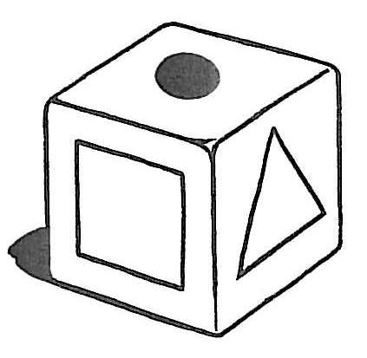

**Focus—Chance and Data**

**Getting Knowledge Ready**

**Step 1**

Use Activity sheet 34.

Use Activity sheet 6 to make the die with the shapes on each face.

Ask:

* *If we throw the die 20 times how can we record the shapes from each throw?*
* *How could we make the data that you collect into a graph?*

**Application**

**Step 1**

Roll the shape die 20 times. After each roll of the die ask your child to record the shape on the upper face of the die on Activity sheet 34

**Step 2**

Transfer the information he / she has collected on Activity sheet 34 into a graph on Activity sheet 35*.*

Ask your child to add labels and a title to make the graph easy to understand.

**Step 3**

Ask your child to complete Activity sheet 36

Encourage your child to discuss why he /she is placing shapes in particular columns or rows when creating the graph.

Ask:

* *What information does your graph show?*
* *How do you think this information could be arranged in another way*?



**Task 10**

**Focus: Review**

1. Have your child to solve these addition and subtraction problems by recording his / her thinking. He / she can draw pictures to help solve the problem.

|  |  |
| --- | --- |
| **Problem** | **My Thinking** |
| 5+5= |  |
| 8+4= |  |
| 10-2= |  |
| 7-1= |  |
| 20-7= |  |
| 20-9= |  |

1. Make a number sentence from this picture:

|  |
| --- |
| Cars |

\_\_\_\_\_\_\_\_\_\_\_\_\_\_\_\_\_\_\_\_\_\_\_\_\_\_\_\_\_\_\_\_\_\_\_\_\_\_\_\_\_\_\_\_\_\_\_\_\_\_\_\_\_\_\_\_\_\_\_\_\_\_\_\_\_\_\_\_\_\_\_\_\_\_\_\_\_\_\_\_\_\_\_\_\_\_\_\_\_\_\_\_\_\_\_\_\_\_\_\_\_\_\_\_\_\_\_\_\_\_\_\_\_\_\_\_\_\_\_\_\_\_\_\_\_\_\_\_\_\_\_\_\_\_\_\_\_\_\_\_\_\_\_\_\_\_\_\_\_\_\_\_\_\_\_\_\_\_\_\_\_\_\_\_\_

3. Ask your child to:

* Name the months of the year in order.
* Name the four seasons.
* Look at a calendar, find the current month and work out how many months or weeks or days it is until their next birthday.

\_\_\_\_\_\_\_\_\_\_\_\_\_\_\_\_\_\_\_\_\_\_\_\_\_\_\_\_\_\_\_\_\_\_\_\_\_\_\_\_\_\_\_\_\_\_\_\_\_\_\_\_\_\_\_

1. Ask your child to create a graph using the following information:

|  |  |
| --- | --- |
| On Monday we could see 4 fish in the pond.  On Tuesday we could see 7 fish in the pond.  On Wednesday we could see 5 fish in the pond.  On Thursday we could see 2 fish in the pond.  On Friday we could see 9 fish in the pond. | j0391220 |

|  |  |  |  |  |  |
| --- | --- | --- | --- | --- | --- |
|  |  |  |  |  |  |
|  |  |  |  |  |  |
|  |  |  |  |  |  |
|  |  |  |  |  |  |
|  |  |  |  |  |  |

1. Ask your child to count the number of shapes in the following picture.

|  |  |  |
| --- | --- | --- |
| triangle |  |  |
| square |  |  |
| rectangle |  |  |
| circle |  |  |

**Activity Pages**



|  |  |  |  |
| --- | --- | --- | --- |
| **Maths Activity Sheet 1**  **Shape Cards 1** | | |  |
|  |  |  | |
|  |  |  | |
|  |  |  | |
|  |  |  | |

|  |  |  |
| --- | --- | --- |
| **Maths Activity Sheet 2**  **Shape Cards 2** | |  |
|  |  | |
|  |  | |
|  |  | |
|  |  | |

|  |  |  |
| --- | --- | --- |
| **Maths Activity Sheet 3**  **Shape Cards 3** | |  |
|  |  | |
|  |  | |
|  |  | |
|  |  | |

**Maths Activity Sheet 4**

**My Mind Map of Shapes and Patterns**

|  |  |  |
| --- | --- | --- |
| What do I already know about patterns? | MCj00786290000[1] | Where can I see patterns? |

Shapes and Patterns

**Maths Activity Sheet 5**

**My Shape Patterns**

1.

|  |
| --- |
| 2. |
| 3. |

4.

|  |
| --- |
| 5. |
| 6. |

I like playing with shapes.

**Maths Activity Sheet 6**

**Shape Die**

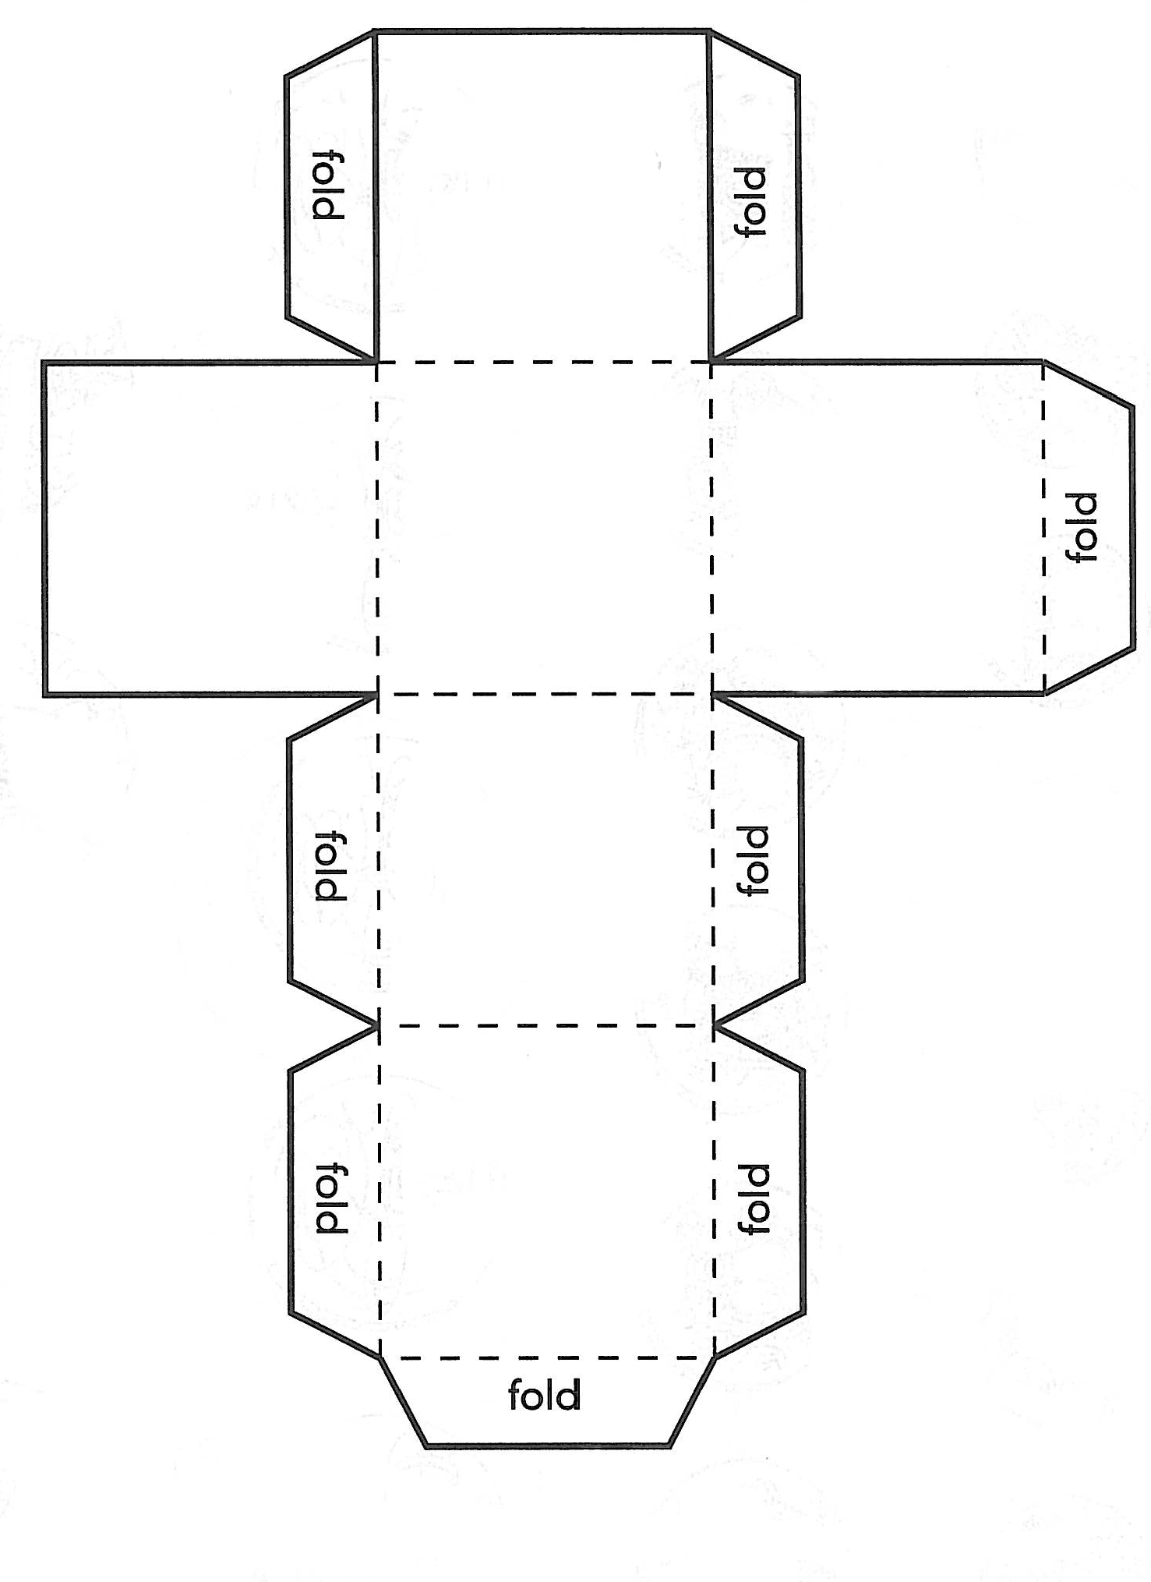

**Maths Activity Sheet 7**

Finish the Patterns!

**j0078793**

**Player A**

|  |  |  |  |  |  |  |  |
| --- | --- | --- | --- | --- | --- | --- | --- |
|  |  |  |  |  |  |  |  |
|  |  |  |  |  |  |  |  |
|  |  |  |  |  |  |  |  |
|  |  |  |  |  |  |  |  |

**Player B**

|  |  |  |  |  |  |  |  |
| --- | --- | --- | --- | --- | --- | --- | --- |
|  |  |  |  |  |  |  |  |
|  |  |  |  |  |  |  |  |
|  |  |  |  |  |  |  |  |
|  |  |  |  |  |  |  |  |

|  |  |  |  |
| --- | --- | --- | --- |
| **Maths Activity Sheet 8**  **Number and Sign Cards** | | |  |
| **1** | **2** | **3** | |
| **6** | **7** | **8** | |
| **13** | **16** | **=** | |
| **+** | **+** | **-** | |

**Maths Activity Sheet 9**

**My Mind Map of Addition, Subtraction and Equations**

|  |  |  |
| --- | --- | --- |
| What do I already know about addition and subtraction? |  | What do I already know about equations? |

In the space below ask your child to create a mind map about addition, subtraction and equations. Help your child to write answers to questions such as:

* *What are equations?*
* *What do I know about addition?*
* *What do I know about subtraction?*
* *What is a number sentence or number story?*

Spread the answers around the heading below to create your mind map.

Addition Subtraction Equations

|  |  |  |
| --- | --- | --- |
| **Maths Activity Sheet 10**  **Look at the pictures on this page and create number sentences for them.** | | |
| 1. | egg groups day 2 | How many eggs are in the carton?  How many eggs are in the frying pan? |

Write an addition or subtraction number sentence about the above picture.

\_\_\_\_\_\_\_\_\_\_\_\_\_\_\_\_\_\_\_\_\_\_\_\_\_\_\_\_\_\_\_\_\_\_\_\_\_\_\_\_\_\_\_\_\_\_\_\_\_\_\_\_\_\_\_\_\_\_

\_\_\_\_\_\_\_\_\_\_\_\_\_\_\_\_\_\_\_\_\_\_\_\_\_\_\_\_\_\_\_\_\_\_\_\_\_\_\_\_\_\_\_\_\_\_\_\_\_\_\_\_\_\_\_\_\_\_

\_\_\_\_\_\_\_\_\_\_\_\_\_\_\_\_\_\_\_\_\_\_\_\_\_\_\_\_\_\_\_\_\_\_\_\_\_\_\_\_\_\_\_\_\_\_\_\_\_\_\_\_\_\_\_\_\_\_

|  |  |  |
| --- | --- | --- |
| 2. | sheep groups day 2 | How many sheep are inside the paddock?  How many sheep have walked out the gate? |

Write an addition or subtraction number sentence about the above picture.

\_\_\_\_\_\_\_\_\_\_\_\_\_\_\_\_\_\_\_\_\_\_\_\_\_\_\_\_\_\_\_\_\_\_\_\_\_\_\_\_\_\_\_\_\_\_\_\_\_\_\_\_\_\_\_\_\_\_\_\_\_\_\_\_\_\_\_\_\_\_\_\_\_\_\_\_\_\_\_\_\_\_\_\_\_\_\_\_\_\_\_\_\_\_\_\_\_\_\_\_\_\_\_\_\_\_\_\_\_\_\_\_\_\_\_\_\_\_\_\_\_\_\_\_\_\_\_\_\_\_\_\_\_\_\_\_\_\_\_\_\_\_\_\_\_\_\_\_\_\_\_\_\_\_\_\_\_\_\_\_\_\_\_\_\_\_\_\_\_\_\_\_\_\_

**Maths Activity Sheet 11**

**Complete these *turn around* number sentences:**

|  |
| --- |
| 6 + 3 =  3 + = 9  9 - 3 =  9 - = 3 |

j0158007

|  |
| --- |
| 8 + 2 =  2 + = 10  10 - 8 =  10 - = 8 |

j0158007

|  |  |  |
| --- | --- | --- |
| **Maths Activity Sheet 12**  **Months cards** | | |
| **January** |  | **July** |
| **February** |  | **August** |
| **March** |  | **September** |
| **April** |  | **October** |
| **May** |  | **November** |
| **June** |  | **December** |

|  |  |  |  |  |  |  |  |  |  |  |  |  |  |
| --- | --- | --- | --- | --- | --- | --- | --- | --- | --- | --- | --- | --- | --- |
| **Maths Activity Sheet 13**  **Months of the Year**   |  |  | | --- | --- | | **1.** | **2.** | | **3.** | **4.** | | **5.** | **6.** | | **7.** | **8.** | | **9.** | **10.** | | **11.** | **12.** | |  |

**Maths Activity Sheet 14**

**Seasons of the Year Wheel**

|  |  |  |
| --- | --- | --- |
|  |  |  |
|  |  |  |
| **Spring**  **Summer**  **Autumn**  **Winter** | | |
|  |  |  |
|  |  |  |
|  |  |  |

|  |  |  |  |  |  |  |  |  |  |  |  |  |  |  |  |  |  |
| --- | --- | --- | --- | --- | --- | --- | --- | --- | --- | --- | --- | --- | --- | --- | --- | --- | --- |
| **Maths Activity Sheet 15**  **Number and Sign Cards**   |  |  |  | | --- | --- | --- | | **0** | **1** | **2** | | **3** | **4** | **5** | | **6** | **7** | **8** | | **9** | **10** | **+** | | **-** | **=** | **+** | |  |  |

**Maths Activity Sheet 16**

**Create your own Number Sentences**

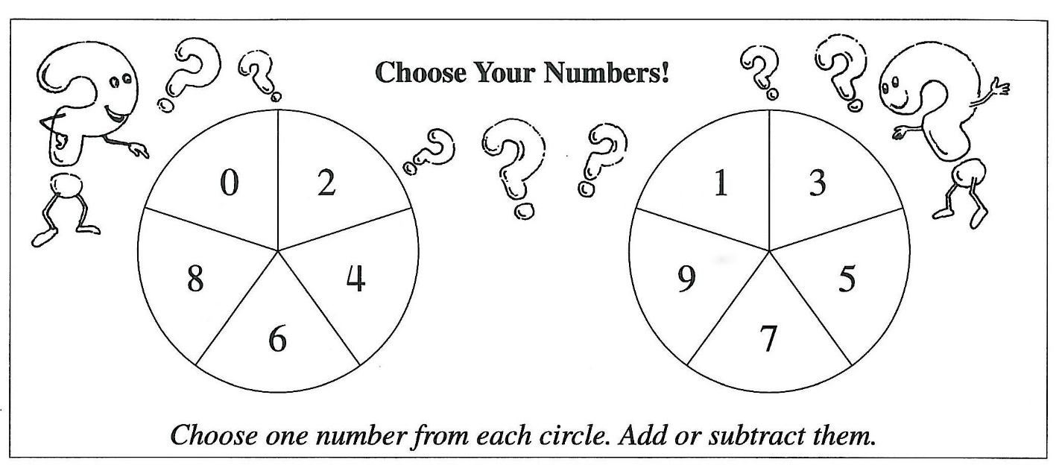

1. Show Tom how to make *1* five different ways. \_\_\_\_\_\_\_\_\_\_\_\_\_\_\_\_\_\_\_\_\_\_\_\_\_\_\_\_\_\_\_\_\_\_\_\_\_\_\_\_\_\_\_\_\_\_\_\_\_\_\_\_\_\_

\_\_\_\_\_\_\_\_\_\_\_\_\_\_\_\_\_\_\_\_\_\_\_\_\_\_\_\_\_\_\_\_\_\_\_\_\_\_\_\_\_\_\_\_\_\_\_\_\_\_\_\_\_\_

\_\_\_\_\_\_\_\_\_\_\_\_\_\_\_\_\_\_\_\_\_\_\_\_\_\_\_\_\_\_\_\_\_\_\_\_\_\_\_\_\_\_\_\_\_\_\_\_\_\_\_\_\_\_

\_\_\_\_\_\_\_\_\_\_\_\_\_\_\_\_\_\_\_\_\_\_\_\_\_\_\_\_\_\_\_\_\_\_\_\_\_\_\_\_\_\_\_\_\_\_\_\_\_\_\_\_\_\_

\_\_\_\_\_\_\_\_\_\_\_\_\_\_\_\_\_\_\_\_\_\_\_\_\_\_\_\_\_\_\_\_\_\_\_\_\_\_\_\_\_\_\_\_\_\_\_\_\_\_\_\_\_\_

\_\_\_\_\_\_\_\_\_\_\_\_\_\_\_\_\_\_\_\_\_\_\_\_\_\_\_\_\_\_\_\_\_\_\_\_\_\_\_\_\_\_\_\_\_\_\_\_\_\_\_\_\_\_

1. List five different numbers you could get for answers in the *Choose Your Numbers* game.  
   \_\_\_\_\_\_\_\_\_\_\_\_\_\_\_\_\_\_\_\_\_\_\_\_\_\_\_\_\_\_\_\_\_\_\_\_\_\_\_\_\_\_\_\_\_\_\_\_\_\_\_\_\_\_

\_\_\_\_\_\_\_\_\_\_\_\_\_\_\_\_\_\_\_\_\_\_\_\_\_\_\_\_\_\_\_\_\_\_\_\_\_\_\_\_\_\_\_\_\_\_\_\_\_\_\_\_\_\_

**Maths Activity Sheet 17**

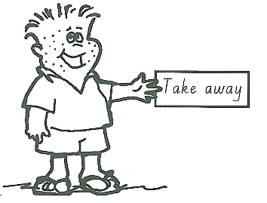**Patterns in Subtraction**

Today we are looking at patterns in subtraction.

|  |  |
| --- | --- |
| There were 20 ice-creams at a party for 10 frogs.   * Complete the number sentences as each frog receives his first ice-cream. | j0133545 |

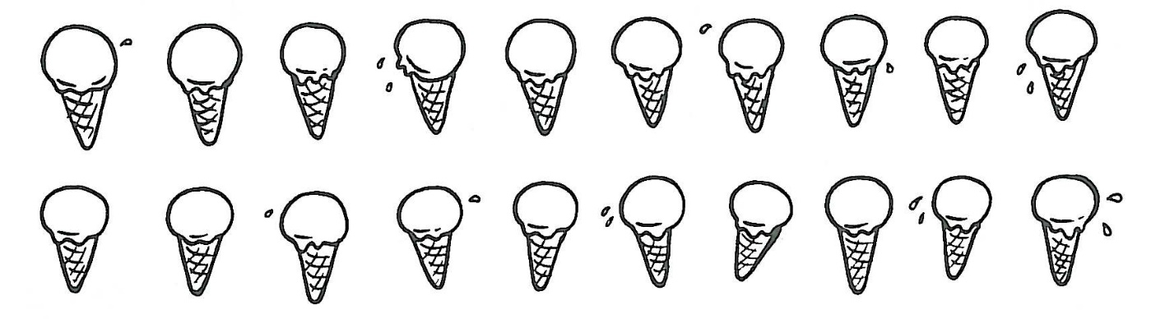

|  |  |
| --- | --- |
| 20 - 1 = | 20 - 6 = |
| 20 - 2 = | 20 - 7 = |
| 20 - 3 = | 20 - 8 = |
| 20 - 4 = | 20 - 9 = |
| 20 - 5 = | 20 -10 = |

**Maths Activity Sheet 18**

**Roller Coaster Ride**

This is a game for two or more players.

Have fun on your roller coaster ride!

|  |  |
| --- | --- |
| j0286941 |  |

1. You will need the *Roller Coaster Ride* game board—found on the next page, a die and two or more tokens.
2. Place a token for each player on *Start*.
3. Each player starts with 10 points.
4. *Player One* throws the die.
5. Move forward that many places.
6. Create a number sentence for the sign and number that you land on.
7. At the start you have 10 points. If you throw a 3 you will land on +1 so your number sentence would be 10 + 1 = 11.
8. The next time you have a turn you will start with 11 points because that was the total of your number sentence.
9. *Player Two* now throws the die and repeats steps 5 to 8.
10. Keep alternating until one player lands on *Finish*.
11. Share your number sentences with other players.

**Maths Activity Sheet** 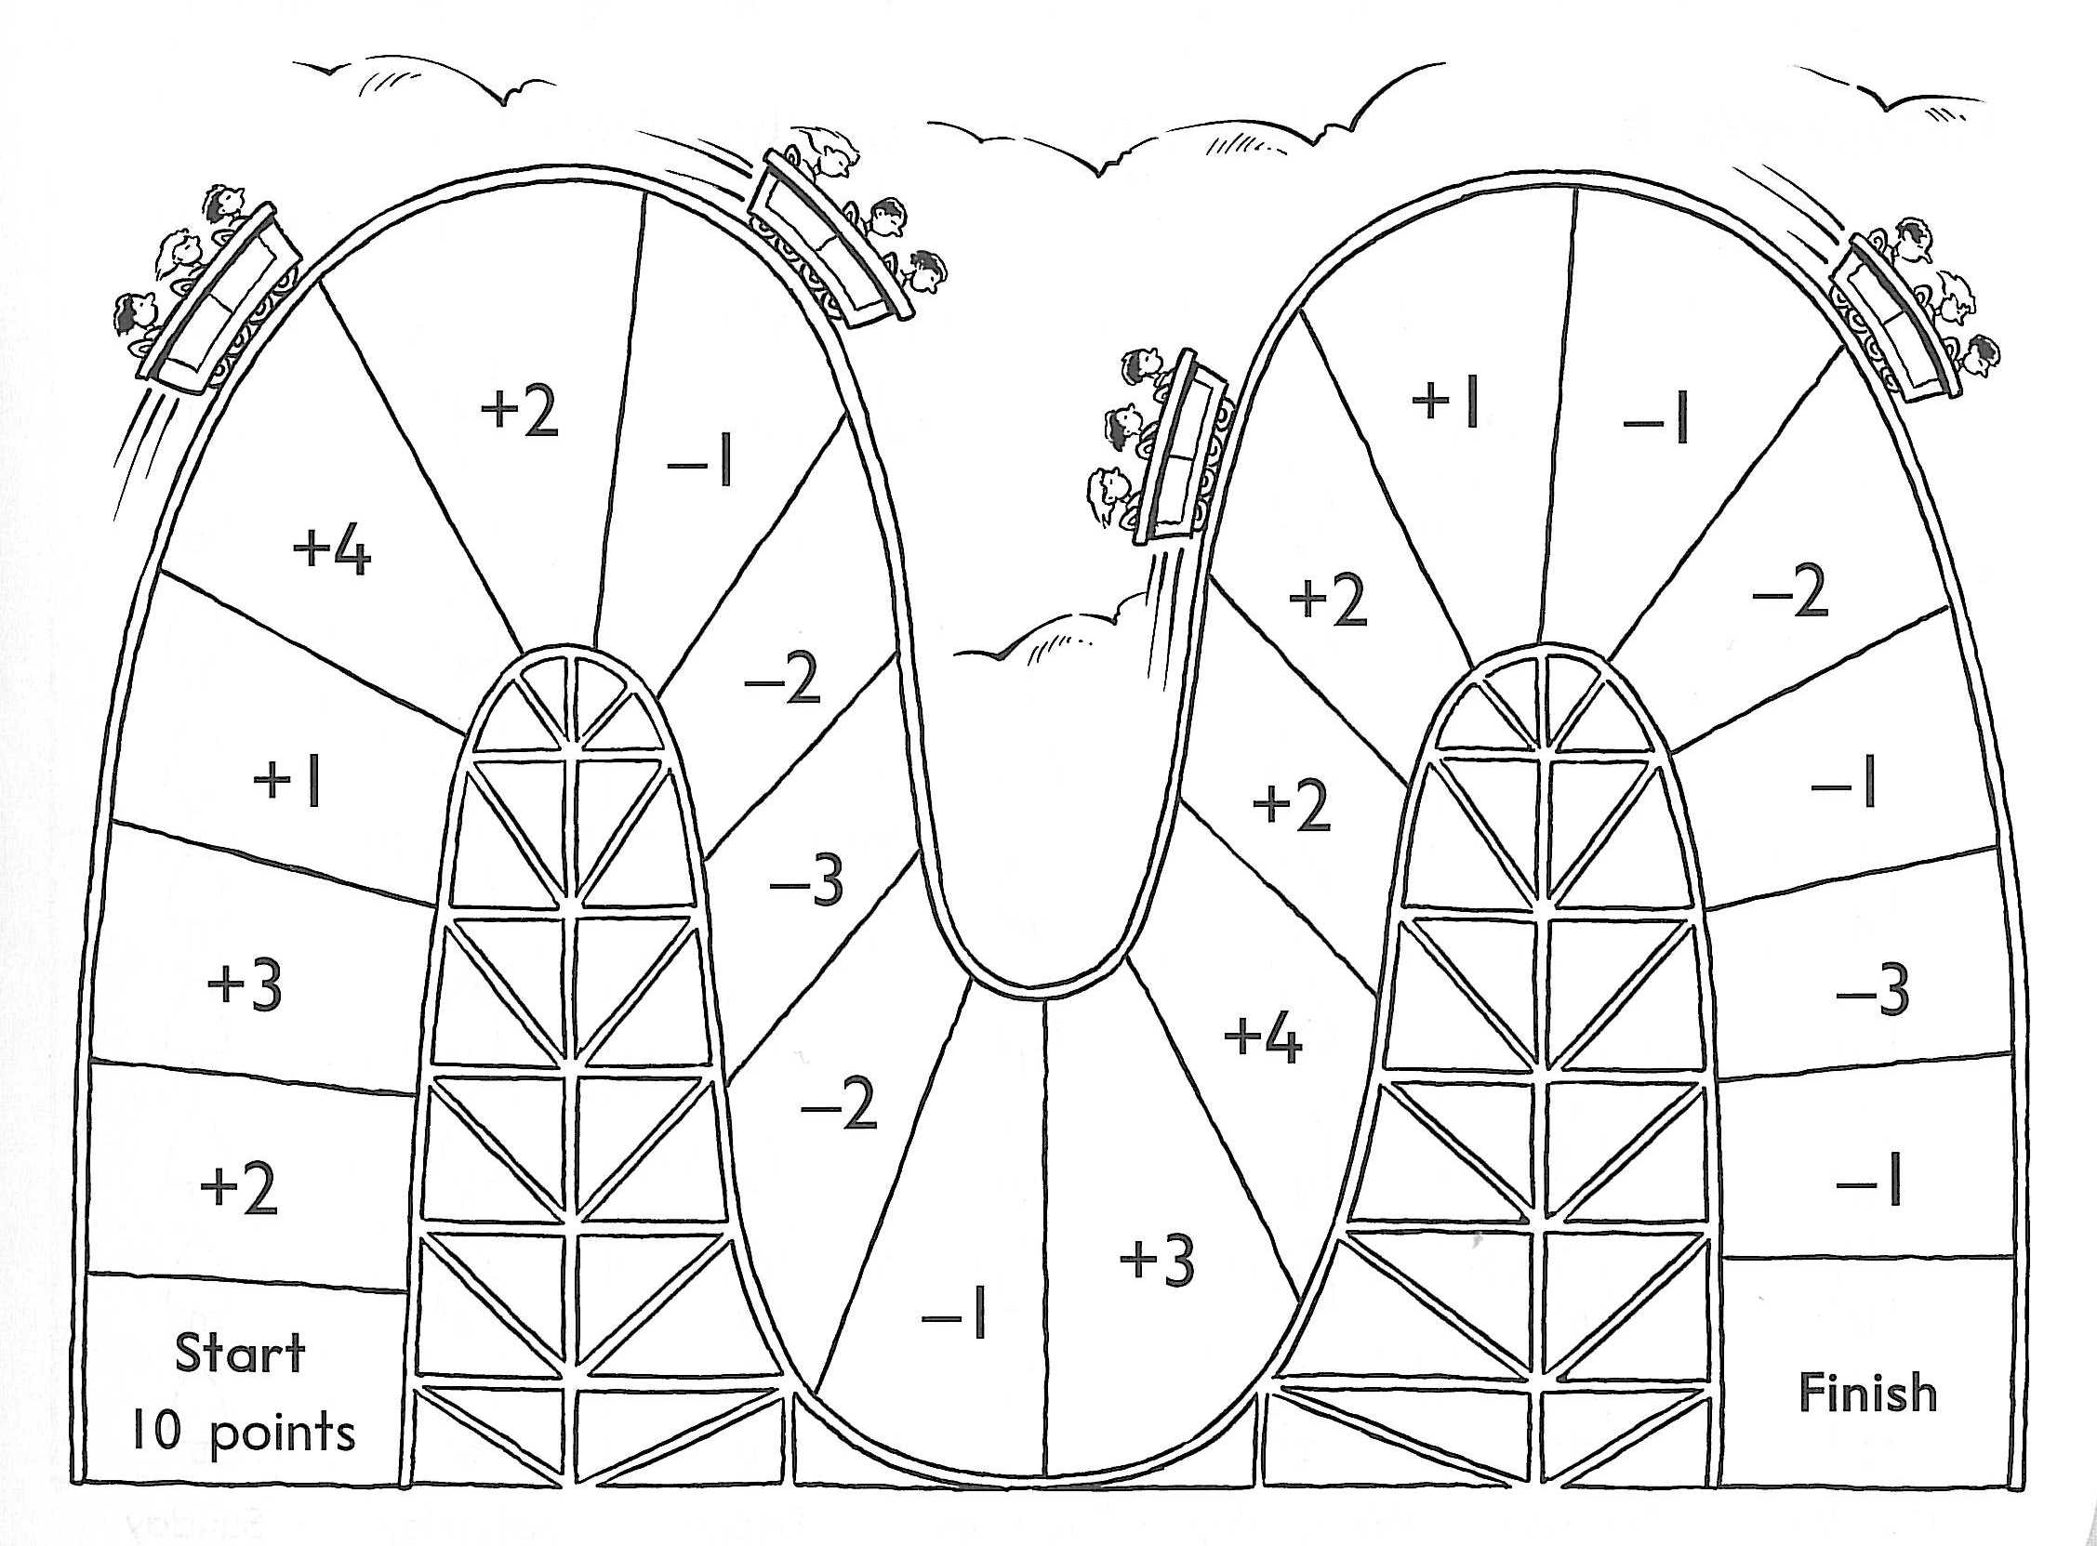**19**

|  |  |
| --- | --- |
| **Maths Activity Sheet 20**  **Cross-sections of fruit and vegetables** | |
| **Names of fruit or vegetable** | **Prints of cross-sections** |
|  |  |
|  |  |
|  |  |

|  |  |
| --- | --- |
| **Maths Activity Sheet 21**  **Cross-sections of fruit and vegetables** | |
| **Names of fruit or vegetables** | **Prints of cross-sections** |
|  |  |
|  |  |
|  |  |

**Maths Activity Sheet 22**

**Beach balls**

|  |  |  |
| --- | --- | --- |
| sl00367_ | sl00367_ | sl00367_ |
| sl00367_ | sl00367_ | sl00367_ |
| sl00367_ | sl00367_ | sl00367_ |
|  | sl00367_ |  |

**Maths Activity Sheet 23**

**Number sentences for 10**

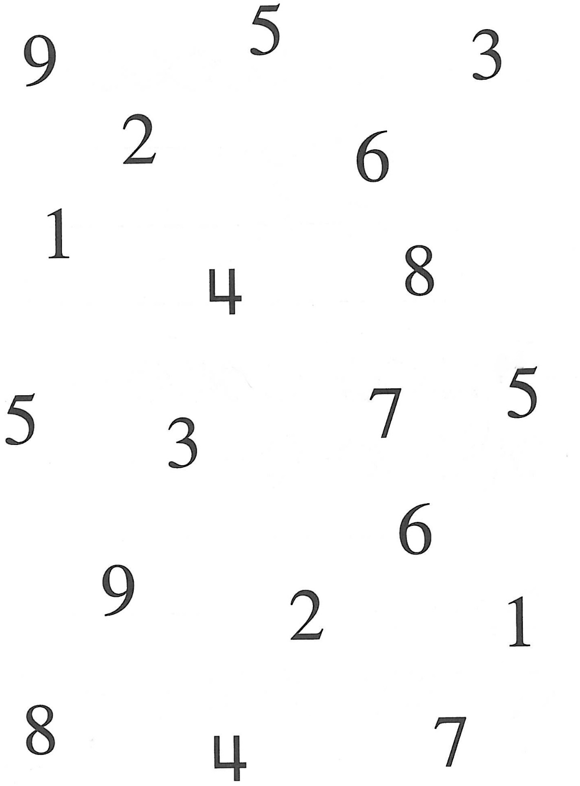

1. Circle two numbers that make 10.
2. Join these numbers with a coloured line.

One has been done for you.

1. Create as many pairs as possible that make 10.

**Maths Activity Sheet 24**

**Number sentences for 10**

1. Write down all the number sentences or equations that you created to make 10.

\_\_\_\_\_\_\_\_\_\_\_\_\_\_\_\_\_\_\_\_\_\_\_\_\_\_\_\_\_\_\_\_\_\_\_\_\_\_\_\_\_\_\_\_\_\_\_\_\_\_\_\_\_

\_\_\_\_\_\_\_\_\_\_\_\_\_\_\_\_\_\_\_\_\_\_\_\_\_\_\_\_\_\_\_\_\_\_\_\_\_\_\_\_\_\_\_\_\_\_\_\_\_\_\_\_\_

\_\_\_\_\_\_\_\_\_\_\_\_\_\_\_\_\_\_\_\_\_\_\_\_\_\_\_\_\_\_\_\_\_\_\_\_\_\_\_\_\_\_\_\_\_\_\_\_\_\_\_\_\_

\_\_\_\_\_\_\_\_\_\_\_\_\_\_\_\_\_\_\_\_\_\_\_\_\_\_\_\_\_\_\_\_\_\_\_\_\_\_\_\_\_\_\_\_\_\_\_\_\_\_\_\_\_

\_\_\_\_\_\_\_\_\_\_\_\_\_\_\_\_\_\_\_\_\_\_\_\_\_\_\_\_\_\_\_\_\_\_\_\_\_\_\_\_\_\_\_\_\_\_\_\_\_\_\_\_\_

\_\_\_\_\_\_\_\_\_\_\_\_\_\_\_\_\_\_\_\_\_\_\_\_\_\_\_\_\_\_\_\_\_\_\_\_\_\_\_\_\_\_\_\_\_\_\_\_\_\_\_\_\_

\_\_\_\_\_\_\_\_\_\_\_\_\_\_\_\_\_\_\_\_\_\_\_\_\_\_\_\_\_\_\_\_\_\_\_\_\_\_\_\_\_\_\_\_\_\_\_\_\_\_\_\_\_

\_\_\_\_\_\_\_\_\_\_\_\_\_\_\_\_\_\_\_\_\_\_\_\_\_\_\_\_\_\_\_\_\_\_\_\_\_\_\_\_\_\_\_\_\_\_\_\_\_\_\_\_\_

\_\_\_\_\_\_\_\_\_\_\_\_\_\_\_\_\_\_\_\_\_\_\_\_\_\_\_\_\_\_\_\_\_\_\_\_\_\_\_\_\_\_\_\_\_\_\_\_\_\_\_\_\_

\_\_\_\_\_\_\_\_\_\_\_\_\_\_\_\_\_\_\_\_\_\_\_\_\_\_\_\_\_\_\_\_\_\_\_\_\_\_\_\_\_\_\_\_\_\_\_\_\_\_\_\_\_

|  |  |
| --- | --- |
| j0215229 | Maths is fun.  You can make lots of number stories. |
| CG9F j0356113 j0356113 j0356113 |

**Maths Activity Sheet 25**

**Addition number stories**

There were 3 children playing ball and 4 more came to play.

There were 7 children altogether.

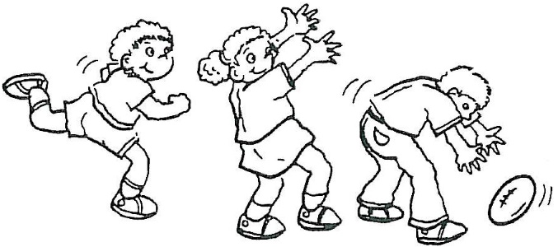 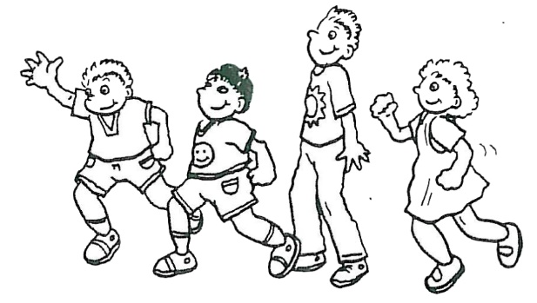

|  |  |  |  |  |
| --- | --- | --- | --- | --- |
| 3 | and | 4 | makes | 7 |

1. Draw a picture about:

|  |  |  |  |  |
| --- | --- | --- | --- | --- |
| 6 | and | 3 | makes | 9 |

|  |
| --- |
|  |

**Maths Activity Sheet 26**

**Addition number stories**

2. Write a number story about:

|  |  |  |  |  |
| --- | --- | --- | --- | --- |
| 2 | and | 5 | makes | 7 |

\_\_\_\_\_\_\_\_\_\_\_\_\_\_\_\_\_\_\_\_\_\_\_\_\_\_\_\_\_\_\_\_\_\_\_\_\_\_\_\_\_\_\_\_\_\_\_\_\_\_\_\_\_\_\_\_\_\_

\_\_\_\_\_\_\_\_\_\_\_\_\_\_\_\_\_\_\_\_\_\_\_\_\_\_\_\_\_\_\_\_\_\_\_\_\_\_\_\_\_\_\_\_\_\_\_\_\_\_\_\_\_\_\_\_\_\_

\_\_\_\_\_\_\_\_\_\_\_\_\_\_\_\_\_\_\_\_\_\_\_\_\_\_\_\_\_\_\_\_\_\_\_\_\_\_\_\_\_\_\_\_\_\_\_\_\_\_\_\_\_\_\_\_\_\_

\_\_\_\_\_\_\_\_\_\_\_\_\_\_\_\_\_\_\_\_\_\_\_\_\_\_\_\_\_\_\_\_\_\_\_\_\_\_\_\_\_\_\_\_\_\_\_\_\_\_\_\_\_\_\_\_\_\_

\_\_\_\_\_\_\_\_\_\_\_\_\_\_\_\_\_\_\_\_\_\_\_\_\_\_\_\_\_\_\_\_\_\_\_\_\_\_\_\_\_\_\_\_\_\_\_\_\_\_\_\_\_\_\_\_\_\_

\_\_\_\_\_\_\_\_\_\_\_\_\_\_\_\_\_\_\_\_\_\_\_\_\_\_\_\_\_\_\_\_\_\_\_\_\_\_\_\_\_\_\_\_\_\_\_\_\_\_\_\_\_\_\_\_\_\_

3. Draw a picture about your number story. j0410977

**Maths Activity Sheet 27**

**How I use adding and subtracting in my daily activities**

Adding

Subtracting

|  |  |  |
| --- | --- | --- |
| **Maths Activity Sheet 28**  **Today’s Target**  **Today’s target is 10!** | 10 Rocks | |
| Draw pictures or write number stories  to answer the problems below. | | Face 50 20 100 |
| * Make the target 10 by: | |

1. Adding two numbers

|  |
| --- |
|  |

1. Subtracting two numbers

|  |
| --- |
|  |

1. Adding three numbers

|  |
| --- |
|  |

**Maths Activity Sheet 29**

* How many other ways can you make the target 10?

|  |
| --- |
|  |

|  |
| --- |
|  |

|  |
| --- |
|  |

|  |
| --- |
|  |

|  |
| --- |
|  |

**Maths Activity Sheet 30**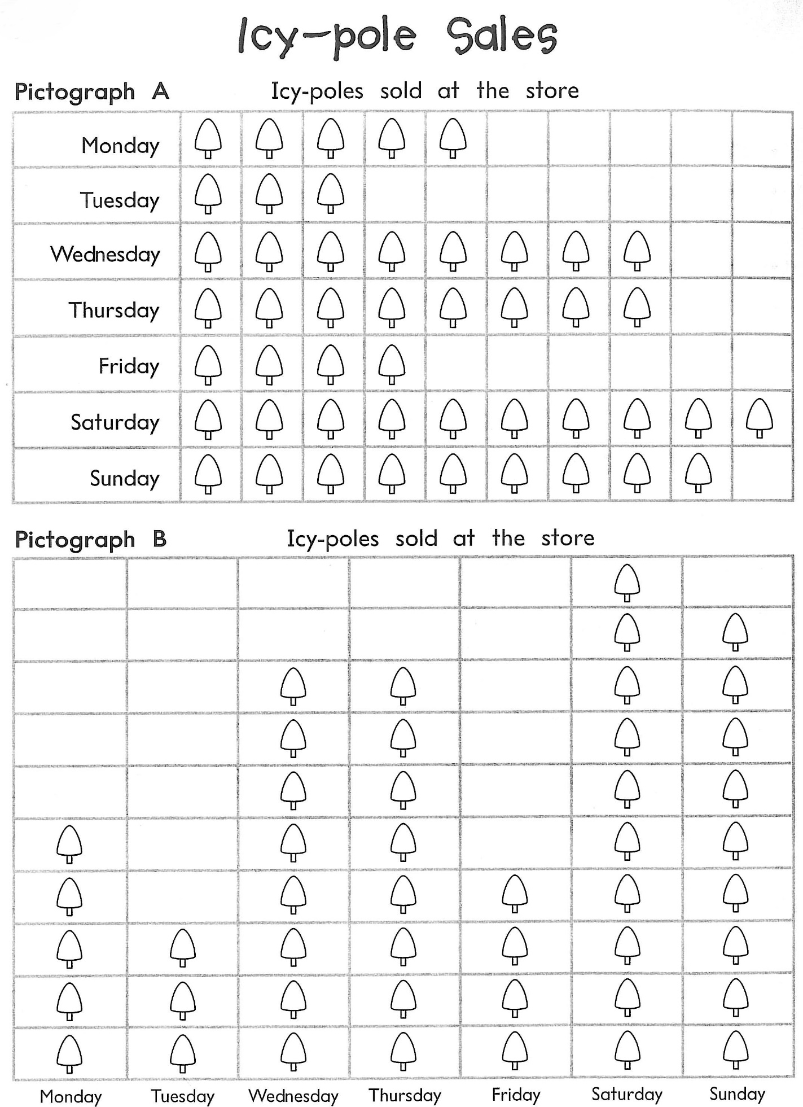

**Animal graph**

**Maths Activity Sheet 31**

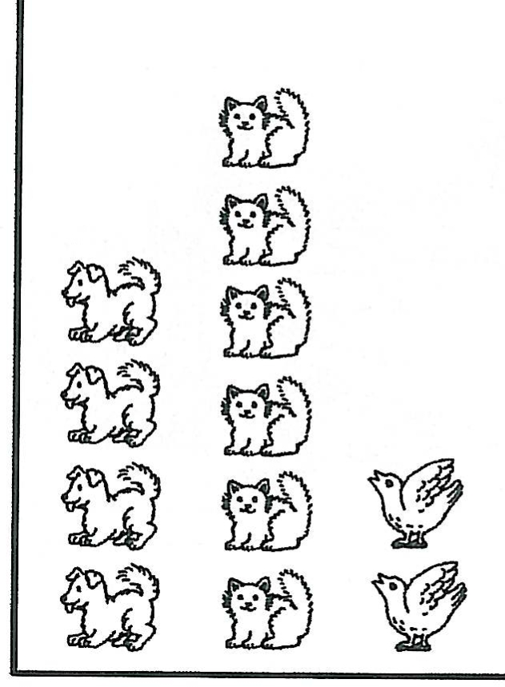

Write a story about this picture.

You can add labels or a title for the picture too.

\_\_\_\_\_\_\_\_\_\_\_\_\_\_\_\_\_\_\_\_\_\_\_\_\_\_\_\_\_\_\_\_\_\_\_\_\_\_\_\_\_\_\_\_\_\_\_\_\_\_\_\_\_\_\_\_\_\_\_\_\_\_\_\_\_\_\_\_\_\_\_\_\_\_\_\_\_\_\_\_\_\_\_\_\_\_\_\_\_\_\_\_\_\_\_\_\_\_\_\_\_\_\_\_\_\_\_\_\_\_\_\_\_\_\_\_\_\_\_\_\_\_\_\_\_\_\_\_\_\_\_\_\_\_\_\_\_\_\_\_\_\_\_\_\_\_\_\_\_\_\_\_\_\_\_\_\_\_\_\_\_\_\_\_\_\_\_\_\_\_\_\_\_\_\_\_\_\_\_\_\_\_\_\_\_\_\_\_\_\_\_\_\_\_\_\_\_\_\_\_\_\_\_\_\_\_\_\_\_\_\_\_\_\_\_\_\_\_\_\_\_\_\_\_\_\_\_\_\_\_\_\_\_\_\_\_\_\_\_\_\_\_\_\_\_\_\_\_\_\_\_\_\_\_\_\_\_\_\_\_\_\_\_\_\_\_\_\_\_\_\_\_\_\_\_\_\_\_\_\_\_\_\_\_\_\_\_\_\_\_

**Maths Activity Sheet 32**

**Weather graph**

*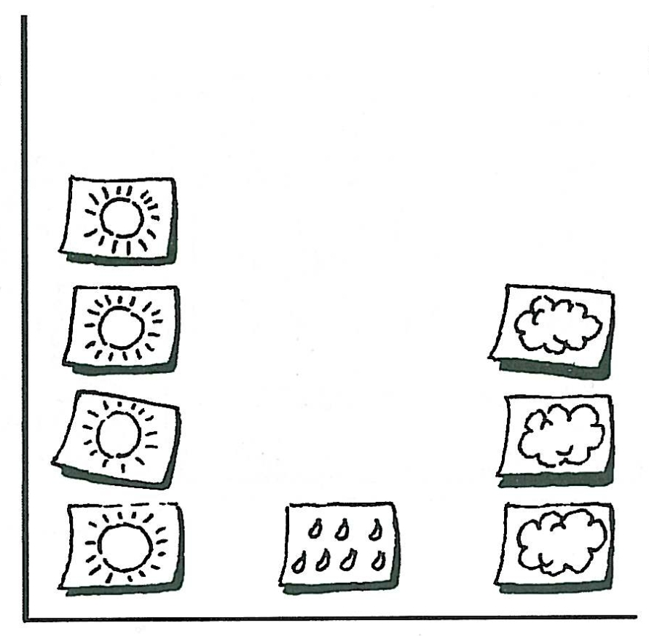*

Write a story about this picture.

You can add labels or a title for the picture too.

\_\_\_\_\_\_\_\_\_\_\_\_\_\_\_\_\_\_\_\_\_\_\_\_\_\_\_\_\_\_\_\_\_\_\_\_\_\_\_\_\_\_\_\_\_\_\_\_\_\_\_\_\_\_\_\_\_\_\_\_\_\_\_\_\_\_\_\_\_\_\_\_\_\_\_\_\_\_\_\_\_\_\_\_\_\_\_\_\_\_\_\_\_\_\_\_\_\_\_\_\_\_\_\_\_\_\_\_\_\_\_\_\_\_\_\_\_\_\_\_\_\_\_\_\_\_\_\_\_\_\_\_\_\_\_\_\_\_\_\_\_\_\_\_\_\_\_\_\_\_\_\_\_\_\_\_\_\_\_\_\_\_\_\_\_\_\_\_\_\_\_\_\_\_\_\_\_\_\_\_\_\_\_\_\_\_\_\_\_\_\_\_\_\_\_\_\_\_\_\_\_\_\_\_\_\_\_\_\_\_\_\_\_\_\_\_\_\_\_\_\_\_\_\_\_\_\_\_\_\_\_\_\_\_\_\_\_\_\_\_\_\_\_\_\_\_\_\_\_\_\_\_\_\_\_\_\_\_\_\_\_\_\_\_\_\_\_\_\_\_\_\_\_\_\_\_\_\_\_\_\_\_\_\_\_\_\_\_\_\_

**Maths Activity Sheet 33**

**Teddy’s house graph**

|  |  |  |
| --- | --- | --- |
| j0187821 |  | On Monday Teddy looked at 7 houses.  On Tuesday he looked at 3 houses.  On Wednesday he looked at 4 houses.  On Thursday he looked at 8 houses.  On Friday he looked at 1 house. |

|  |  |  |  |  |
| --- | --- | --- | --- | --- |
|  |  |  |  |  |
|  |  |  |  |  |
|  |  |  |  |  |
|  |  |  |  |  |
|  |  |  |  |  |

**Maths Activity Sheet 34**

**Shape die throws**

|  |  |
| --- | --- |
| boysquatShape dice | Shape dice  What shape will I throw this time? |

* Throw the *Shape die* you made 20 times.
* Draw your first shape result in *Box number 1*.
* Draw your second shape result in *Box number 2*.
* Continue until you have placed a shape in all the boxes.

|  |  |
| --- | --- |
| 1. | 2. |
| 3. | 4. |
| 5. | 6. |
| 7. | 8. |
| 9. | 10. |
| 11. | 12. |
| 13. | 14. |
| 15. | 16. |
| 17. | 18. |
| 19. | 20. |

Are you able to see quickly how many *squares* you threw? Write your answer here: \_\_\_\_\_\_\_\_\_\_\_\_\_\_\_\_\_\_\_\_\_\_\_\_\_\_\_\_\_\_\_\_\_\_\_\_\_\_\_\_\_\_\_\_\_\_\_\_\_\_\_\_\_\_\_\_\_\_

**Maths Activity Sheet 35**

**Shape graph from die throws**

1. Create a *Shape graph* to show your throwing results so they are much easier to understand.
2. Give your graph a special title and label any parts.

-------------------------------------------------------------------------------------------------

|  |  |  |  |  |  |
| --- | --- | --- | --- | --- | --- |
|  |  |  |  |  |  |
|  |  |  |  |  |  |
|  |  |  |  |  |  |
|  |  |  |  |  |  |
|  |  |  |  |  |  |
|  |  |  |  |  |  |

**Maths Activity Sheet 36**

Castle shape graph

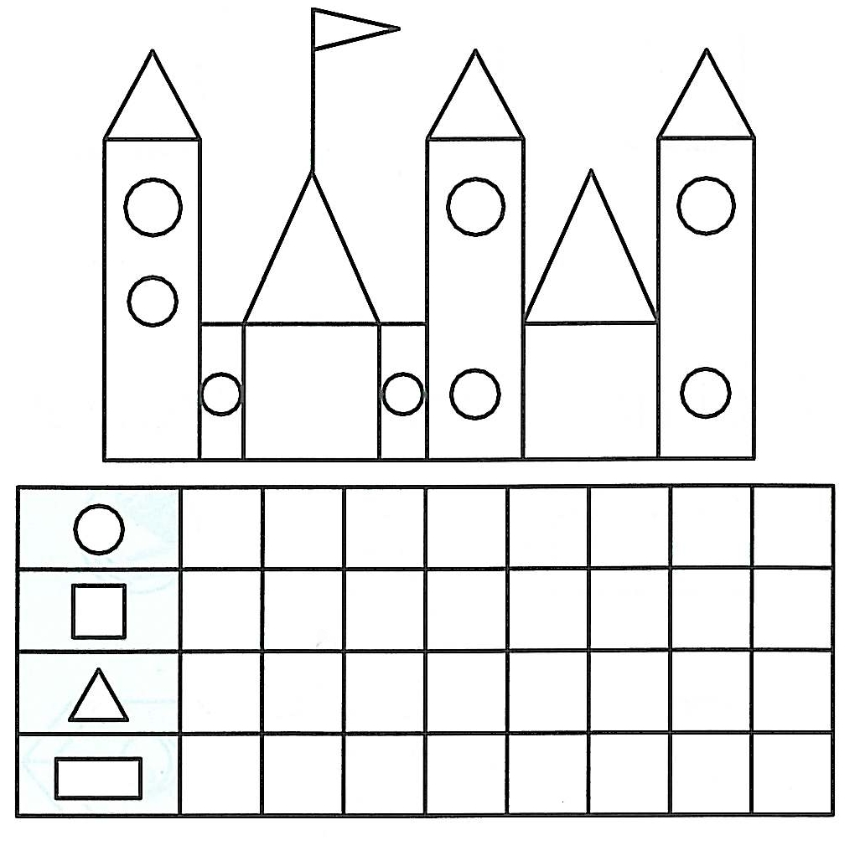

Create your *Castle shape graph* by:

1. Counting the number of shapes in the picture.
2. Colouring in the number of squares beside the appropriate shape, using a different colour for each shape.