Maths

Numbers to 5 and Positional Language

EN00892_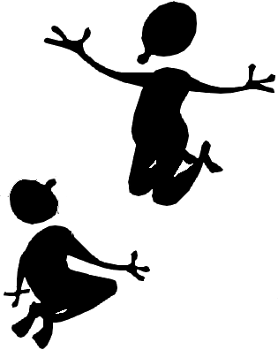

**Copyright**

*The Department of Education and Training (DET) encourages the dissemination and re-use of information provided in this document.*

Material on this website is provided under a Creative Commons Attribution 4.0 international licence, with the exception of:

* any images, photographs, trademarks or branding, including the Victorian Government logo and the DET logo; and
* content supplied by third parties.



For licence conditions, see: [Creative Commons Attribution 4.0 international licence](http://creativecommons.org/licenses/by/4.0/)

**Attribution**

Material to be attributed as:

© State of Victoria (Department of Education and Training)

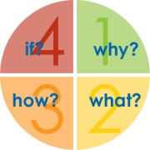

###### Learning Intentions

**Number**

Recognises numerals 0–5

Counts objects and matches them to a numeral

**Space**

Understands positional language in order to complete a picture

Uses everyday location language, including explaining where an object is, and follow simple directions to objects.

Note: Activity sheets are numbered and provided at the back of this resource

**Task 1**

###### Step 1

Revise a number of counting rhymes. See Activity sheets 13-23

Use the number cards to show your child the numeral 4.  
Ask your child to clap the number of times shown on the card.

Repeat for the other numerals 1 to 5, asking him or her to jump, hop, turn around, touch objects, etc. for each numeral.

Repeat the activity, using the number word cards.

###### Step 2

Ask your child to: walk across the room.

put his or her hand across the table.

put a matchstick across a box.

lie across a cushion, etc.

Ask your child to walk around the room.

hop around a table.

make a play dough sausage to fit around a block.

write his or her name and draw around it.

make a circle of blocks around a toy, etc.

###### Step 3

Give your child five blocks. Ask him or her to give you the blocks in different ways, e.g. one and one and one and one and one, or two and three, or one and four, etc.

Use Activity sheet 1.

To complete the worksheet, your child has to colour, then cut out, the flowers and paste the correct number next to each numeral.

###### math2Task 2

###### Step 1

Revise the counting rhyme *The Beehive*  See Activity sheet 17

Ask your child to put out 10 buttons, 10 sticks, 10 pieces of pasta, 10 counters, etc.

Using toy animals (or draw pictures) ask,

*How many legs on two cows?*

*one cow and one horse?*

*one cow and one person?*

*three people?*

*two people and one cow?*

*two cows and a hen?*

###### Step 2

Revise the terms *over* and *past*, in much the same way as you did for *across* and *around* in Task 1. Ask your child to crawl *over* the cushion, climb *over* the chair, go *over* the fence, etc., and go *past* the back door, walk *past* the bathroom, move the toy car *past* the chair etc.

###### Step 3

Watch the second hand move around an analogue clock once.

Can your child walk around the house, room, caravan, etc. in one minute?

How many lentils can your child put, one by one, in a cup in one minute?

How many can your child take out, one by one, in one minute?

How many lids can your child screw on a jar in one minute?

How many can your child take off?

###### Step 4

Ask your child to make a movement pattern, e.g. hands up in the air, down by the side and jump twice, hands up in the air, etc.

Can you tell what the pattern is?

You create a movement pattern.

Can your child tell what it is?

Can your child tell you what the number pattern is when counting by 2s?

|  |
| --- |
| j0269188[1] j0269188[1]j0269188[1]j0269188[1]j0269188[1]j0269188[1]j0269188[1]j0269188[1] |

###### math2Task 3

###### Step 1

Revise the counting rhyme *Ten in the Bed*. See Activity sheet 15

Ask your child to count to 20, or further if able.

From a handful of blocks, ask your child to show you seven blocks, three blocks, nine blocks, two blocks.

**Step 2**

Revise the number pattern for five (5 0 5 0).

Help your child count by fives to 30, using the bead frame if you have one.

Show your child the five-minute intervals on an analogue clock. Explain how we count by fives to 30 when we are telling the time, so that when the minute hand is on the numeral 1, it is five minutes past o’clock. The aim is to show that there are occasions when we need to be able to count by fives. It is not to teach your child how to tell the time at this stage.

**Step 3**

Revise the terms *over* and *past*, and *across* and *around.*

Introduce the term *through*. Ask your child to walk *through* the doorway, climb *through* the legs of a chair, squeeze *through* a tight space, let some water run *through* a sieve, etc.

Introduce the term *under.* Ask your child to crawl *under* a chair, sit *under* the table, put a sheet of paper *under* a box, put one hand *under* the tap, put a toy *under* the newspapers, etc.

**Step 4**

Use Activity sheet 24

Ask your child to order the number word and numeral cards one to five.

**Step 5**

Use Activity sheet 2**.**

Ask your child to complete the worksheet, which revises the numerals and number words 1 to 5.

|  |  |
| --- | --- |
|  |  |

###### math2Task 4

###### Step 1

Revise some counting rhymes. See Activity sheets 13-23

Ask your child to count to 20, jumping as he or she does so.

Clap 9 times. Ask your child to count the claps.

Vary the activities and repeat for different numbers (up to 10).

###### Step 2

**Talk about the number 6.**

Insects have six legs.

Six is half a dozen.

There are six sides on a cube.

There are six sides on a rectangular box.

A hit over the boundary in cricket scores six runs.

6 comes before 7.

6 comes after 5.

Use Activity sheet 3.

Show your child the numeral 6 on the cards. Flash the number cards in front of your child.

Ask your child to put “hands on head” when he or she sees the numeral for 6, etc.

**Step 3**

Use the Activity Sheet 4.

To complete the worksheet, he or she has to colour the sets of 6.

###### Step 4

Give your child considerable time to build with blocks and/or manipulative materials. Give him or her some restrictions, e.g.

Say: *Make sure there are three tall towers in your building.*

*Can you make a bridge that you can drive your toy pram under?*

*Can you make a building that is as tall as the seat on the chair?*

*Build a city with seven buildings.*

*Can you make a road as long as you?*

###### math2Task 5

###### Step 1

Count to 20. Accompany the counting with clapping, tapping, jumping.

Count out any number of objects up to 10, e.g. legs on two cows, shoes on four people, saucepans on the shelf, etc.

**Step 2**

###### Use Activity sheet 3

###### Revise the numeral, and introduce the number word for 6.

Can your child find the numeral amongst the other cards (1-6)?

Can your child order the numeral and number word cards?

Can your child match them up?

**Step 3**

Use Activity sheets 25-30

Create the book *Charlie’s Early Morning Walk*.

Read the story

Ask: *Do you think Charlie walked around the farmyard in one minute?*

*How long do you think it took him? Why?*

Talk about where and how Charlie walked.

Revise: ***across, around, over, past, through,*** and ***under*.**

Can your child take a walk at your place in a similar way? Discuss his or her options. For instance, your child could walk *across* the veranda, *around* a tree, *over* the path, etc.

Go outside and do it. How long did it take your child to do his walk?

###### Step 4

Plan a new book describing your child’s walk. Use your child’s name in the story, if you like. Use the same maths vocabulary as in *Charlie’s Early Morning Walk*.

For example:

**Billy the boy went for a walk**

**across the veranda**

**around a tree**

**over the path**

**past the garage**

**through the gate**

**under the clothes line**

**and got back in time for lunch.**

Write one phrase per page.

Ask your child to illustrate each page, or take photographs to illustrate the pages.

Add covers, title, (*Billy’s Walk*) and staple the book together.

Can your child read this new book?

.

**Task 6**

###### Step 1

Revise the counting rhymes *Ten Fingers* and *One, Two Buckle my Shoe*. See Activity sheets 13 and 22

Clap 6 times, and ask your child to make that many play dough balls.

Repeat for other numbers, chosen from 1 to 10.

**Step 2**

###### Use Activity sheet 5.

###### To complete the worksheet, your child has to draw extra objects so that the total number of pictures in each line matches the numeral at the beginning of the line.

###### Step 3

###### Read the book your child made about his or her walk to revise the terms *around*, *past, through, over, under* and *across*.

###### Ask him or her to walk *around* the chair, climb *over* the lounge, crawl *under* the table, and walk *across* the room back to where he or she started.

###### Ask him or her to push a toy car *around* the table, *across* a book, *through* the pencil tins, over the ruler, etc., until all these terms have been revised.

###### Step 4

###### Look at a square block.

###### Count its sides.

###### Explain that this shape is called a *cube*.

###### How many other *cubes* can you find in the house (boxes, dice, containers, etc.)?

###### Do they all have six sides?

###### Are the sides all the same shape?

###### Step 5

Play a game that requires a die. You may choose Ludo or Snakes and Ladders, but use any game your family enjoys. If you don’t have either of these games, use Activity sheet 6 and cut out the teddy bear pieces from the worksheet and play the game *Teddy Bears*.

You will need:

2 players

1 die

teddy bear pieces (from worksheet)

|  |  |
| --- | --- |
| Take turns to have one throw of the dice.  You must throw a 6 to start with the body.  Join on other body parts, according to the number rolled.  The first person with a completed teddy is the winner. |  |

###### math2Task 7

###### Step 1

Ask your child to use objects around the house to count to 20, or further if able.

Count by 5s and 2s to 20, encouraging your child to join in.

Clap several times, and ask your child to continue the count by jumping to 10. Repeat several times, stopping the clap at a different number each time.

Put a different number of pasta pieces (from 5 to 10) in one side of an egg carton. Ask your child to put the same number of pieces to match in the opposite side.

###### Step 2

Read *Charlie’s Early Morning Walk*.

Use Activity sheet 7.

Discuss the worksheet. Your child is to draw a *snail trail*, on the page, according to what you say.

Say: *Sammy Snail was on his way home after visiting his friend Silver. He slid slowly around the tree, over the stone, under the bush, across the seat, through the long grass, past the flower bed, and into his own little house.*

Write the words *around, over, under,* etc. next to the appropriate place on the worksheet. Display the worksheet.

|  |  |
| --- | --- |
| *AN00789_* |  |

###### Step 3 Constructing a cube

Use Activity sheet 8.

Look at the outline on the worksheet.

Ask your child to count the number of squares.

What does your think it will make? Revise the term **cube**.

Draw one dot on one face, two dots on another, three on the next, etc. to six.

Cut out and tape the edges together to make a cube.

**Step 4 Chance and data activity**

Using this large die, ask your child how many times he or she thinks the die can roll a 6 out of 10 turns.

How many times does he or she think **you** can roll a 6 out of 20 turns?

Does your child have a reason for his or her answer?

How do the results compare to the prior estimations and to each other?

Ask your child to draw a picture about this activity, and to dictate a story to you about the work. Write it below the picture.

|  |  |
| --- | --- |
| EN00892_ |  |

|  |  |
| --- | --- |
| Task 8 | **math2** |

###### Step 1

* Revise the counting rhymes *Five little Ladies* and *The Squirrel.* See Activity sheets 19 and 22
* Ask your child to count to 20 or beyond, tapping on the table top as he or she  
  does so.
* Clap to 7, ask your child to continue to 20. Repeat, asking him or her to continue the count from different numbers each time.

###### Step 2

* Put out some knives and forks and ask your child to make a pattern.
* Can he or she tell you about it?
* You make a pattern using pasta, icy-pole sticks, buttons, lids, etc.  
  Make a mistake in the pattern. Can he or she tell you where the mistake is?   
  Can he or she correct the mistake?

###### Step 3

* Ask your child to close his or her eyes. Take his or her hand and to help draw the numeral 4 on the table. Ask him or her to jump that many times.
* Repeat for each of the other numerals 1 to 6.

**Step 4**

Use Activity sheets 3 and 24

* Show your child the number word cards one to six. Is he or she able to put them in order? Is he or she able to match them to their numeral card?

**Step 4**

* Use Activity sheet 9.
* Introduce the worksheet  **6 six legs**
* To complete the page, your child is to use coloured scrap paper to fill in the numeral, then illustrate the page by colouring the ant and pasting on six legs.

###### math2Task 9

###### Step 1

* Revise the song *Can You Walk on Two Legs?* See Activity sheet 18
* Use Activity sheet 10.
* Show your child the worksheet.
* Ask: *How many legs, on all the children?*

*How many girls shoes?*

*How many boys shoes?*

*How many skirts?*

*How many caps?*

*How many legs altogether*?

###### Encourage your child to count by 2s where appropriate.

|  |  |
| --- | --- |
| Step 2 Talk about *before* and *after* in relation to time.  Ask: *What do you do before you have breakfast?*  *What do you do after you have breakfast?*  Check the list you made some time ago. Is it still relevant?  Explain that it takes three minutes to boil an egg. Some people use an egg timer to do this. Use your egg timer and check it with an analogue clock. Does it run out in three minutes? Sometime today, cook an egg, timing it with the egg timer. | BS00989_ |

###### Step 3

Use Activity sheets 3 and 24

* Show the number cards 1 to 6.
* Say: *Stand up when you see the number 6.*
* Sit down when you see the number word 6
* Can your child order the cards?

**Step 4**

Use Activity sheet 11.

* Complete the worksheet by drawing, colouring, and writing the numeral.

###### math2Task 10

###### Step 1

Revise a number of counting rhymes. See Activity sheets 13-23

Ask your child to count in his or her head as you bounce a ball. How many bounces?

Repeat for different numbers between 1 and 20.

Ask: *What is the number before 6, after 3, before 4,two after 3,* etc.

Use Activity sheet 12.

Draw the same number of dots to match each picture on the worksheet.

###### Step 2

Look at the patterns on Activity sheet 12.

Can your child tell you about them?

Can he or she tell you the mistake in each pattern?

He or she is to circle the mistake in each pattern.

###### Step 3

Use play dough to make:

the numeral 6.

6 bowls, 6 apples, 6 sausages, etc.

something big and something little.

a plate with a pattern around the edge.

**Step 4**

Use Activity sheets 6 and 8

Play a game of Teddy Bear.

EN00892_

**Activity Pages**

Description: EN00892_

**Maths Activity Sheet 1**

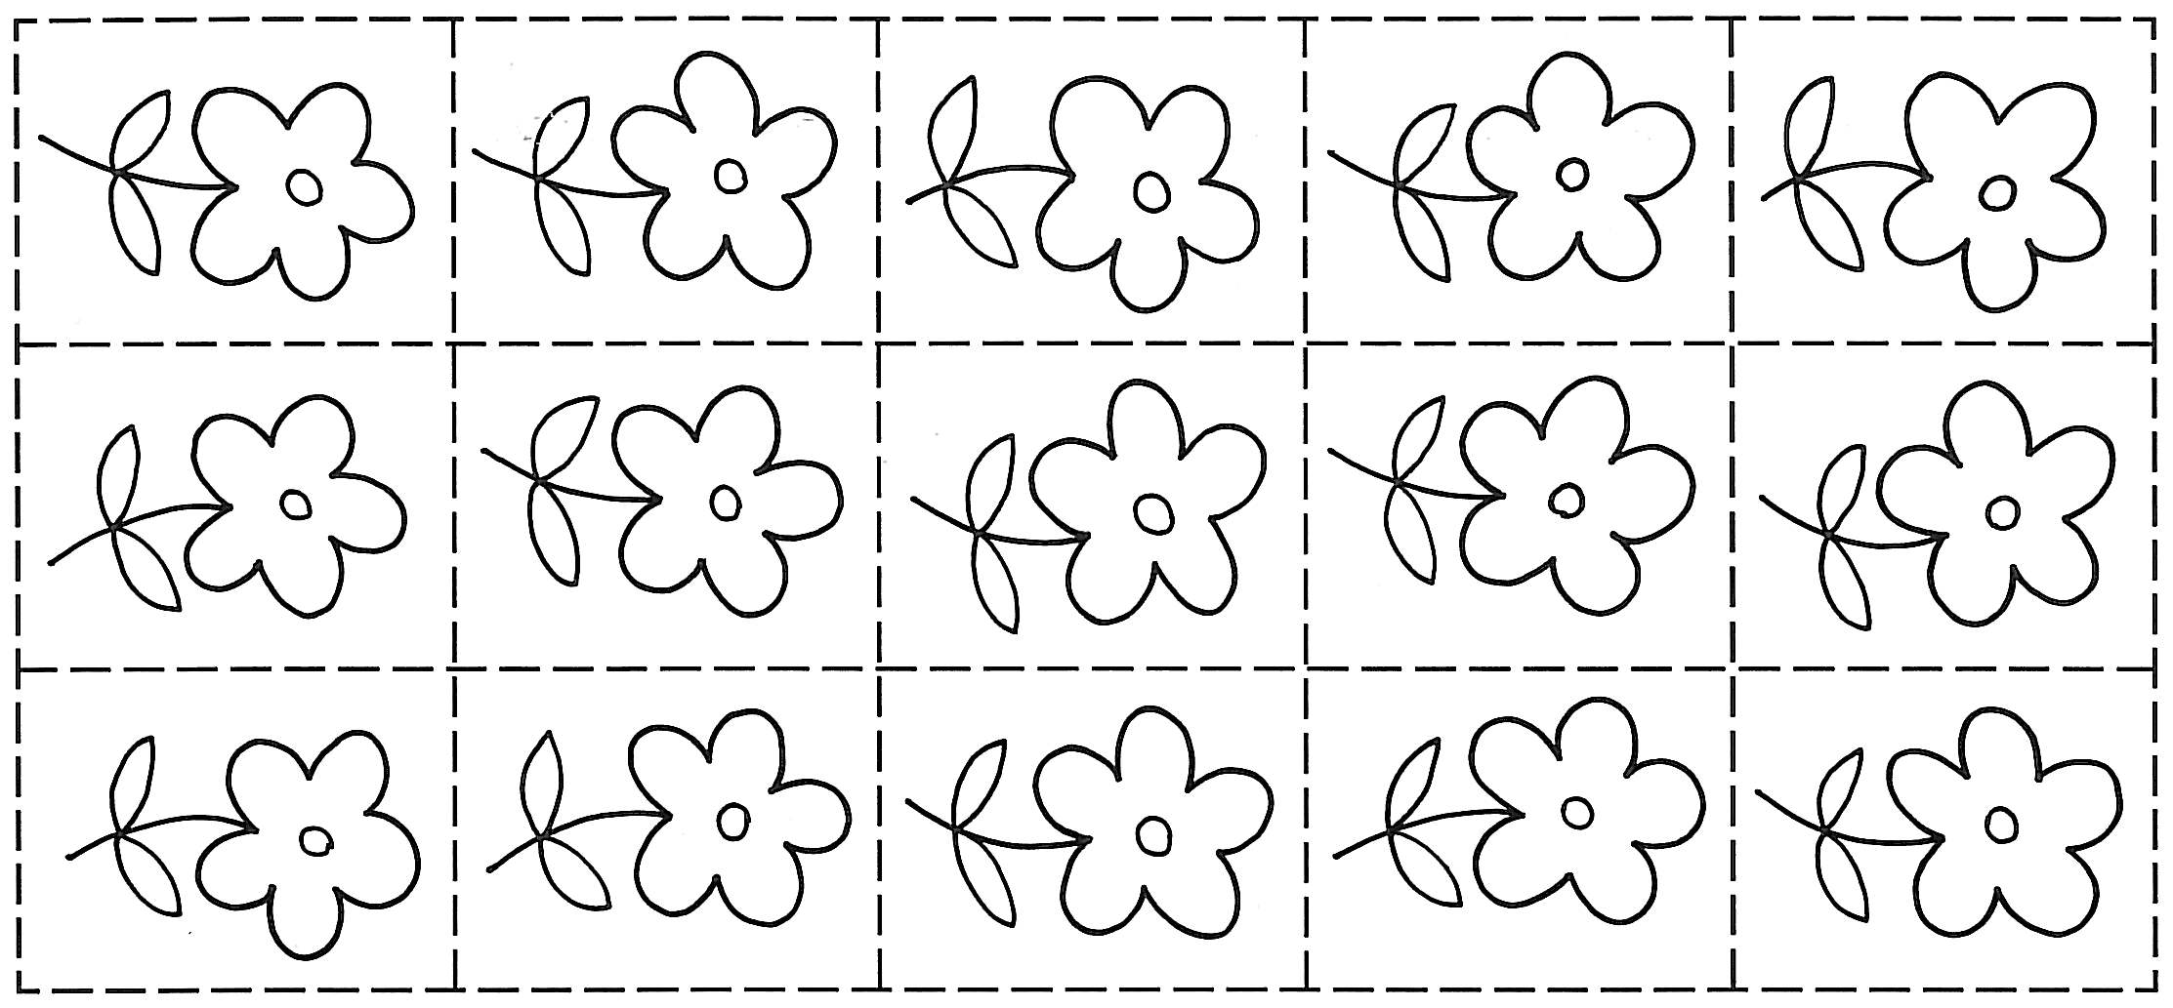

**5**

**4**

**3**

**2**

**1**

**Maths Activity Sheet 2**

|  |
| --- |
| Trace over the numerals, then link each one to a group of snakes.  1 2 3 4 5 |

|  |  |  |
| --- | --- | --- |
| Trace over the numerals and numbers in words, then link the words to the matching numerals.  five 4  three 2  two 3  four 1  one 5 |  | Draw 5 balloons |

**Maths Activity Sheet 3**

|  |  |  |
| --- | --- | --- |
| **ten** | **seven** | **six** |
| **6** | **nine** | **eight** |
| **7** |
| **10** | **9** | **8** |

**Maths Activity Sheet 4**

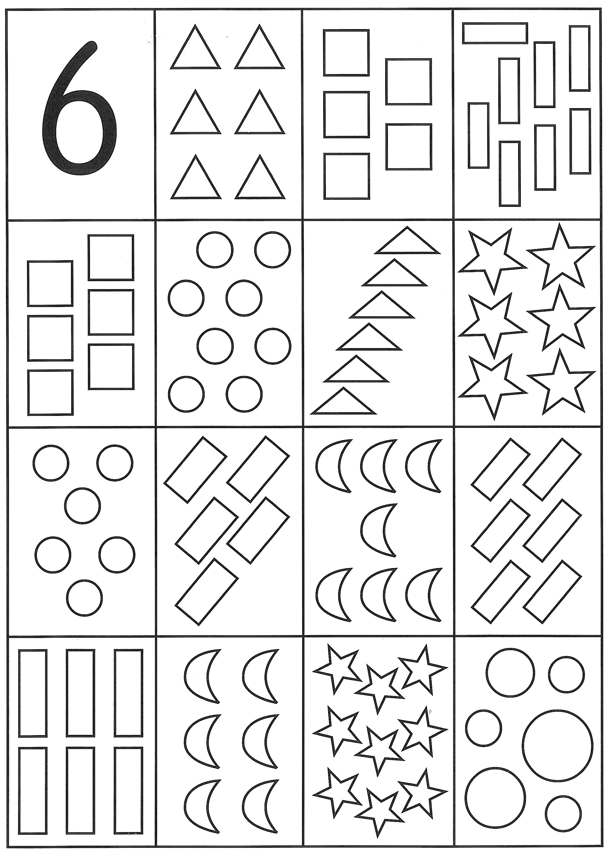

**Maths Activity Sheet 5**

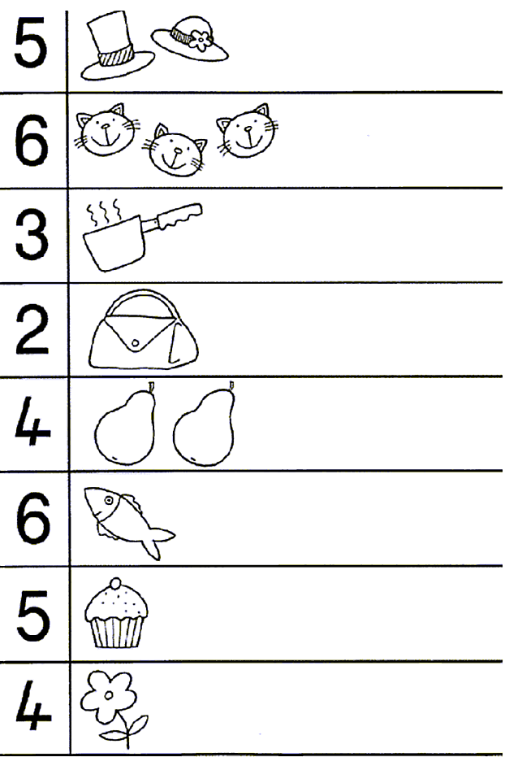

**Maths Activity Sheet 6**

|  |
| --- |
|  |

**Maths Activity Sheet 7**

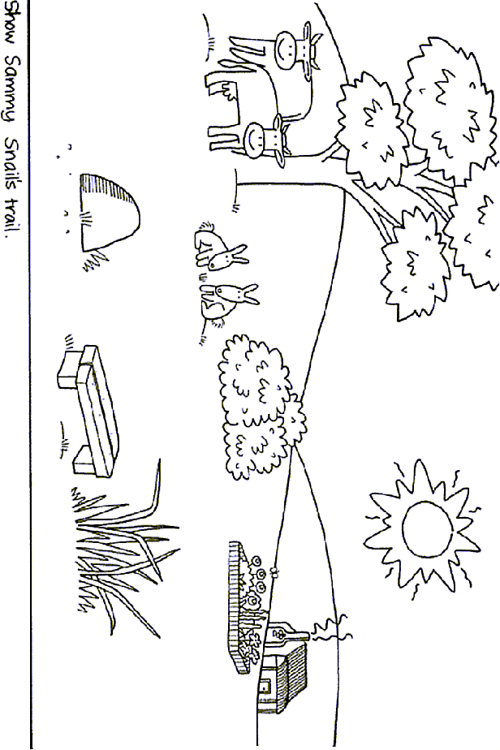

**Maths Activity Sheet 8**

|  |
| --- |
| Draw 1 dot on one face, 2 dots on another, up to 6.  Cut on solid lines.  Fold on broken lines.  Tape cube together. |

**Maths Activity Sheet 9**

|  |
| --- |
|  |
| six legs |

**Maths Activity Sheet 10**

|  |
| --- |
| Count by 1s.  Count by 2s.    How many faces?  How many hats?  How many girls’ shoes?  How many boys’ shoes?  How many T-shirts?  How many skirts?  How many legs altogether? |
| **Maths Activity Sheet 11** |

**Maths Activity Sheet 12**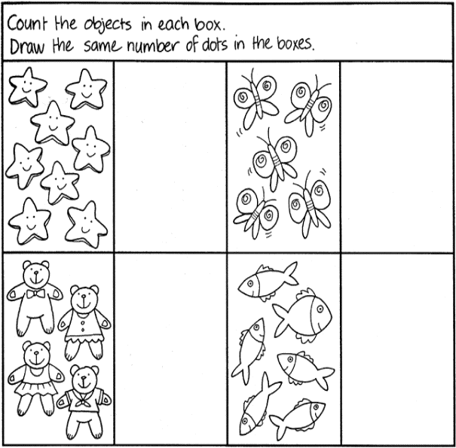

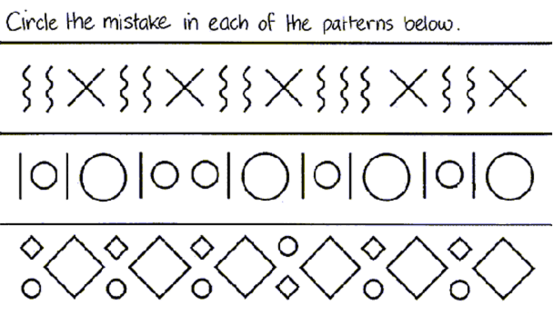

**Maths Activity Sheet 13**

**One, two, buckle my shoe**

One, two, buckle my shoe  
Three, four, shut the door  
Five, six, pick up sticks  
Seven, eight, lay them straight  
Nine, ten, begin again

Okay everybody, one more time

One, two, buckle my shoe  
Three, four, shut the door  
Five, six, pick up sticks  
Seven, eight, lay them straight  
Nine, ten, that's the end

That's the end

**1, 2, 3, 4, 5, Once I Caught a Fish Alive**

One, Two, Three, Four, Five,

Once I caught a fish alive,

Six, Seven, Eight, Nine, Ten,

Then I threw him back again.

Why did you let him go?

Because he bit my finger so.

Which finger did he bite?

This little finger on my right.

**Maths Activity Sheet 14**

Tic, Tac, Toe

Tic, tac, toe, here I go.

Where I land I do not know.

To play the game Tic, Tac, Toe choose a topic sheet of mixed symbols and images

Your child taps each picture in turn, as you say the rhyme together

He or she stops at the picture when the rhyme finishes. He or she counts the objects in that particular picture or names the image, then the rhyme begins again.

**Maths Activity Sheet 15**

**Ten in the Bed**

There were ten in the bed and the Little One said,

“Roll over! Roll over!”

So they all rolled over and one fell out.

There were nine in the bed and the little one said,

“Roll over! Roll over!”

So they all rolled over and one fell out.

There were eight in the bed and the little one said,

“Roll over! Roll over!”

So they all rolled over and one fell out.

There were seven in the bed and the little one said,

“Roll over! Roll over!”

So they all rolled over and one fell out.

There were six in the bed and the little one said,

“Roll over! Roll over!”

So they all rolled over and one fell out.

There were five in the bed and the little one said,

“Roll over! Roll over!”

So they all rolled over and one fell out.

There were four in the bed and the little one said,

“Roll over! Roll over!”

So they all rolled over and one fell out.

There were three in the bed and the little one said,

“Roll over! Roll over!”

So they all rolled over and one fell out.

There were two in the bed and the little one said,

“Roll over! Roll over!”

So they all rolled over and one fell out.

There was one in the bed and the little one said,

“I’m lonely! I’m lonely!”

So they all climbed back in

**Maths Activity Sheet 16**

Two Little Kittens

Two little kittens, one stormy night,  
Began to quarrel, and then to fight;  
One had a mouse and the other had none,  
And that's the way the quarrel begun.  
  
"I'll have that mouse," said the biggest cat,  
"You'll have that mouse? We'll see about that!"  
"I will have that mouse," said the eldest son;  
"You shan't have that mouse," said the little one.  
  
I told you before 't was a stormy night  
When these two little kittens began to fight;  
The old woman seized her sweeping broom,  
And swept the two kittens right out of the room.  
  
The ground was covered with frost and snow,  
And the two little kittens had nowhere to go.  
So they laid them down on the mat at the door  
While the old woman finished sweeping the floor.  
  
Then they crept in, as quiet as mice,  
All wet with snow and as cold as ice;  
For they found it was better, that stormy night,  
To lie down and sleep than to quarrel and fight.

**Maths Activity Sheet 17**

The beehive

Here is the beehive.  
But where are all the bees?  
Hiding away where nobody sees.  
Here they come flying out of their hive.  
One, two, three, four, five!

Here is the beehive.  
But where are all the bees?  
Hiding away where nobody sees.  
Here they come flying out of their hive.  
One, two, three, four, five!

Buzz up high. Buzz down low.  
Buzzing fast. Buzzing slow.  
Buzz to the left. Buzz to the right.  
Buzz all day but sleep at night.

Here is the beehive.  
But where are all the bees?  
Hiding away where nobody sees.  
Here they come flying out of their hive.  
One, two, three, four, five!

Two Little Eyes

Two little eyes to look around.  
Two little ears to hear each sound.  
  
One little nose to smell what's sweet.  
One little mouth that likes to eat.

**Maths Activity Sheet 18**

Can you Walk on Two Legs?

Can you walk on two legs, two legs, two legs?

Can you walk on two legs,

Round and round and round?

I can walk on two legs, two legs, two legs,

I can walk on two legs,

Round and round and round.

Can you hop on one leg, one leg, one leg?

Can you hop on one leg,

Round and round and round?

I can hop on one leg, one leg, one leg,

I can hop on one leg,

Round and round and round.

Can you wave with one hand, one hand, one hand?

Can you wave with one hand,

Round and round and round?

I can wave with one hand, one hand, one hand,

I can wave with one hand,

Round and round and round.

Can you wave with two hands, two hands, two hands?

Can you wave with two hands,

Round and round and round?

I can wave with two hands, two hands, two hands,

I can wave with two hands,

Round and round and round.

**Maths Activity Sheet 19**

Mary at the Cottage Gate

One, two, three, four

Mary at the cottage door

Two, four, six, eight

Mary at the garden gate

The Squirrel

Five little squirrels, sitting by the door

One ran away and then there were four

Four little squirrels, climbing up a tree

One ran down and that left three

The little squirrels, with coats so new

One got dirty and then there were two

Two little squirrels sitting in the sun

One got sun burnt and that left one

**Maths Activity Sheet 20**

Goldilocks

When Goldilocks went to the house of the bears,

Oh what did her blue eyes see?

A bowl that was huge,

A bowl that was small,

A bowl that was tiny and that was all,

She counted them one, two, three.

When Goldilocks went to the house of the bears,

Oh what did her blue eyes see?

A chair that was huge,

A chair that was small,

A chair that was tiny and that was all,

She counted them one, two, three.

When Goldilocks went to the house of the bears,

Oh what did her blue eyes see?

A bed that was huge,

A bed that was small,

A bed that was tiny and that was all,

She counted them one, two, three.

When Goldilocks went to the house of the bears,

Oh what did her blue eyes see?

A bear that was huge,

A bear that was small,

A bear that was tiny and that was all,

They growled at her “Grrrrr! Grrr! Grr!”

**Maths Activity Sheet 21**

Three Little Kittens

The three little kittens, they lost their mittens,

And they began to cry,

"Oh, mother dear, we sadly fear,

That we have lost our mittens."

"What!   Lost your mittens, you naughty kittens!

Then you shall have no pie."

"Meow, meow, meow."

"Then you shall have no pie."

The three little kittens, they found their mittens,

And they began to cry,

"Oh, mother dear, see here, see here,

For we have found our mittens."

"Put on your mittens, you silly kittens,

And you shall have some pie."

"Purr, purr, purr,

Oh, let us have some pie."

The three little kittens put on their mittens,

And soon ate up the pie,

"Oh, mother dear, we greatly fear,

That we have soiled our mittens."

"What, soiled your mittens, you naughty kittens!"

Then they began to sigh,

"Meow, meow, meow,"

Then they began to sigh.

The three little kittens, they washed their mittens,

And hung them out to dry,

"Oh, mother dear, do you not hear,

That we have washed our mittens?"

"What, washed your mittens, then you're good kittens,

But I smell a rat close by."

"Meow, meow, meow,

We smell a rat close by."

**Maths Activity Sheet 22**

Ten Fingers

I have ten little fingers and they all belong to me.  
I can make them do things, would you like to see?  
I can shut them up tight, I can open them wide.  
I can put them together, I can make them hide.  
I can make them jump high, I can make them jump low.  
I can rolly, rolly, them around and fold them just so.

Five Little Ladies

Five little ladies going for a walk.   
Five little ladies stopping for a talk.  
Along came five little gentlemen,  
And they all danced together and that makes 10!

Five Little Soldiers

Five little Soldiers stand in a row,  
Four stand up straight and one bends low.  
Along came the Seargent and what do you think?  
Up pops the Soldier, as quick as a wink.

**Maths Activity Sheet 23**

Ten Little Fish

One little fishy swimming in the sea.  
Along came another one, and then there were two.

Two little fishies swimming in the sea.  
Along came another one, and then there were three.

Three little fishies swimming in the sea.  
Along came another one, and then there were four.

Swimming swimming swimming in the sea.  
That big ol’ shark will never catch me.

Four little fishies swimming in the sea.  
Along came another one, and then there were five.

Five little fishies swimming in the sea.  
Along came another one, and then there were six.

Six little fishies swimming in the sea.  
Along came another one, and then there were seven

Swimming swimming swimming in the sea.  
That big ol’ shark will never catch me.

Seven little fishies swimming in the sea.  
Along came another one, and then there were eight.

Eight little fishies swimming in the sea.  
Along came another one, and then there were nine.

Nine little fishies swimming in the sea.  
Along came another one, and then there were ten.

Swimming swimming swimming in the sea.  
That big ol’ shark will never catch me.

Swimming swimming swimming in the sea.  
That big ol’ shark will never catch me.

Swimming swimming swimming in the sea.  
That big ol’ shark will never catch me.

He’ll never,  
Never,  
Never,  
Never,  
That big old shark will never catch me!

Maths Activity Sheet 24

|  |  |  |  |
| --- | --- | --- | --- |
| **three** |  | **two** | **one** |
| **4** | **3** | **five** | **four** |
| **5** |  | **2** | **1** |

**Maths Activity Sheet 25**

|  |  |
| --- | --- |
| image001  image003  Written by Gayle  \_\_ \_\_ \_\_ \_\_ \_\_ \_\_ \_\_ \_\_ \_\_ \_\_ \_\_ \_\_ \_\_ \_\_ \_\_ \_\_ \_   |  | | --- | | 1 |   Charlie the farm cat woke up and stretched.  image007image005 |

**Maths Activity Sheet 26**

|  |
| --- |
| 2 |
| Charlie decided to go for a walk.  image009  image007  He climbed out of his basket.  \_\_ \_\_ \_\_ \_\_ \_\_ \_\_ \_\_ \_\_ \_\_ \_\_ \_\_ \_\_ \_\_ \_\_ \_\_ \_\_ \_   |  | | --- | | 3 |   image012image014  He went through the door |
| 4 |
| **Maths Activity Sheet 27**  image016  and out into the yard.  \_\_ \_\_ \_\_ \_\_ \_\_ \_\_ \_\_ \_\_ \_\_ \_\_ \_\_ \_\_ \_\_ \_\_ \_\_ \_\_ \_   |  | | --- | | 5 |   Charlie went across the yard  image025image025image025image025image025image018image025 |
| 6 |
| and over the farm-yard fence.  **Maths Activity Sheet 28**  image027image029  \_\_ \_\_ \_\_ \_\_ \_\_ \_\_ \_\_ \_\_ \_\_ \_\_ \_\_ \_\_ \_\_ \_\_ \_\_ \_\_ \_ |
| 7 |
| He went around the duck pond,  image032image030image034image034 |
| 8 |
| through the mud,  **Maths Activity Sheet 29**  image037  \_\_ \_\_ \_\_ \_\_ \_\_ \_\_ \_\_ \_\_ \_\_ \_\_ \_\_ \_\_ \_\_ \_\_ \_\_ \_\_ \_ |
| 9 |
| behind the barn  image040 |
| 10 |
| **Maths Activity Sheet 30**  and got back home in time for breakfast.  image042  \_\_ \_\_ \_\_ \_\_ \_\_ \_\_ \_\_ \_\_ \_\_ \_\_ \_\_ \_\_ \_\_ \_\_ \_\_ \_\_ \_  image043 |