Maths

Counting up to 5 Objects and Using Time Language

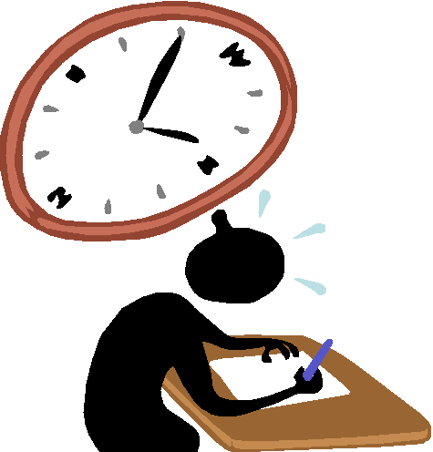

**Copyright**

*The Department of Education and Training (DET) encourages the dissemination and re-use of information provided in this document.*

Material on this website is provided under a Creative Commons Attribution 4.0 international licence, with the exception of:

* any images, photographs, trademarks or branding, including the Victorian Government logo and the DET logo; and
* content supplied by third parties.



For licence conditions, see: [Creative Commons Attribution 4.0 international licence](http://creativecommons.org/licenses/by/4.0/)

**Attribution**

Material to be attributed as:

© State of Victoria (Department of Education and Training

|  |  |
| --- | --- |
| Learning Intentions | what-is-a-learning-style_pg8 |

* Counts a collection from 0–5 using one-to-one correspondence
* Recognises names and models of numbers
* Recognises that time can be measured
* Can describe the purpose of a clock and describe at least one of its features
* Can use informal units such as heartbeats and hand claps at regular intervals to measure and describe the passage of time

Note: Activity sheets are numbered and provided at the back of this resource

###### mathTask 1

**Step 1**

Revise the number rhymes *Three Little Kittens* and *Ten Fingers*.

Introduce the rhyme *Five Little Ladies. See Activity sheets 20 and 21*

#### Step 2

Play a game of *Skittles* (use five plastic bottles or empty cartons). Count the number of skittles that are knocked over as well as the number of skittles that remain standing.

#### Step 3

Use Activity sheets 1 and 2.

Complete the worksheet, revising the numerals 1 to 4, by cutting and pasting the correct number of toadstools to match each numeral.

**Step 4**

Put out some junk materials such as bottle tops, bread tags, paper clips.

1. Ask your child to sort the materials into sets.

Can he or she tell you about the sets he or she has made?

Is he or she able to sort the material into just two sets?

Can he or she tell you about the sets that were made? For e.g. plastic/non-plastic objects

1. Use the junk material to make a pattern.

Is your child able to tell you about the pattern, and continue it?

Is he or she able to make a pattern of his or her own?

Step 5

* Use Activity sheet 3.
* Ask your child to tell you what the patterns on the worksheet are today.
* He or she is to complete each pattern.

#### Step 6

Talk about the number 5

You have five fingers on each hand.

You have five toes on each foot.

A five cent piece is our smallest coin.

There are five stars in the Southern Cross.

There are five minute intervals on an analogue clock.

There are five players in a basketball team.

5 comes after 4

5 comes before 6.

5 and 5 are ten.

Use Activity sheet 24

Show your child the numeral 5 on the cards.

Flash the numeral cards in quick succession, at your child.

Hands on head when he or she sees the numeral for 5, etc.

###### math2Task 2

**Step 1**

Use Activity sheet 24

1. Give your child the numeral cards 1 to 5, and ask him or her to put them in order from 1 to 5.
2. Give your child a number of paper clips. Ask your child to put the correct number of paper clips on each numeral card so that the clips match the numeral.

**Step 2**

1. Make up a book, and name it *Patterns*.
2. Look for household items that have patterns on them which can be pasted in the book, e.g. serviettes, pieces of fabric, sweet wrappers, wallpaper samples, wrapping paper, etc.
3. Write a brief sentence under each item in the book, e.g. *This is a floral pattern. This pattern has two blue stripes and yellow dots.*
4. Ask your child to complete Activity sheet 3. Add it to the *Patterns* book as a reminder that we can create patterns of our own.
5. Keep adding to the book as you find new patterns. Read the book often.

#### Step 3

Use Activity sheet 24

1. Introduce the number word *five* (on a card).
2. Look at it carefully and compare it to the word four. Can your child tell which word is which?

#### Step 4

Use Activity sheet 4.

1. Your child is to colour all the flowers that have five petals.

###### math2Task 3

**Step 1**

1. Revise the rhymes *Five Little Ladies* and *The Squirrel*. See Activity sheets 18 and 21
2. Clap a couple of times. Ask your child to count ‘in his or her head as you do so, then continue to clap up to ten. Repeat this several times, varying your number of claps.

**Step 2**

1. Make a movement pattern, e.g. clap your hand above your head twice then squat down once, before standing up again and clapping your hands above your head twice. Is your child able to repeat your movement pattern? Repeat for several different patterns. Ask your child to make up a pattern for you to copy.
2. Read the book *Patterns* that you created in Task 2. Add any more samples you may have found

**Step 3**

Use Activity sheet 24

Revise all the numerals and number words 1 to 5.

Muddle all the cards up.

Is your child able to put the numeral cards in order from 1 to 5?

Is he or she able to match the number words to the numerals?

Ask him or her to make the correct number of play dough balls to match the numerals.

**Step 4**

Use a clock or a watch with a second hand to show your child how one minute of time is measured.

What can your child do in a minute?

Decide on some activities he or she will try, e.g. write own name, jump, put own shoes on, etc.

Write down how many times your child thinks he or she can do the activity in one minute (estimation).

When he or she has completed each activity, write, e.g. ‘Penny can jump thirty times in one minute. His or her guess was sixty.’

Let your child illustrate his or her own work.

###### math2Task 4

**Step 1**

1. Revise some of the rhymes you have learnt See Activity pages 12-22
2. Count by two’s to ten. If need be, you say the odd numbers and let your child say the even numbers.
3. Put out counters, gumnuts or such, and ask your child to count them by twos, touching two counters each time.

**Step 2**

What can your child do in one minute today?

Is he or she able to stare without blinking for one minute?

Is he or she able to stand on one leg, with hands on his head for one minute?

How many times can he or she write the number 3 correctly in one minute?

How much of a candle burns down in one minute? (Compare an ordinary candle to a birthday cake candle.)

How much water can be collected from a dripping tap in one minute?

**Step 3**

1. Continue adding pages to the *Patterns* book. Read the book together.
2. Ask your child to make a pattern by threading coloured beads or different kinds of pasta on a string. Can he or she tell you about the pattern?
3. Ask your child to put out a circular pattern by him or herself. Can he or she tell you about the pattern?

**Step 4**

Use Activity sheet 24

Revise the numbers 1 to 5.

Ask your child to order the numeral cards.

Ask: What’s the number before 5? before 2? etc.

What’s the number after 3? after4? etc.

How many is 2 and 3 altogether?

How many is 3 and 1 altogether? etc.

#### Step 5

Use Activity sheet 5.

To complete the worksheet, your child is to write in the missing numbers.

**Task 5**

#### Step 1

1. Revise the rhymes *Five Little Ladies* and *Two Little Kittens.*
2. Introduce *Five Little Soldiers*. See Activity sheets 15 and 21
3. Use objects your child enjoys playing with to count to twenty, or further if your child is able.
4. Ask: What’s the number before 4?

What’s the number after 2? etc.

**Step 2**

1. Do you do any activities in your family at a specific time, e.g. get up, leave for work, have a meal, watch television, go to bed?

If you do, discuss this with your child.

1. Make a list showing these times, e.g.

7 o’clock: shower and dress

8 o’clock: have breakfast

12 o’clock: have lunch

5 o’clock: watch television

6 o’clock: have tea

8 o’clock: go to bed

1. Place the list in a place where your child is able to see it.

**Step 3**

Use Activity sheet 24

Show your child the number word cards one to five. Is he or she able to put them in order from one to five? Is he or she able to match them to their numeral card?

#### Step 4

* Use Activity sheet 6.

1. Introduce the worksheet *5 five fingers*
2. To complete the page, your child is to use coloured scrap paper to fill in the numeral and then illustrate the page by drawing around his hand and colouring, it, adding finger nails, knuckles, etc.
3. Display this page, along with the completed pages for one to four if you have used other booklets, or put them into a book so that they can be read and referred to often. They should be especially helpful when your child wants to know how to write particular number words.

**Step 5**

#### Give your child a number of paper squares cut from coloured paper or wrapping paper. How many different ways can he arrange and paste five squares? Is he or she able to arrange them five different ways, ten different ways, or more? Discuss these patterns, e.g. their overall shape, whether he or she has used the squares on the diagonal or as squares, etc.

#### Ask your child to paste the arrangements on paper. Some examples are below.

|  |
| --- |
|  |

###### math2Task 6

**Step 1**

Ask your child to count aloud to ten, twenty or further (if he or she is able).

Revise the rhyme *Five Little Soldiers*. See Activity sheet 21

Using either five cent coins or coloured beads on a bead frame, count by fives to fifty. Your child does not have to be able to do this, but at this stage, he or she has to know it can be done.

**Step 2**

Use Activity sheet 23

Play *Tic, Tac, Toe,* See Activity sheet 13

**Step 3**

Ask your child to use differently shaped pasta pieces to create a pattern. Is he or she able to tell you about the pattern? Can he or she make a different pattern and tell you about it? Ask your child to thread the pasta on to a string, retaining this pattern. Tie it up to make a necklace. Can your child tell you about the pattern now it is in a circle? Let your child wear the necklace and show it to other family members.

**Step 4**

Talk with your child about the things that he or she could do, or that could be done, in one minute.

Show him or her an analogue clock and explain how the second hand has to go around sixty times before one hour has passed.

Talk about what he or she will do in one hour. For example,

Say, *In one hour’s time you will have finished this work and you will have had your lunch. One hour is the same as sixty minutes and sixty minutes is a long time.*

Your child does not need to know how to tell the time at this stage.

**Step 5**

Use Activity sheet 7.

Show them the worksheet about five.

Your child is to draw 5 suns, copy the number word five, colour 5 balloons, etc.

**Task 7**

#### Step 1

1. Introduce the counting rhyme *Ten Little Fish.* See Activity sheet 22
2. Ask your child to count to twenty, clapping, jumping, hopping, etc. as he or she does so.
3. Start a count to ten and ask your child to complete it. Do this several times, getting him or her to continue on from different numbers.

#### Step 2

Make four finger-paint hand prints, or ask your child to trace around his or her hand four times. Make sure these are in a line on a long piece of paper, or cut them out and paste them in a line.

Ask your child to count the fingers on the first hand. Write the numeral 5 underneath the first hand. Continue counting the fingers on the next hand and write 10 underneath that hand. Continue in this way until you have written 5, 10, 15, 20. Read this counting pattern with your child. Explain that this is the counting pattern when you are counting by fives.

Can he or she recognise the written pattern? (5 0 5 0)

Count by fives again, this time showing five fingers on one hand spread apart, for each group of fives. Ask your child to do the same.

#### Step 3

Put out some bottles and lids. Is your child able to:

Arrange them in a pattern?

Describe the pattern?

Put them in 2 sets?

Describe the sets?

Put the bottles in order of size?

Put the lids in order of size?

#### Step 4

Read the numerals and number words for 1 to 5.

Ask: *What is one more than 4?*

*one more than 2?*

*one less than 2?*

*one more than 1?*

*two more than 3?*

*two more than 2?*

*three more than 1?* etc*.*

#### Step 5

Use Activity sheet 8

Your child is to colour the number of shapes indicated by the numeral at the beginning of each line.

###### math2Task 8

**Step 1**

1. Revise some counting rhymes, including *Ten Little Fish*.
2. Ask your child to count the number of chairs in your house, touching each one as he or she counts. Repeat this for other objects, pot plants, cushions, toys on the floor, etc.

**Step 2**

Use Activity sheet 24

1. Put out the numeral cards 1 to 5 in the wrong order.

Can your child re-order them correctly?

1. Repeat this process for the number word cards.

**Step 3**

1. Use Activity sheet 9.
2. Show your child the worksheet, and ask him to draw the correct number of teddy bears in the numbered spaces.

#### Step 4

1. Revise the pattern when counting by fives.
2. Read together the book *Patterns*, and add any new patterns you may have found.
3. Clap a pattern and ask your child to clap it back.  
   Repeat for several different patterns.

#### Step 5

Use Activity sheet 9

Ask your child to find the pattern in each line

To complete the sheet, he or she has to cut and paste the pattern piece that belongs. Ask him or her to read each pattern when he or she has finished to make sure he or she is correct.

#### Step 6

Allow your child time to play with any manipulative equipment, building blocks or jigsaws he or she may have. Encourage him or her to talk about what he or she is doing: the shape of the jigsaw piece he or she is looking for, the size and shape of the building he has made with his or blocks, etc.

###### math2Task 9

#### Step 1

Ask your child to put out five blocks, then ask him or her how many different ways he or she can give you five blocks.

Your child could, for instance, give you the blocks one by one, in which case he or she would say, ‘One and one and one and one and one’.

He or she could give you two and three, in which case he or she would say, ‘Two and three’. Continue in this way until you have been given all the blocks in at least three different ways.

**Step 2**

Talk about the things that your child could do in one minute.

How many clothes pegs can your child peg on the line in one minute?

How many cars go past your house in one minute?

How many leaves can your child pick up in one minute?

**Step 3**

Use Activity sheet 10.

Show your child the worksheet. He or she is to colour the activities that might take only a short time to do, then draw a picture of something that might take a long time to do.

**Step 4**

Read the book *Patterns* that you have created

Ask your child to make a pattern using blocks and pieces of pasta.

Can he or she tell you about the pattern?

Can your child make a circular pattern with his blocks and pasta?

Ask your child to tell you about the pattern made.

#### Step 5

Revise a number of counting rhymes. See Activity sheets 12-22

Read the number and numeral pages completed for 1 to 5.

Give your child a handful of pasta, and ask him or her to show you a set of three, a set of five, a set of four, etc.

**Step 6**

Use Activity sheet 11**.**

To complete this sheet, your child is to colour all the pictures, then circle the numeral to indicate the number of objects in each set.

**Task 10**

**Task 1**

**Before and after**

What is the number before 3? \_\_\_\_\_\_\_\_\_\_\_

What is the number after 4? \_\_\_\_\_\_\_\_\_\_\_\_

What is the number before 2? \_\_\_\_\_\_\_\_\_\_\_

What is the number after 1? \_\_\_\_\_\_\_\_\_\_\_\_

**Task 2**

Write the number for each picture.

|  |  |  |  |  |
| --- | --- | --- | --- | --- |
|  |  |  |  |  |
| j0398569[1]j0398569[1]j0398569[1]  j0398569[1]j0398569[1] | j0435448[1]j0435448[1]  j0435448[1]j0435448[1] | j0281171[1] | j0424138[1]  j0424138[1] | j0434593[1] |

**Task 3**

Draw the right number of marbles for each number.

|  |  |  |  |  |
| --- | --- | --- | --- | --- |
| **5** | **2** | **1** | **4** | **3** |
|  |  |  |  |  |

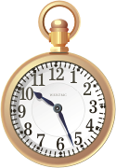**Task 4**

Show your child the picture of the clock.

Can your child tell you what a clock does?

……………………………………………………………………………

Ask your child to clap hands while you time 10 seconds

on the clock.

Could your child count the number of times clapped in

10 seconds?

……………………………………………………………………………

**Activity Pages**



**Maths Activity Sheet 1**

|  |
| --- |
| Cut and paste the right number of mushrooms in each box. |

**Maths Activity Sheet 2**

|  |  |
| --- | --- |
| **1** | **2** |
| **3** | **4** |

**Maths Activity Sheet 3**

|  |
| --- |
| image006  image008 |

**Maths Activity Sheet 4** 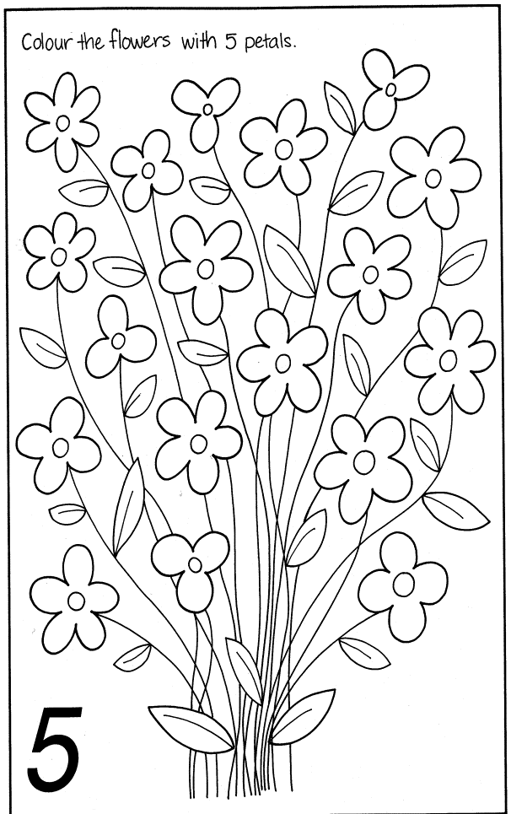

|  |
| --- |
| **Maths Activity Sheet 5**  **Write the missing numerals** |
| **1 2 3 4 5** |
| **\_ 2 \_ 4 5** |
| **5 4 3 \_ 1** |
| **1 \_ \_ 4 5** |
| **1 2 \_ \_ 5** |

|  |
| --- |
| **Maths Activity Sheet 6** |
|  |
| five fingers |

**Maths Activity Sheet 7**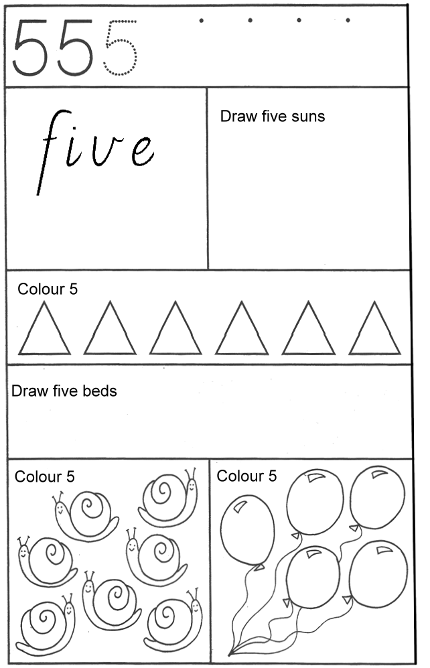

**Maths Activity Sheet 8**

**Colour the correct number**

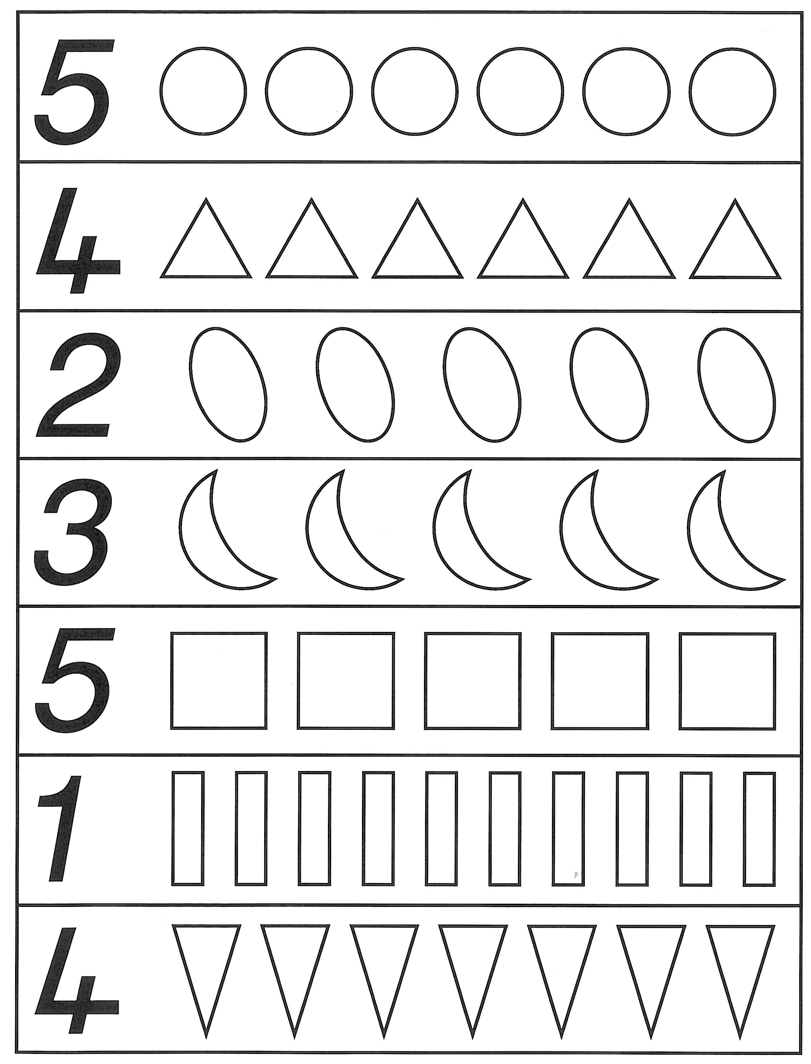

**Maths Activity Sheet 9**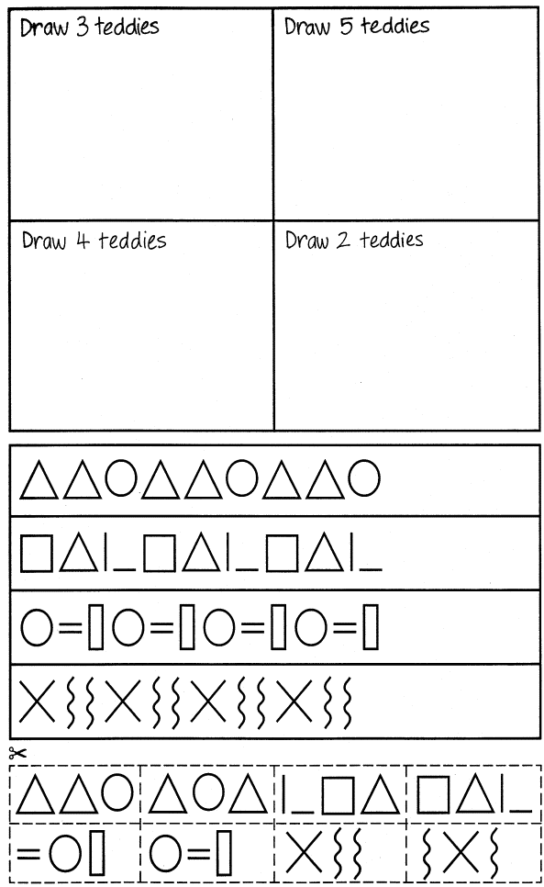

**Maths Activity Sheet 10**

Colour the pictures of activities that would take a short time.

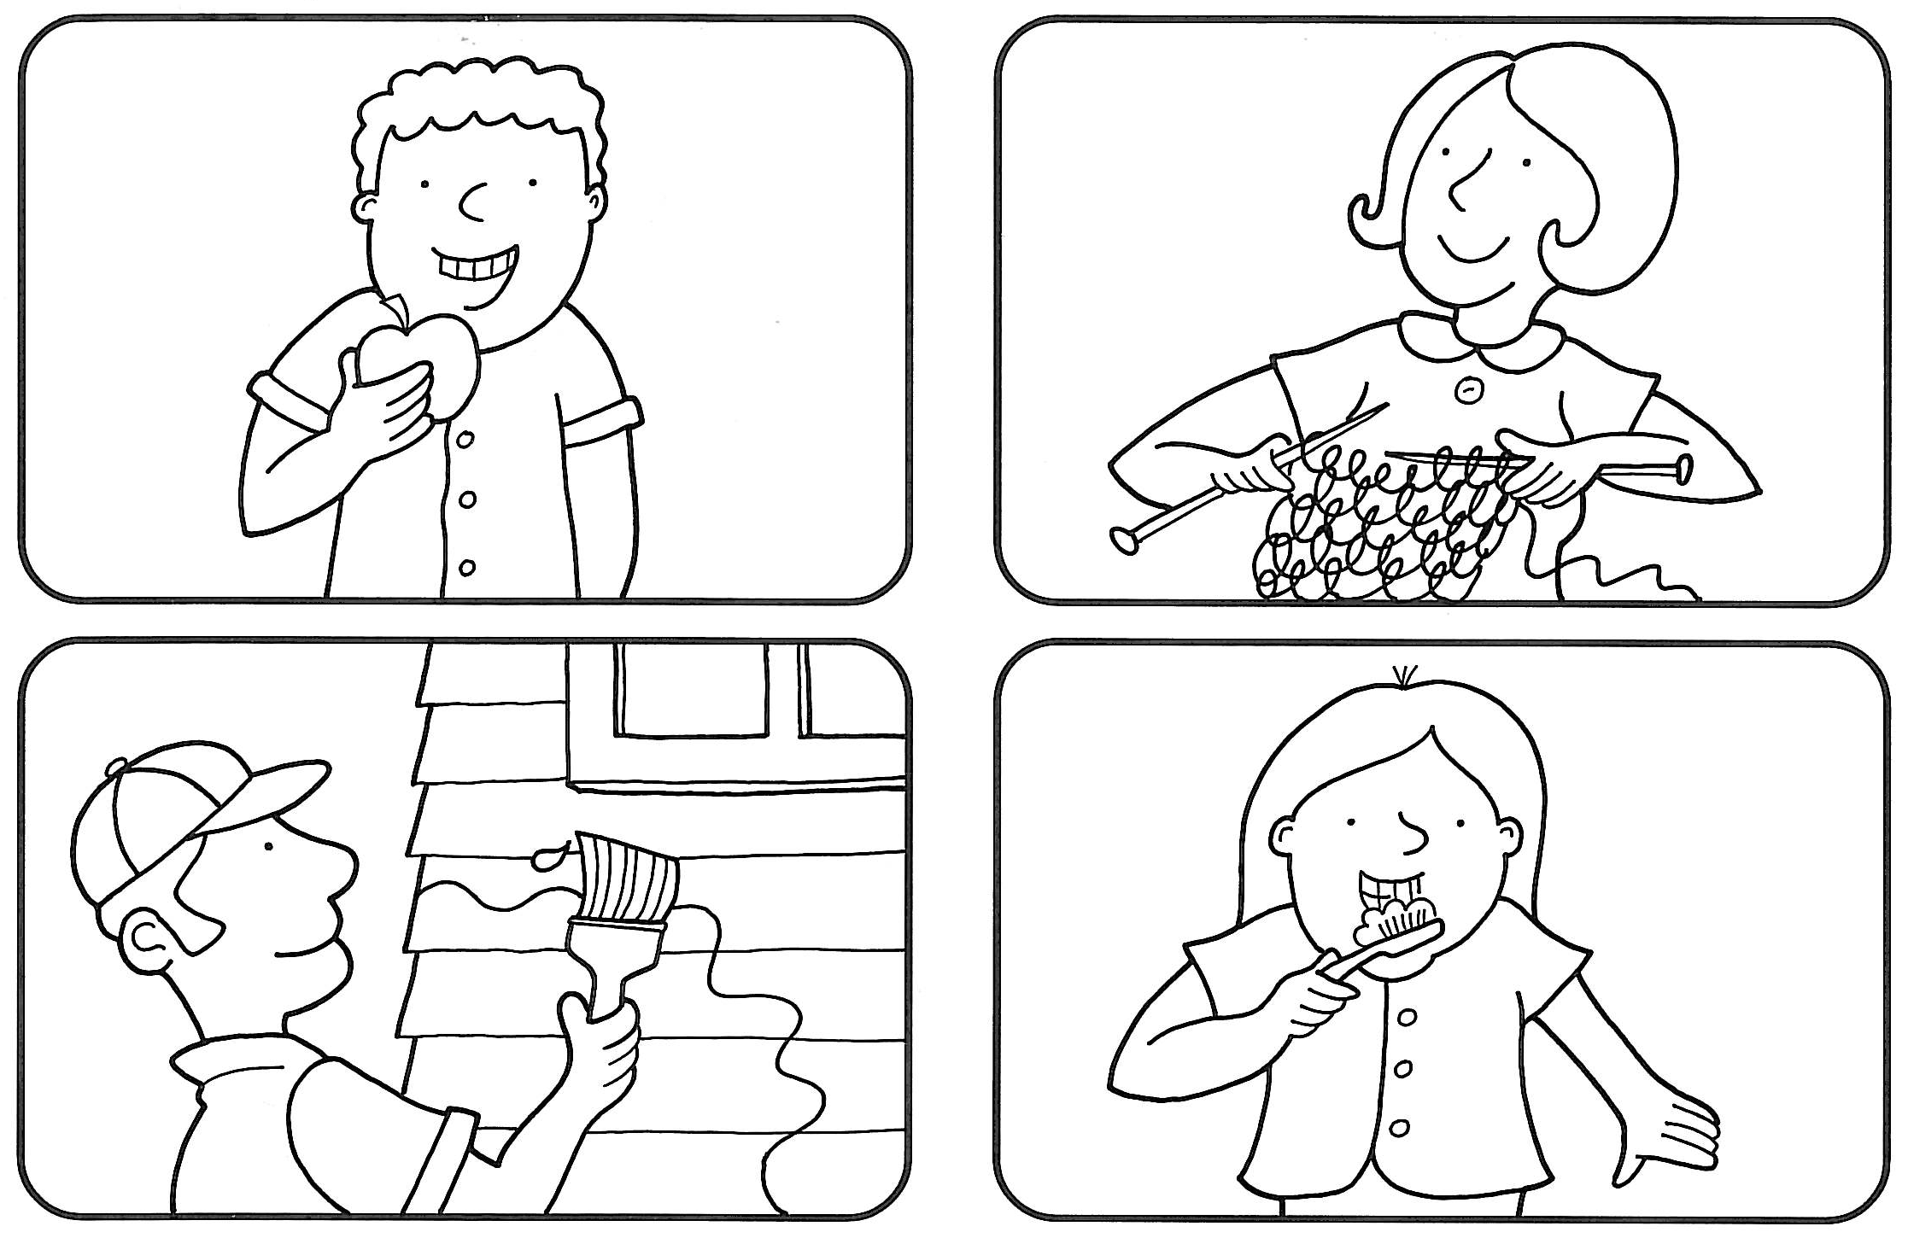

|  |
| --- |
| Draw a picture of something that would take a long time to do. |

**Maths Activity Sheet 11**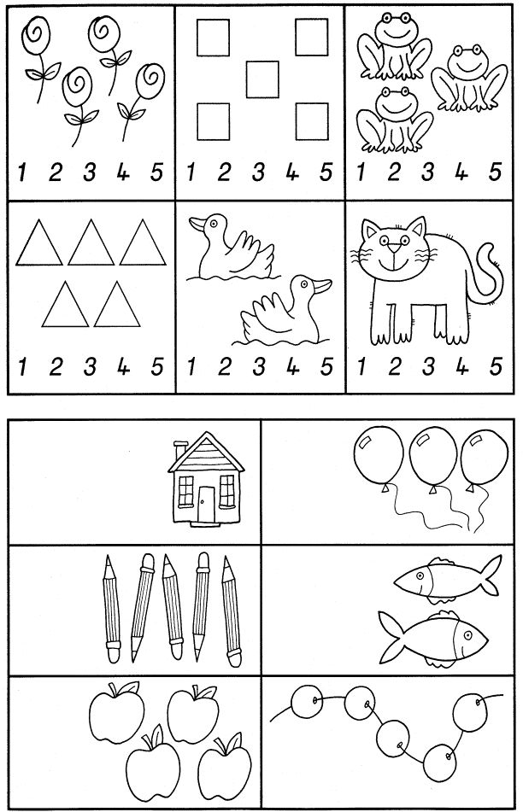

**Maths Activity Sheet 12**

**One, two, buckle my shoe**

One, two, buckle my shoe  
Three, four, shut the door  
Five, six, pick up sticks  
Seven, eight, lay them straight  
Nine, ten, begin again

Okay everybody, one more time

One, two, buckle my shoe  
Three, four, shut the door  
Five, six, pick up sticks  
Seven, eight, lay them straight  
Nine, ten, that's the end

That's the end

**1, 2, 3, 4, 5, Once I Caught a Fish Alive**

One, Two, Three, Four, Five,

Once I caught a fish alive,

Six, Seven, Eight, Nine, Ten,

Then I threw him back again.

Why did you let him go?

Because he bit my finger so.

Which finger did he bite?

This little finger on my right.

**Maths Activity Sheet 13**

Tic, Tac, Toe

Tic, tac, toe, here I go.

Where I land I do not know.

To play the game Tic, Tac, Toe choose a topic sheet of mixed symbols and images

Your child taps each picture in turn, as you say the rhyme together

He or she stops at the picture when the rhyme finishes. He or she counts the objects in that particular picture or names the image, then the rhyme begins again.

**Maths Activity Sheet 14**

**Ten in the Bed**

There were ten in the bed and the Little One said,

“Roll over! Roll over!”

So they all rolled over and one fell out.

There were nine in the bed and the little one said,

“Roll over! Roll over!”

So they all rolled over and one fell out.

There were eight in the bed and the little one said,

“Roll over! Roll over!”

So they all rolled over and one fell out.

There were seven in the bed and the little one said,

“Roll over! Roll over!”

So they all rolled over and one fell out.

There were six in the bed and the little one said,

“Roll over! Roll over!”

So they all rolled over and one fell out.

There were five in the bed and the little one said,

“Roll over! Roll over!”

So they all rolled over and one fell out.

There were four in the bed and the little one said,

“Roll over! Roll over!”

So they all rolled over and one fell out.

There were three in the bed and the little one said,

“Roll over! Roll over!”

So they all rolled over and one fell out.

There were two in the bed and the little one said,

“Roll over! Roll over!”

So they all rolled over and one fell out.

There was one in the bed and the little one said,

“I’m lonely! I’m lonely!”

So they all climbed back in

**Maths Activity Sheet 15**

Two Little Kittens

Two little kittens, one stormy night,  
Began to quarrel, and then to fight;  
One had a mouse and the other had none,  
And that's the way the quarrel begun.  
  
"I'll have that mouse," said the biggest cat,  
"You'll have that mouse? We'll see about that!"  
"I will have that mouse," said the eldest son;  
"You shan't have that mouse," said the little one.  
  
I told you before 't was a stormy night  
When these two little kittens began to fight;  
The old woman seized her sweeping broom,  
And swept the two kittens right out of the room.  
  
The ground was covered with frost and snow,  
And the two little kittens had nowhere to go.  
So they laid them down on the mat at the door  
While the old woman finished sweeping the floor.  
  
Then they crept in, as quiet as mice,  
All wet with snow and as cold as ice;  
For they found it was better, that stormy night,  
To lie down and sleep than to quarrel and fight.

**Maths Activity Sheet 16**

The beehive

Here is the beehive.  
But where are all the bees?  
Hiding away where nobody sees.  
Here they come flying out of their hive.  
One, two, three, four, five!

Here is the beehive.  
But where are all the bees?  
Hiding away where nobody sees.  
Here they come flying out of their hive.  
One, two, three, four, five!

Buzz up high. Buzz down low.  
Buzzing fast. Buzzing slow.  
Buzz to the left. Buzz to the right.  
Buzz all day but sleep at night.

Here is the beehive.  
But where are all the bees?  
Hiding away where nobody sees.  
Here they come flying out of their hive.  
One, two, three, four, five!

Two Little Eyes

Two little eyes to look around.  
Two little ears to hear each sound.  
  
One little nose to smell what's sweet.  
One little mouth that likes to eat.

**Maths Activity Sheet 17**

Can you Walk on Two Legs?

Can you walk on two legs, two legs, two legs?

Can you walk on two legs,

Round and round and round?

I can walk on two legs, two legs, two legs,

I can walk on two legs,

Round and round and round.

Can you hop on one leg, one leg, one leg?

Can you hop on one leg,

Round and round and round?

I can hop on one leg, one leg, one leg,

I can hop on one leg,

Round and round and round.

Can you wave with one hand, one hand, one hand?

Can you wave with one hand,

Round and round and round?

I can wave with one hand, one hand, one hand,

I can wave with one hand,

Round and round and round.

Can you wave with two hands, two hands, two hands?

Can you wave with two hands,

Round and round and round?

I can wave with two hands, two hands, two hands,

I can wave with two hands,

Round and round and round.

**Maths Activity Sheet 18**

Mary at the Cottage Gate

One, two, three, four

Mary at the cottage door

Two, four, six, eight

Mary at the garden gate

The Squirrel

Five little squirrels, sitting by the door

One ran away and then there were four

Four little squirrels, climbing up a tree

One ran down and that left three

The little squirrels, with coats so new

One got dirty and then there were two

Two little squirrels sitting in the sun

One got sun burnt and that left one

**Maths Activity Sheet 19**

Goldilocks

When Goldilocks went to the house of the bears,

Oh what did her blue eyes see?

A bowl that was huge,

A bowl that was small,

A bowl that was tiny and that was all,

She counted them one, two, three.

When Goldilocks went to the house of the bears,

Oh what did her blue eyes see?

A chair that was huge,

A chair that was small,

A chair that was tiny and that was all,

She counted them one, two, three.

When Goldilocks went to the house of the bears,

Oh what did her blue eyes see?

A bed that was huge,

A bed that was small,

A bed that was tiny and that was all,

She counted them one, two, three.

When Goldilocks went to the house of the bears,

Oh what did her blue eyes see?

A bear that was huge,

A bear that was small,

A bear that was tiny and that was all,

They growled at her “Grrrrr! Grrr! Grr!”

**Maths Activity Sheet 20**

Three Little Kittens

The three little kittens, they lost their mittens,

And they began to cry,

"Oh, mother dear, we sadly fear,

That we have lost our mittens."

"What!   Lost your mittens, you naughty kittens!

Then you shall have no pie."

"Meow, meow, meow."

"Then you shall have no pie."

The three little kittens, they found their mittens,

And they began to cry,

"Oh, mother dear, see here, see here,

For we have found our mittens."

"Put on your mittens, you silly kittens,

And you shall have some pie."

"Purr, purr, purr,

Oh, let us have some pie."

The three little kittens put on their mittens,

And soon ate up the pie,

"Oh, mother dear, we greatly fear,

That we have soiled our mittens."

"What, soiled your mittens, you naughty kittens!"

Then they began to sigh,

"Meow, meow, meow,"

Then they began to sigh.

The three little kittens, they washed their mittens,

And hung them out to dry,

"Oh, mother dear, do you not hear,

That we have washed our mittens?"

"What, washed your mittens, then you're good kittens,

But I smell a rat close by."

"Meow, meow, meow,

We smell a rat close by."

**Maths Activity Sheet 21**

Ten Fingers

I have ten little fingers and they all belong to me.  
I can make them do things, would you like to see?  
I can shut them up tight, I can open them wide.  
I can put them together, I can make them hide.  
I can make them jump high, I can make them jump low.  
I can rolly, rolly, them around and fold them just so.

Five Little Ladies

Five little ladies going for a walk.   
Five little ladies stopping for a talk.  
Along came five little gentlemen,  
And they all danced together and that makes 10!

Five Little Soldiers

Five little Soldiers stand in a row,  
Four stand up straight and one bends low.  
Along came the Seargent and what do you think?  
Up pops the Soldier, as quick as a wink.

**Maths Activity Sheet 22**

Ten Little Fish

One little fishy swimming in the sea.  
Along came another one, and then there were two.

Two little fishies swimming in the sea.  
Along came another one, and then there were three.

Three little fishies swimming in the sea.  
Along came another one, and then there were four.

Swimming swimming swimming in the sea.  
That big ol’ shark will never catch me.

Four little fishies swimming in the sea.  
Along came another one, and then there were five.

Five little fishies swimming in the sea.  
Along came another one, and then there were six.

Six little fishies swimming in the sea.  
Along came another one, and then there were seven

Swimming swimming swimming in the sea.  
That big ol’ shark will never catch me.

Seven little fishies swimming in the sea.  
Along came another one, and then there were eight.

Eight little fishies swimming in the sea.  
Along came another one, and then there were nine.

Nine little fishies swimming in the sea.  
Along came another one, and then there were ten.

Swimming swimming swimming in the sea.  
That big ol’ shark will never catch me.

Swimming swimming swimming in the sea.  
That big ol’ shark will never catch me.

Swimming swimming swimming in the sea.  
That big ol’ shark will never catch me.

He’ll never,  
Never,  
Never,  
Never,  
That big old shark will never catch me!

**Maths Activity Sheet 23**

|  |  |  |
| --- | --- | --- |
| [Image result for frogImage result for frogImage result for frog](https://www.google.com/url?sa=i&url=https%3A%2F%2Fwww.pngitem.com%2Fmiddle%2FhxoTwiR_transparent-frogs-clipart-clipart-frog-hd-png-download%2F&psig=AOvVaw2nrxoIV_oplH8_sxXHzWyt&ust=1584674550734000&source=images&cd=vfe&ved=0CAIQjRxqFwoTCJjy3e_KpegCFQAAAAAdAAAAABAD) | [Image result for frogImage result for frog](https://www.google.com/url?sa=i&url=https%3A%2F%2Fwww.pngitem.com%2Fmiddle%2FhxoTwiR_transparent-frogs-clipart-clipart-frog-hd-png-download%2F&psig=AOvVaw2nrxoIV_oplH8_sxXHzWyt&ust=1584674550734000&source=images&cd=vfe&ved=0CAIQjRxqFwoTCJjy3e_KpegCFQAAAAAdAAAAABAD) | [Image result for frog](https://www.google.com/url?sa=i&url=https%3A%2F%2Fwww.pngitem.com%2Fmiddle%2FhxoTwiR_transparent-frogs-clipart-clipart-frog-hd-png-download%2F&psig=AOvVaw2nrxoIV_oplH8_sxXHzWyt&ust=1584674550734000&source=images&cd=vfe&ved=0CAIQjRxqFwoTCJjy3e_KpegCFQAAAAAdAAAAABAD)  [Image result for frog](https://www.google.com/url?sa=i&url=https%3A%2F%2Fwww.pngitem.com%2Fmiddle%2FhxoTwiR_transparent-frogs-clipart-clipart-frog-hd-png-download%2F&psig=AOvVaw2nrxoIV_oplH8_sxXHzWyt&ust=1584674550734000&source=images&cd=vfe&ved=0CAIQjRxqFwoTCJjy3e_KpegCFQAAAAAdAAAAABAD) |
| [Image result for frog](https://www.google.com/url?sa=i&url=https%3A%2F%2Fwww.pngitem.com%2Fmiddle%2FhxoTwiR_transparent-frogs-clipart-clipart-frog-hd-png-download%2F&psig=AOvVaw2nrxoIV_oplH8_sxXHzWyt&ust=1584674550734000&source=images&cd=vfe&ved=0CAIQjRxqFwoTCJjy3e_KpegCFQAAAAAdAAAAABAD)  [Image result for frogImage result for frog](https://www.google.com/url?sa=i&url=https%3A%2F%2Fwww.pngitem.com%2Fmiddle%2FhxoTwiR_transparent-frogs-clipart-clipart-frog-hd-png-download%2F&psig=AOvVaw2nrxoIV_oplH8_sxXHzWyt&ust=1584674550734000&source=images&cd=vfe&ved=0CAIQjRxqFwoTCJjy3e_KpegCFQAAAAAdAAAAABAD) | [Image result for frog](https://www.google.com/url?sa=i&url=https%3A%2F%2Fwww.pngitem.com%2Fmiddle%2FhxoTwiR_transparent-frogs-clipart-clipart-frog-hd-png-download%2F&psig=AOvVaw2nrxoIV_oplH8_sxXHzWyt&ust=1584674550734000&source=images&cd=vfe&ved=0CAIQjRxqFwoTCJjy3e_KpegCFQAAAAAdAAAAABAD) | [Image result for frogImage result for frogImage result for frogImage result for frog](https://www.google.com/url?sa=i&url=https%3A%2F%2Fwww.pngitem.com%2Fmiddle%2FhxoTwiR_transparent-frogs-clipart-clipart-frog-hd-png-download%2F&psig=AOvVaw2nrxoIV_oplH8_sxXHzWyt&ust=1584674550734000&source=images&cd=vfe&ved=0CAIQjRxqFwoTCJjy3e_KpegCFQAAAAAdAAAAABAD) |
| [Image result for frogImage result for frogImage result for frogImage result for frog](https://www.google.com/url?sa=i&url=https%3A%2F%2Fwww.pngitem.com%2Fmiddle%2FhxoTwiR_transparent-frogs-clipart-clipart-frog-hd-png-download%2F&psig=AOvVaw2nrxoIV_oplH8_sxXHzWyt&ust=1584674550734000&source=images&cd=vfe&ved=0CAIQjRxqFwoTCJjy3e_KpegCFQAAAAAdAAAAABAD) | [Image result for frogImage result for frog](https://www.google.com/url?sa=i&url=https%3A%2F%2Fwww.pngitem.com%2Fmiddle%2FhxoTwiR_transparent-frogs-clipart-clipart-frog-hd-png-download%2F&psig=AOvVaw2nrxoIV_oplH8_sxXHzWyt&ust=1584674550734000&source=images&cd=vfe&ved=0CAIQjRxqFwoTCJjy3e_KpegCFQAAAAAdAAAAABAD)  [Image result for frog](https://www.google.com/url?sa=i&url=https%3A%2F%2Fwww.pngitem.com%2Fmiddle%2FhxoTwiR_transparent-frogs-clipart-clipart-frog-hd-png-download%2F&psig=AOvVaw2nrxoIV_oplH8_sxXHzWyt&ust=1584674550734000&source=images&cd=vfe&ved=0CAIQjRxqFwoTCJjy3e_KpegCFQAAAAAdAAAAABAD) | [Image result for frogImage result for frog](https://www.google.com/url?sa=i&url=https%3A%2F%2Fwww.pngitem.com%2Fmiddle%2FhxoTwiR_transparent-frogs-clipart-clipart-frog-hd-png-download%2F&psig=AOvVaw2nrxoIV_oplH8_sxXHzWyt&ust=1584674550734000&source=images&cd=vfe&ved=0CAIQjRxqFwoTCJjy3e_KpegCFQAAAAAdAAAAABAD)  [Image result for frogImage result for frogImage result for frog](https://www.google.com/url?sa=i&url=https%3A%2F%2Fwww.pngitem.com%2Fmiddle%2FhxoTwiR_transparent-frogs-clipart-clipart-frog-hd-png-download%2F&psig=AOvVaw2nrxoIV_oplH8_sxXHzWyt&ust=1584674550734000&source=images&cd=vfe&ved=0CAIQjRxqFwoTCJjy3e_KpegCFQAAAAAdAAAAABAD) |
| [Image result for frog](https://www.google.com/url?sa=i&url=https%3A%2F%2Fwww.pngitem.com%2Fmiddle%2FhxoTwiR_transparent-frogs-clipart-clipart-frog-hd-png-download%2F&psig=AOvVaw2nrxoIV_oplH8_sxXHzWyt&ust=1584674550734000&source=images&cd=vfe&ved=0CAIQjRxqFwoTCJjy3e_KpegCFQAAAAAdAAAAABAD) | [Image result for frogImage result for frog](https://www.google.com/url?sa=i&url=https%3A%2F%2Fwww.pngitem.com%2Fmiddle%2FhxoTwiR_transparent-frogs-clipart-clipart-frog-hd-png-download%2F&psig=AOvVaw2nrxoIV_oplH8_sxXHzWyt&ust=1584674550734000&source=images&cd=vfe&ved=0CAIQjRxqFwoTCJjy3e_KpegCFQAAAAAdAAAAABAD)  [Image result for frog](https://www.google.com/url?sa=i&url=https%3A%2F%2Fwww.pngitem.com%2Fmiddle%2FhxoTwiR_transparent-frogs-clipart-clipart-frog-hd-png-download%2F&psig=AOvVaw2nrxoIV_oplH8_sxXHzWyt&ust=1584674550734000&source=images&cd=vfe&ved=0CAIQjRxqFwoTCJjy3e_KpegCFQAAAAAdAAAAABAD)  [Image result for frog](https://www.google.com/url?sa=i&url=https%3A%2F%2Fwww.pngitem.com%2Fmiddle%2FhxoTwiR_transparent-frogs-clipart-clipart-frog-hd-png-download%2F&psig=AOvVaw2nrxoIV_oplH8_sxXHzWyt&ust=1584674550734000&source=images&cd=vfe&ved=0CAIQjRxqFwoTCJjy3e_KpegCFQAAAAAdAAAAABAD) | [Image result for frogImage result for frog](https://www.google.com/url?sa=i&url=https%3A%2F%2Fwww.pngitem.com%2Fmiddle%2FhxoTwiR_transparent-frogs-clipart-clipart-frog-hd-png-download%2F&psig=AOvVaw2nrxoIV_oplH8_sxXHzWyt&ust=1584674550734000&source=images&cd=vfe&ved=0CAIQjRxqFwoTCJjy3e_KpegCFQAAAAAdAAAAABAD) |

Maths Activity Sheet 24

|  |  |  |  |
| --- | --- | --- | --- |
| **three** |  | **two** | **one** |
| **4** | **3** | **five** | **four** |
| **5** |  | **2** | **1** |