Geography Inquiry



**What is Geography?**



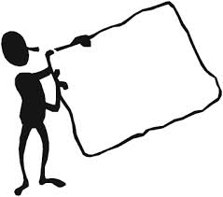

**Introduction**

Here you will:

- Explore the meaning of the terms – Geography and geographer

- investigate geographical tools

- respond like a geographer

Write words or phrases in the rectangles below to show what you already know about Geography.

**What is Geography and**

**Why study it?**

Geography is about our wonderful world.

Geography is a way of thinking.

Geography is something you do.



What does all this mean? *Turn over the page and find out the meaning of Geography.*



**What is Geography?**

**Geography is about our wonderful world**

The world around us is made up of many interesting places, people, cultures and environments. Geography is a way of exploring and understanding the world.

**A person who studies Geography is called a *Geographer.***

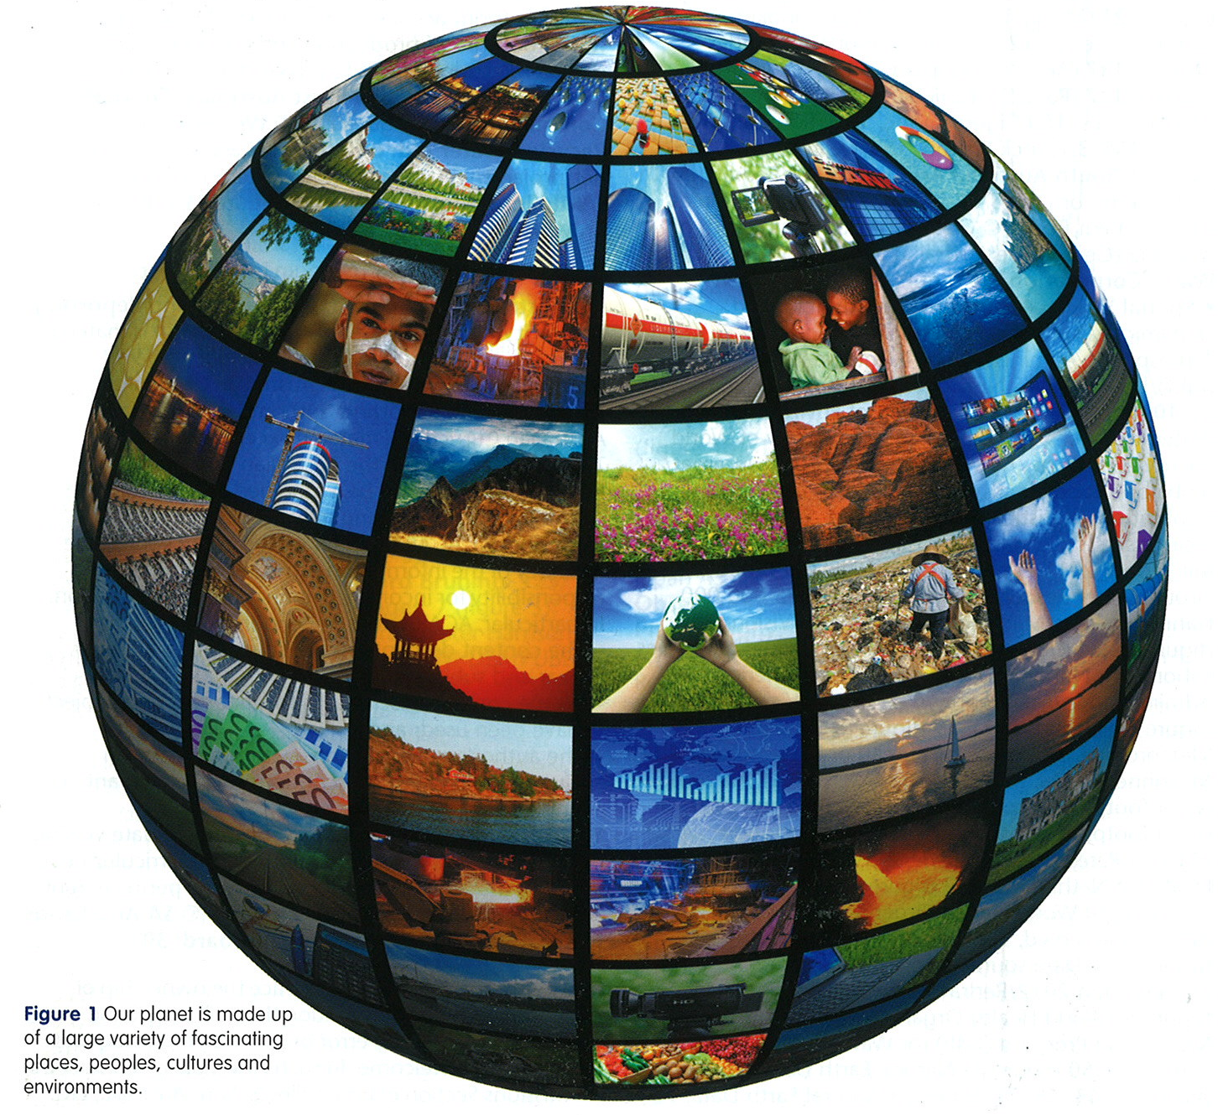

*http://www.google.com.au/search?q=geography&source*

**What is Geography continued**

**Geography is a way of exploring the world**

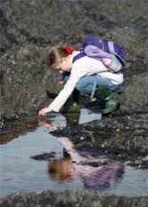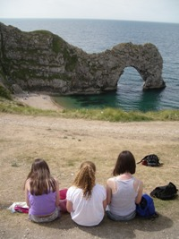Geography is about observing and doing! As a geographer you will explore places from your local area, your nation, region and the world.

**Geography is about something you do**

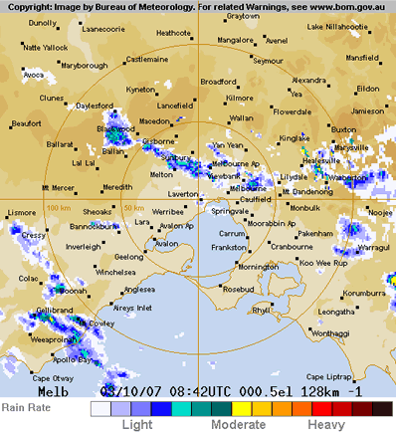It is a way of looking at the world! A geographer’s main tool is a map. If you look carefully at maps they contain a lot of information.

**Why study Geography?**

Geography is important because it helps us learn about the things we need in order to stay alive, such as where water is located and where we can get food.

Geography also helps people make decisions about where to build, such as schools, hospital roads and even cities.

**Some questions geographers ask—**

* Would you build a city on a volcano?
* What should be considered when building in fire and flood prone area?
* 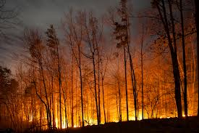How do we get water into desert towns?

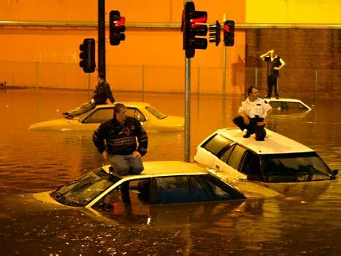

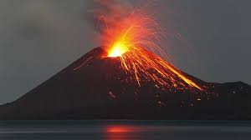

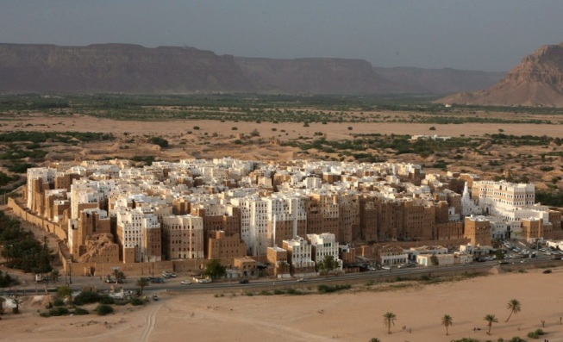

<http://www.google.com.au/search?q=geography&source=lnms&tbm=isch&sa=X&ei=cF_IU->

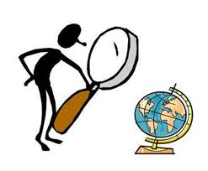**How to be a Geographer!**

To be a geographer you need to use the following skills and tools to help you answer questions about the environment and make decisions about the future.

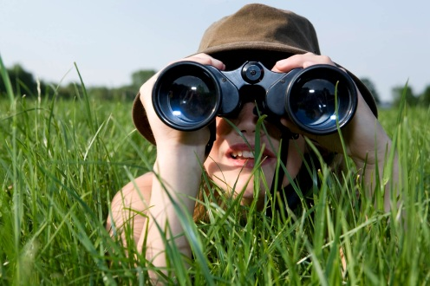They are:

**1. Observation**

The most important tool that a geographer can

have is the power of **observation.**

**2. Images**

These include **maps, photos** and **satellite images.**  For example;

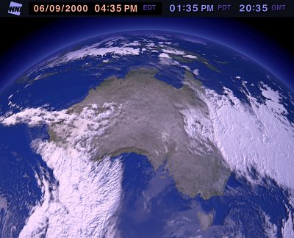

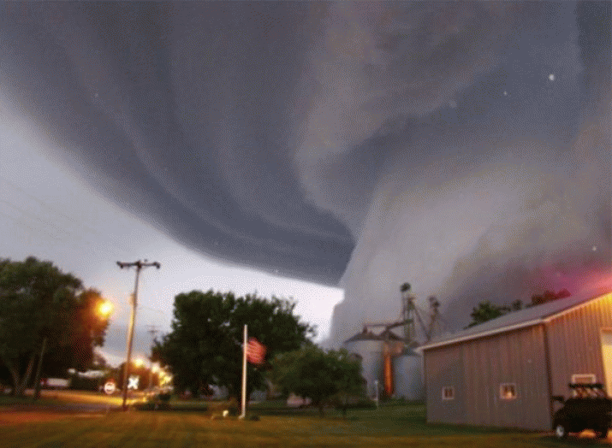

*Satellite map and images of Australia Photo of cyclone*

MCj04247880000[1] **For you to do**

**Activity 1—Observing**

Look closely at the photos below and over the page. Look at the next two photos and write your observations. Helpful questions to think about—

* + *What* ***natural things*** *can I see? These are called* ***physical features.***
  + *What is created by* ***people*** *and Why? These are called* ***human features.***
  + *What does the weather look like? etc*

The first one has been completed for you. *Hampton Beach Melbourne.*

*Landslides −*

*Fences to stop soil sliding further*

*Fence to warn people and keep them from danger*

*Warm weather*

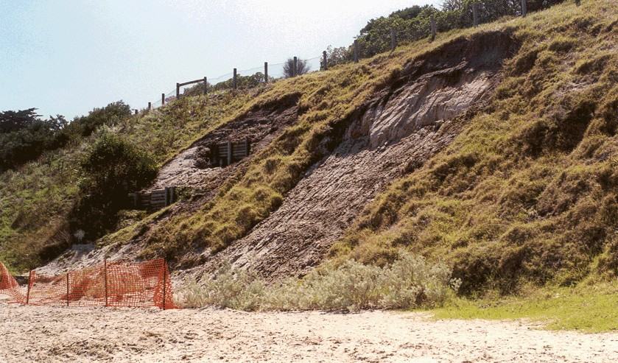

*Footprints on sand, people in the area.*

*Plastic fencing*

*Vegetation – can stop landslides*

*Green vegetation not dry*

**Activity 1 continued**

Make observations on the backyard below—

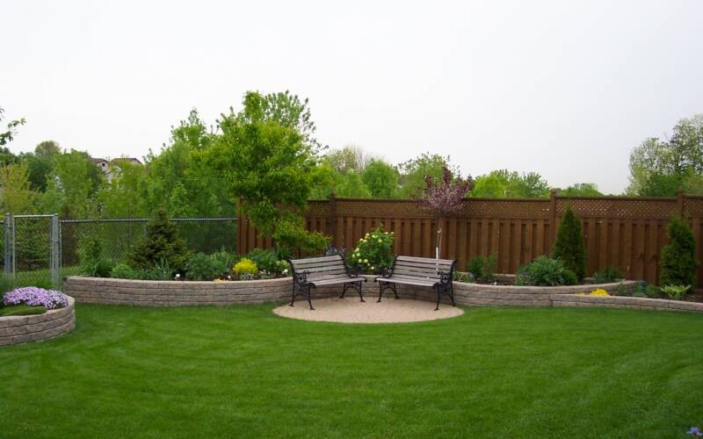

*http://www.google.com.au/search?q=geography&source*

**Activity 1 continued**

Make observations on Uluru and surrounding area.

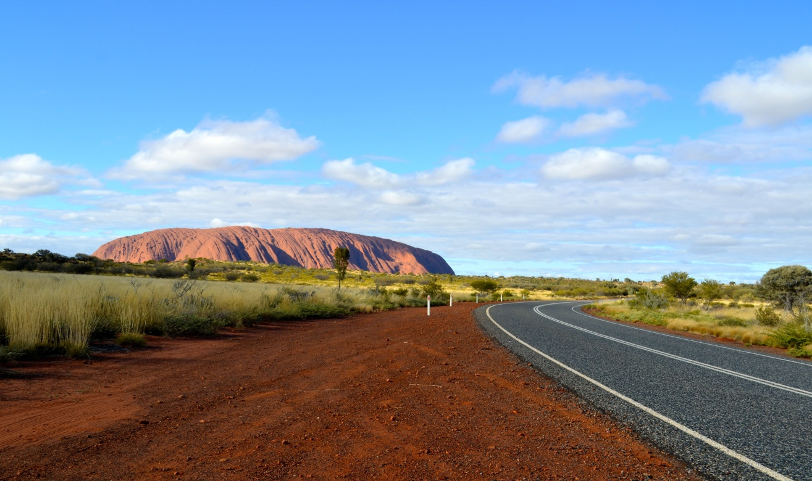

[*http://www.google.com.au/search?q=geography&source*](http://www.google.com.au/search?q=geography&source)

MCj04247880000[1] **For you to do**

**Activity 2—Images –Maps**

In this activity you will be looking at maps and making observations.

Look closely at the images and think about the following.

**Physical features—***land, water, vegetation, land use, buildings*

**Reasons *—****observe what may have happened.*

**The first one has been completed for you.**

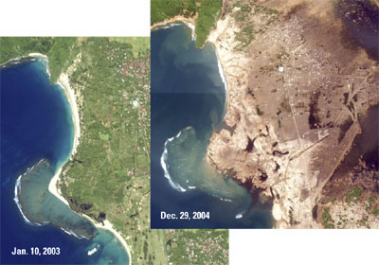

*Satellite map of Sumatran coast* <http://soundwaves.usgs.gov/2005/03/>

**What I can** see—Before photo – There is sand on the coast and there is green vegetation. There are some buildings further inland.

After photo- There is no sand and vegetation, cannot see any building or development.

**What may have happened**—Erosion of coast by wind or waves or a tsunami.

**Activity 2 continued**

Discuss with your supervisor the images below and over the page. Briefly note your conclusions.

*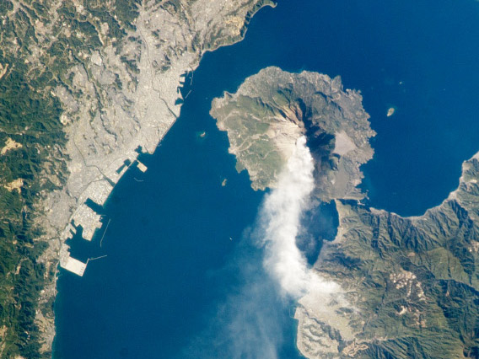http://www.slate.com/blogs/bad_astronomy/2013/02/02/sakurajima_volcano_smoldering_japenese_volcano_seen_from_space.htmlWhat can you see—*

*What can you see?*

*_______________________________________________________________________*

*_______________________________________________________________________*

*_______________________________________________________________________*

*_______________________________________________________________________*

*_______________________________________________________________________*

*Why do you people have settled this way?*

*______________________________________________________________________*

*_______________________________________________________________________*

*_______________________________________________________________________*

*_______________________________________________________________________*

*_______________________________________________________________________*

**Activity 2 continued**

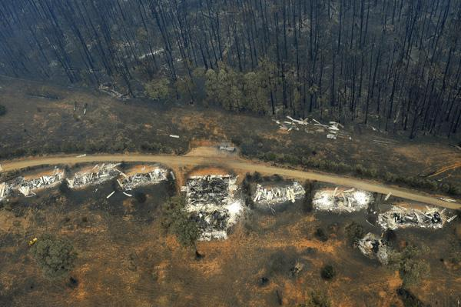

Aerial (bird’s eye view) of aftermath of Victorian bushfires.

[*http://www.smh.com.au/ftimages/2009/02/09/1234027901521.html*](http://www.smh.com.au/ftimages/2009/02/09/1234027901521.html)

*What can you see—_______________________________________________________________________*

*_______________________________________________________________________*

*_______________________________________________________________________*

*_______________________________________________________________________*

*_______________________________________________________________________*

*_______________________________________________________________________*

*What may have happened—_______________________________________________________________________*

*_______________________________________________________________________*

*_______________________________________________________________________*

*_______________________________________________________________________*

*_______________________________________________________________________*

*_______________________________________________________________________*

Fieldtrip

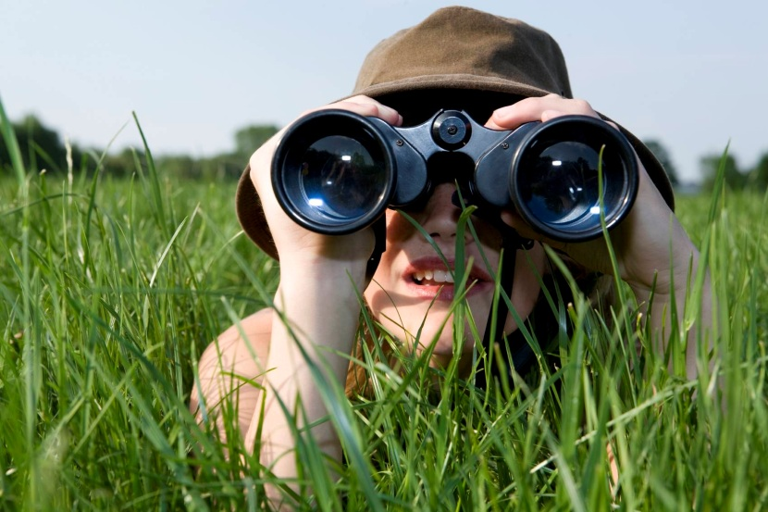

-

**Be a Geographer**

**It is now time for you to become a geographer and observe your local area.**

You will be going on a fieldtrip where you will observe and record what you see, hear, smell and feel in the outdoors.

**Important note!**

You must be accompanied by an adult!

[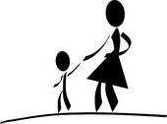](http://www.google.com.au/url?sa=i&rct=j&q=mother%20and%20child%20walking%20through%20the%20park&source=images&cd=&cad=rja&uact=8&docid=4vVtOxWfJBm_SM&tbnid=Rev1eZ2D0bz9rM:&ved=0CAUQjRw&url=http://www.fotosearch.com/clip-art/mother-child.html&ei=Q_aDU4HcF8O8kgXf-4DoBA&psig=AFQjCNFojZScfez1SBgJ0y-6xwUJP7dZtg&ust=1401243547785776)

**Let’s get started!**

**Step 1 —Where do I go?**

1. Discuss the area you will visit.

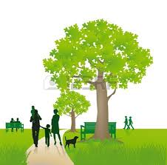Areas to consider—

* 1. backyard
  2. local street or shopping area
  3. local park
  4. town centre
  5. own choice

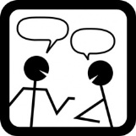**Step 2 —What do I already know?**

Discuss what you already **know** about the area.

What you have **observed** about the area.

**Step 3—What do I need?**

Collect the following to take with you:

* + Pen and paper
  + Field trip Report from page 26
  + Clipboard
  + Camera (optional)
  + Ipad (optional)
  + Map of area (optional)

[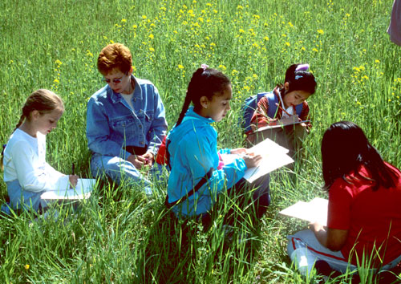](http://www.google.com.au/url?sa=i&rct=j&q=children%20taking%20notes&source=images&cd=&docid=qpzL7xfU4_KUVM&tbnid=SHuWxdGuG_4V7M:&ved=0CAUQjRw&url=http://www.dec.ny.gov/pubs/70633.html&ei=QfuDU8GlOIuXkwWxtYHwBw&psig=AFQjCNGjLuuLwoBv5aGhUWfK34ZPzjI4Ug&ust=1401244704780141)

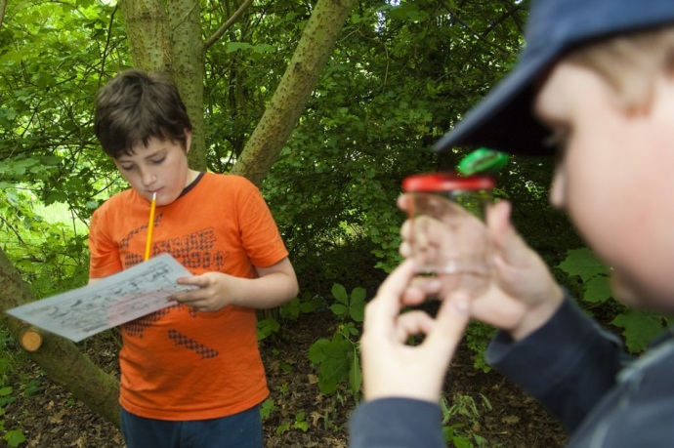 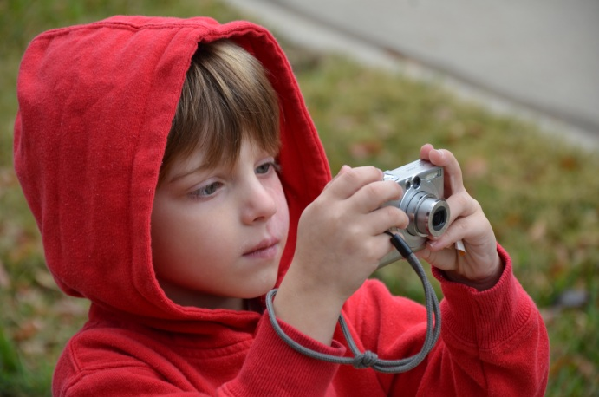

http://www.google.com.au/search?q=geography&source=lnms&tbm=isch&sa=X&ei=cF_IU-

**Step 4—What do I record?**

You will be **observing** and **recording** the human and physical features of your chosen area.

Human features things that have been created by people such as roads, walls, and buildings.

**What do human and physical features mean?**

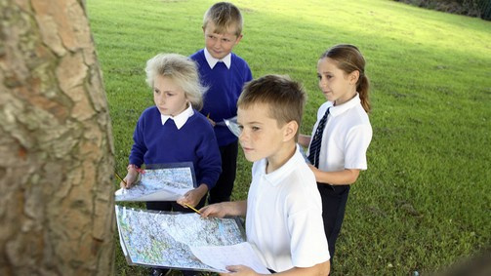

Physical are created by nature such as cliffs, sea, grass, trees.

You will record your observations on the following pages, which outline your instructions.

*http://www.google.com.au/search?q=geography&source=lnms&tbm=isch&sa=X&ei=cF_IU-*

MCj04247880000[1]**Field Trip Report**

Name of place and location: ________________________________________________________________

________________________________________________________________________________________________

________________________________________________________________________________________________

Brief description ____________________________________________________________________________

________________________________________________________________________________________________

________________________________________________________________________________________________

________________________________________________________________________________________________

Observation

What do you see?

Discuss the following:

1. Walk around the area, identify and discuss any human

and physical features in the area.

1. Discuss why you think physical features have been placed (or not placed) in the area.
2. Discuss—Is there a connection between the physical and human features?



**Visuals—**What does it look like?

1. **Create a picture** of the location. You can do this by one of the following ways:

* + - * 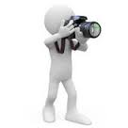Take a **photo** and paste on the following page.
      * 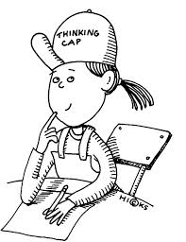Sketch the area on the following page. Include details such as the human and physical feature identified and discussed.

2. **Label the picture —**Identify the human and physical features by writing:

HF for *human features* and PF for *physical features*. For example —

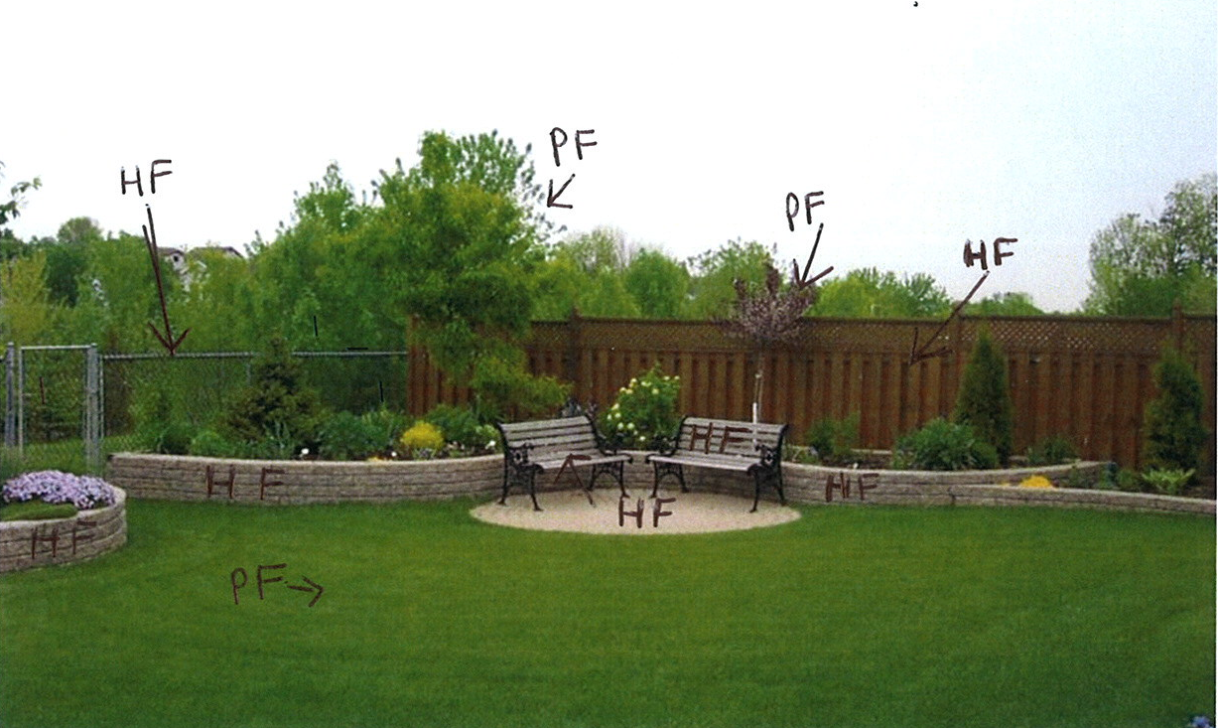

**Optional Challenge activity**

**Mapping**

**Activity –**

* Locate a map of the area. Internet or Information Centre is a useful resource.
* Walk around the area of the map and colour according to the features, shades of brown/green/yellow for physical features and shades of red/purple/blue for human features.
* Add a title and a key.
* Describe the distribution of the physical features.
* Describe the relationship of the physical and human features.

**Challenge**

* Depending on technology you could use the computer to produce a map with photos linked to locations.

**Reflection**

**What have you learnt?**

Write words or phrases in the rectangles below to show what you have learnt in this module.